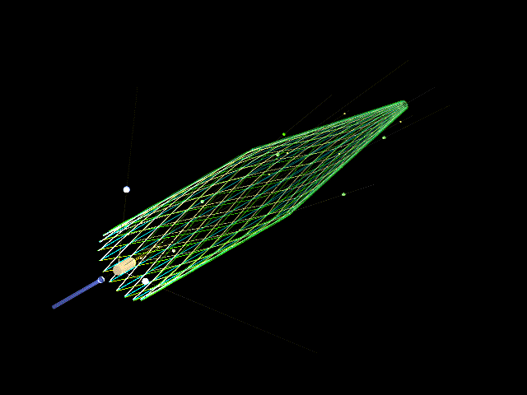

Design Study of the Vertex Detector
for the Glue X Collaboration

Sharon Careccia

Andi Klein

June 20, 2002

Old Dominion University Department of Physics

ABSTRACT

This is an update on the design of the vertex detector to be used in the Hall D project at Thomas Jefferson National Accelerator Facility.

INTRODUCTION

The initial design for this detector was a cylinder and cone configuration made up of six layers of scintillating fibers; two axial layers to measure the (rφ) coordinates, two clockwise helical layers, and two counter clockwise helical layers which will provide a stereo (u or v) measurement. The reason for this configuration was to detect particles at small scattering angles, and to reduce the distance any given particle travels through the width of the fiber. Figure 1 shows the distance particles travel through a cylinder and a cylinder capped with a cone. To get the small scattering angles, the cylinder length would need to be increased. When the particle finally hits the fiber, due to the geometry, it would have to travel through more material. A cone greatly decreases the amount of material the particle travels through.
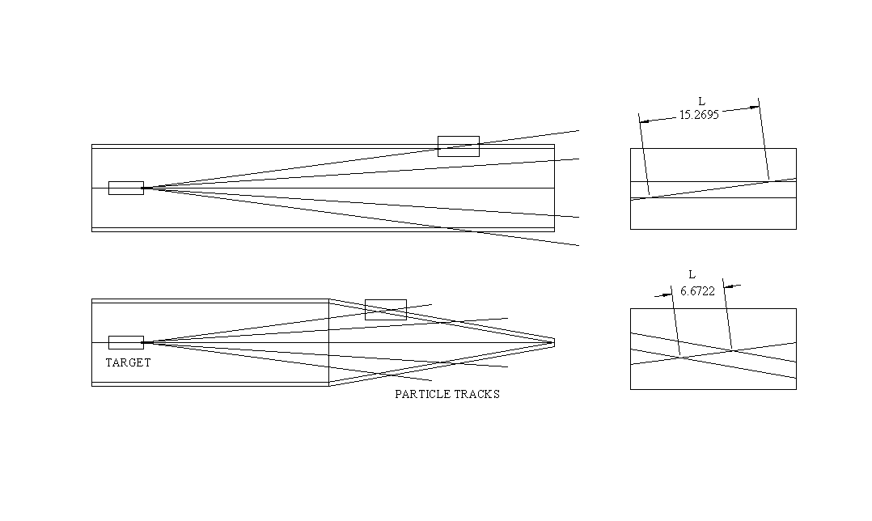
Figure 1. How the distance a particle travels through a fiber changes with the geometry of the detector.

Three designs alternatives were studied. All the designs had a cylinder and cone assembly, with the cylinder having axial and +/-30 helical fibers. Design 1 had circumferential and helical fibers at a constant angle, design 2 has axial and helical fibers running parallel to each other, and design 3 had axial and helical fibers at a constant angle. Table 1 summarizes the main features of each design.

Design | Cylinder | Cone | Design Problems
1 | Axial  +/-30 Helical | Circumferential  +/-30 Helical  Constant-angle | Bend Radius  Connection to  Fiber Readout
2 | Axial  +/-30 Helical | Axial  +/-30 Helical  Parallel Fibers | Light Transfer  Coordinate System
3 | Axial  +/-30 Helical | Axial  +/-30 Helical  Constant-angle | Gaps is Fiber Coverage  Cone Resolution

Table 1: Design Features

DESIGN 1

The first phase of this project was to create a visual model using AutoCAD. Figure 2. This model would serve as a general guide for the design process. For the first design, circumferential fibers were used instead of radial fibers on the cone. This would avoid gaps created by loosing fibers at various intervals due to decreasing diameter. Once this model was created, light loss was calculated at the point where the cylindrical fiber was connected to the conical fiber. With these considerations, the model was constructed using solids in AutoCAD. This model was actually two separate models, one for the cone and one for the cylinder. The mating ends of the model were sliced perpendicular to the axis of the cone and cylinder so that the two models could be aligned. Once the models were aligned and fibers of the cone matched to the fibers of the cylinder, I took a sliced section at the cone cylinder junction and calculated the areas of each joining pairs of ellipses. I then calculated total area and finally the mated area and took the ratio of the mated area to the total area. Figure 3. The total area was .0080cm² and the contact area was .0078cm². The light transfer due to mated area was 97.5%. Because this was done using the AutoCAD array command, the fibers are drawn at equal spacing around the cone and the angles made by the conical fibers relative to the cylindrical fibers remains constant along the circumference.

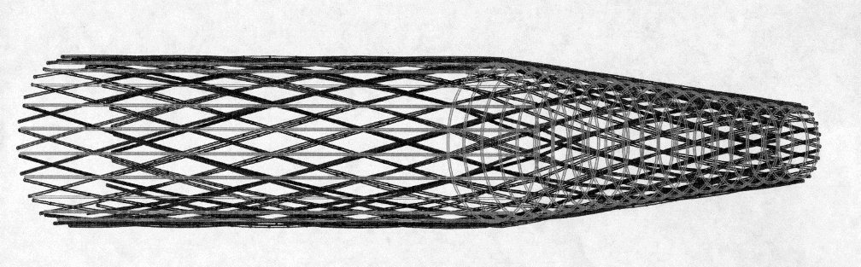
Figure 2. The initial AutoCAD model, (not every fiber is drawn for clarity).

In this initial design we encountered several problems. The first problem was that the minimum bend radius of the fiber was larger than the smallest diameter at the forward end of the cone. The design called for a diameter of 1cm, but the minimum bend radius is 10cm. There was also problems with connecting the circumferential fibers to clear fibers leading to the VLPCs. This would lead to excess material that the particle would travel through, thus increasing the multiple scattering. To eliminate material thickness, we wanted to connect all clear fibers to all scintillating fibers at the base of the cylinder. This could not be done using the circumferential fibers since there was no way to connect those fibers to the axial fibers on the cylinder. Figure 4. To eliminate this problem, the circumferential direction was changed to an axial direction. This allowed a 1 to 1 mating of fibers on the cone to fibers on the cylinder. The problem with this design is the maximum number of fibers that can be placed side by side on the cylinder and large diameter end of the cone is much greater then the number of fibers placed side by side on the small diameter end of the cone. Fibers will have to be cut at various distances along the cylinder. This creates gaps in the detector.

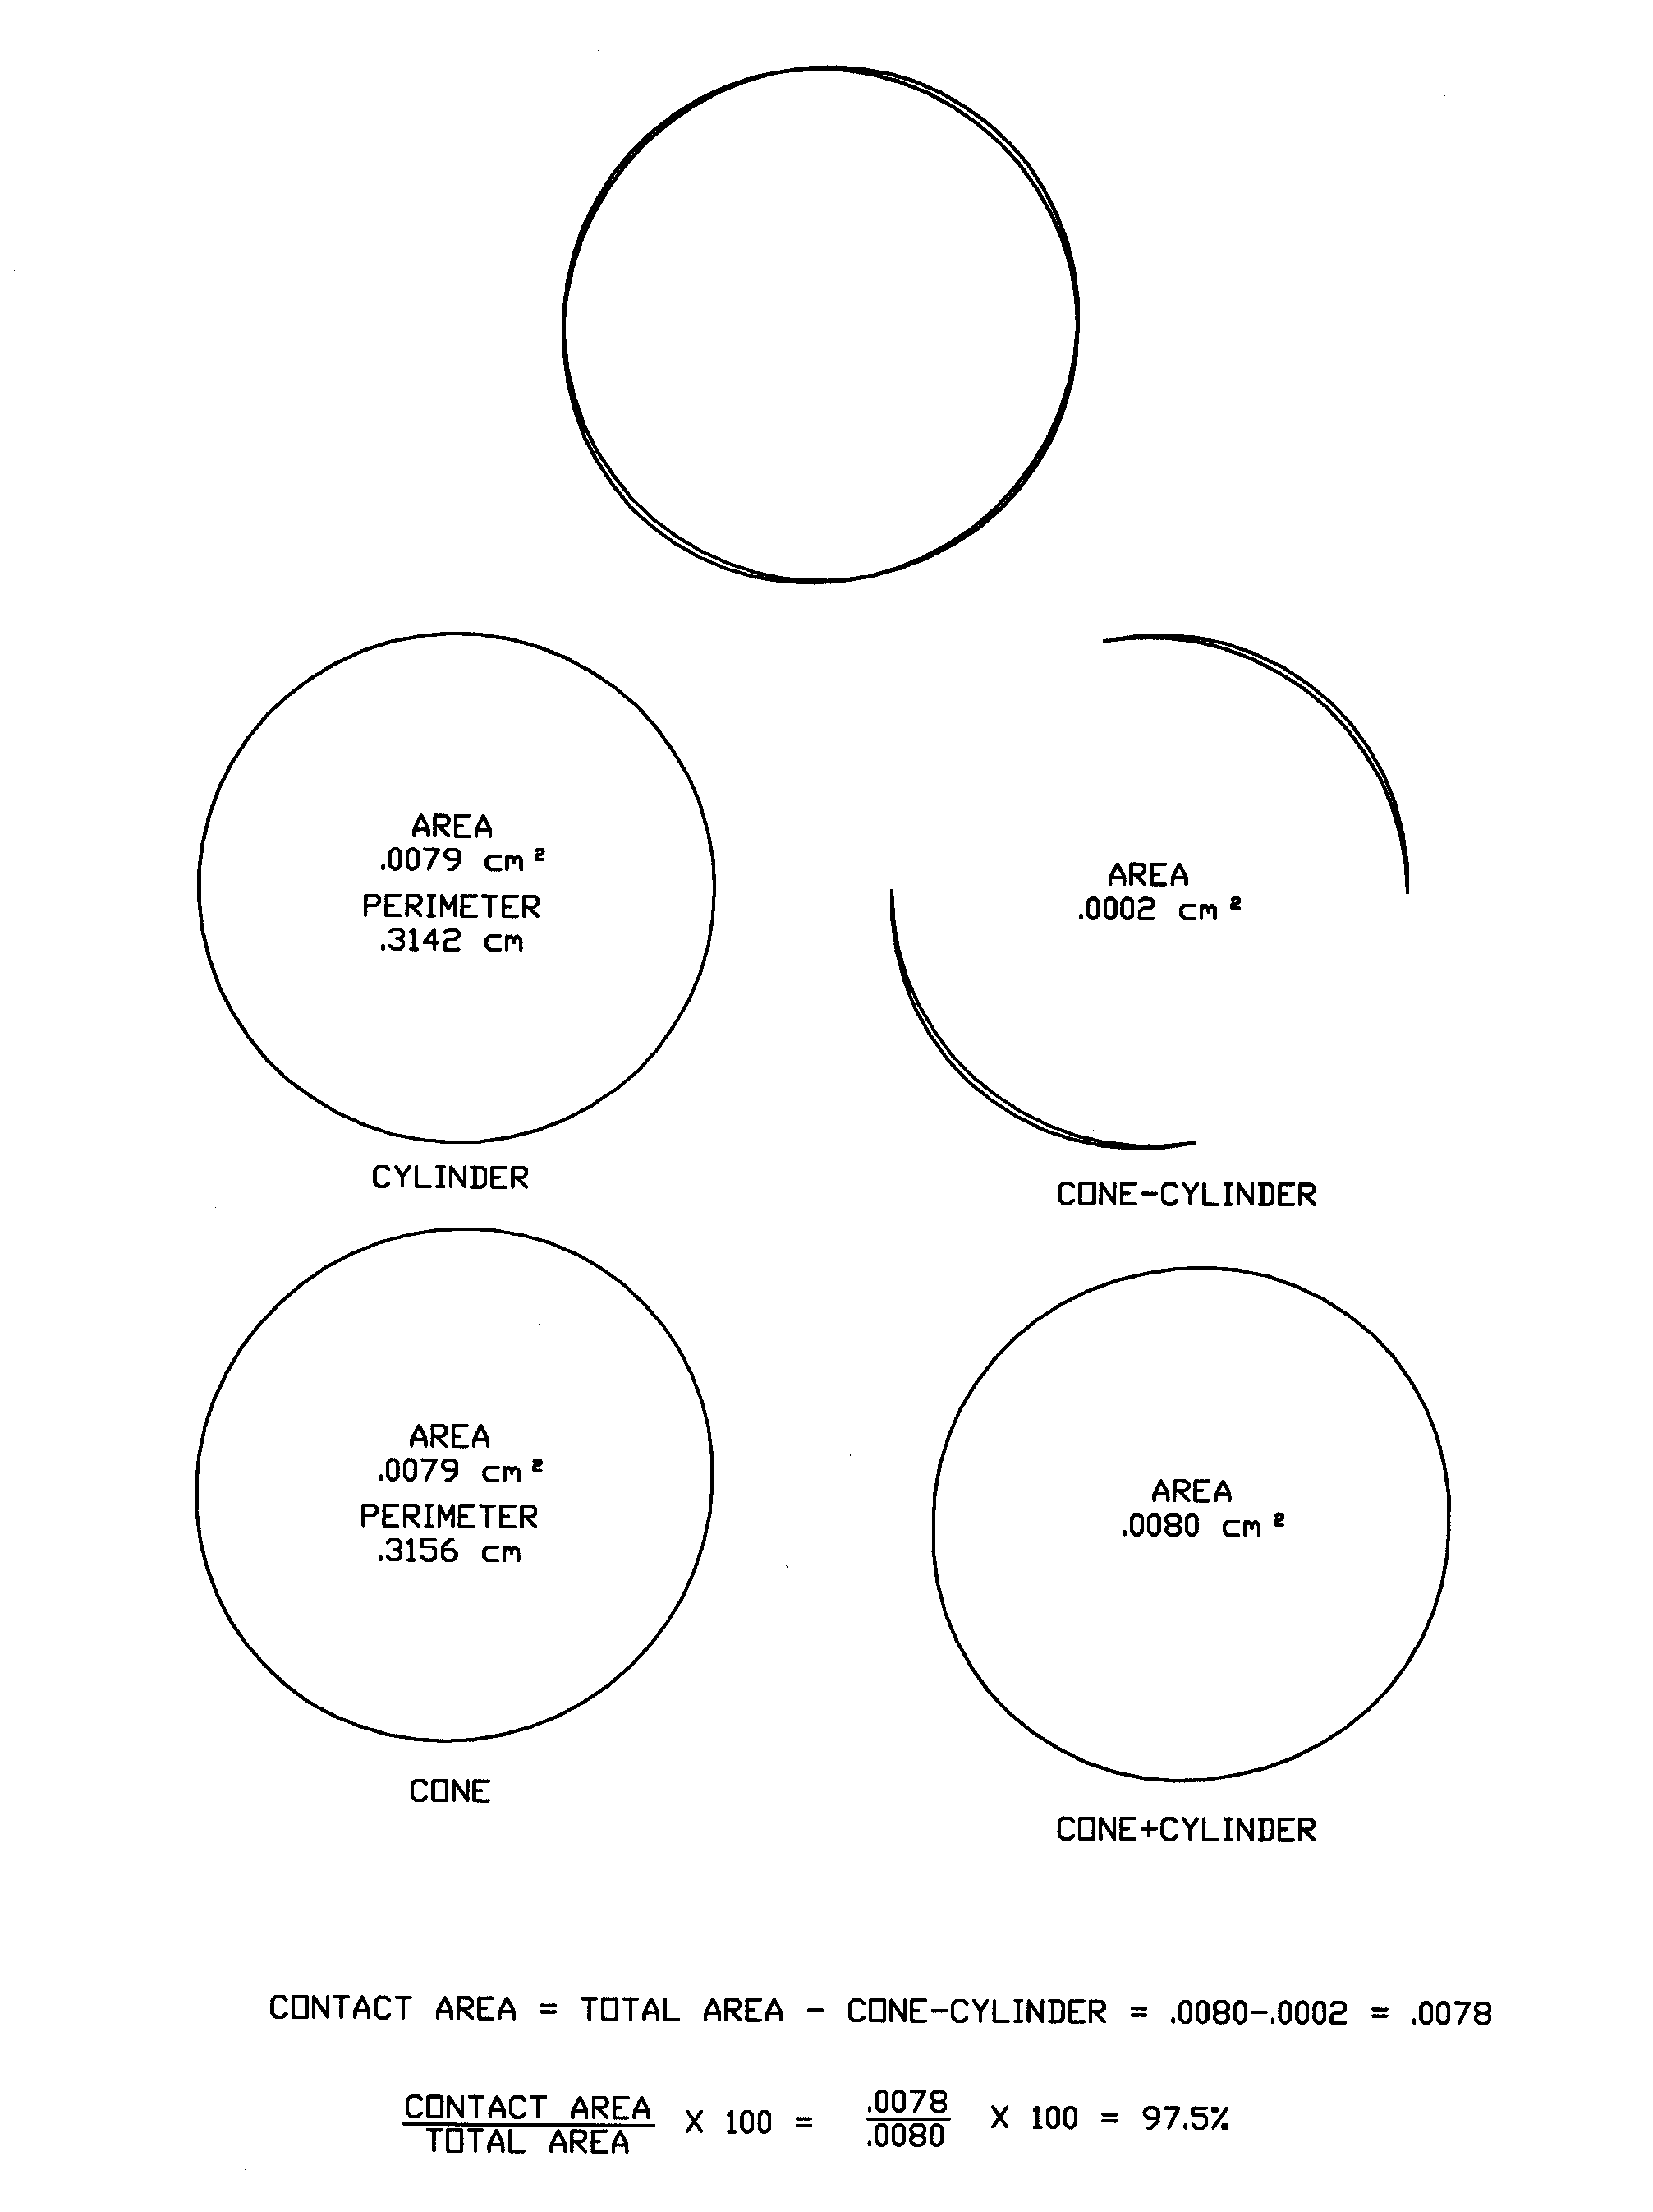

Figure 3. The calculation for the light transfer at the cone and cylinder junction.

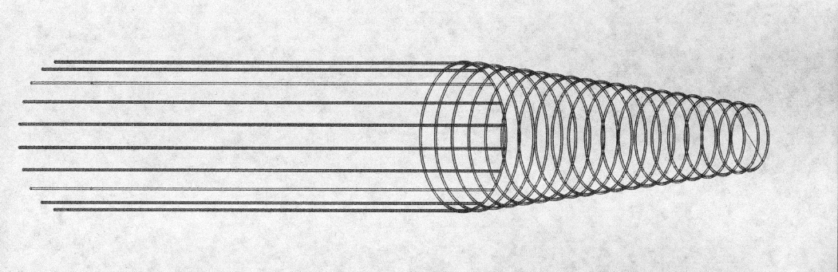

Figure 4. The original layout for fibers with axial fibers on the cylinder and circumferential fibers on the cone. There is no one to one joining of fibers.

DESIGN 2

These considerations led to the next design idea. Developments of the cylinder and cone were drawn. Next the fibers were placed in the development side by side, then rolled back up to form the cylinder and cone. This was done with three different angles for all six layers. Figure 5 is a comparison of this design to the previous design. The advantage of this design is that there is 100% coverage of fibers on the cone and cylinder. Figure 6. The problem was the angle that the fiber ran relative to the axis of the cone changed as a function of position on the circumference of the cone. Figure 7. The fibers on the left side of figure 7 are at an angle of 90 degrees and 85 degrees relative to the base of the cone. The fibers on the right are at angles of 37 degrees and 35 degrees relative to the base of the cone. This model was then created, and the mating ends of the cylinder and cone were again sliced perpendicular to the axis of the cone and cylinder. The mating pairs of ellipses created by the fiber ends were re-calculated for light loss. With this increased angle, the percentage of light transferred decreased. The fibers starting at the seam transmitted 97.5% like the first design, but the fibers between 300 to 360 degrees overlapped only 57.7% to 60.2% depending on layer angle. Figure 8. Due to the light loss, the cylinder-cone idea was replaced by one large cone. This cone would have an inside diameter of 1cm and an outside diameter of 21.67cm. The fibers at the end of the cone would be joined with the clear fibers leading to the VLPCs. To assure a connection that would allow the maximum amount of light transferred, the clear fibers would be placed on an identical truncated cone with the inner diameter being 21.67cm and the outside 5 cm larger. These clear fibers would then be bundled and connected to the VLPCs. The 21.67 cm side of the cone would be polished and joined with the polished end of the cone of scintillating fibers. The next problem was the change of angle of fibers in overlapping layers. To have a well-defined coordinate system, the angles of overlapping layers should be uniform over the entire cone. With this design, the overlapping angles changed as the position around the circumference changed.
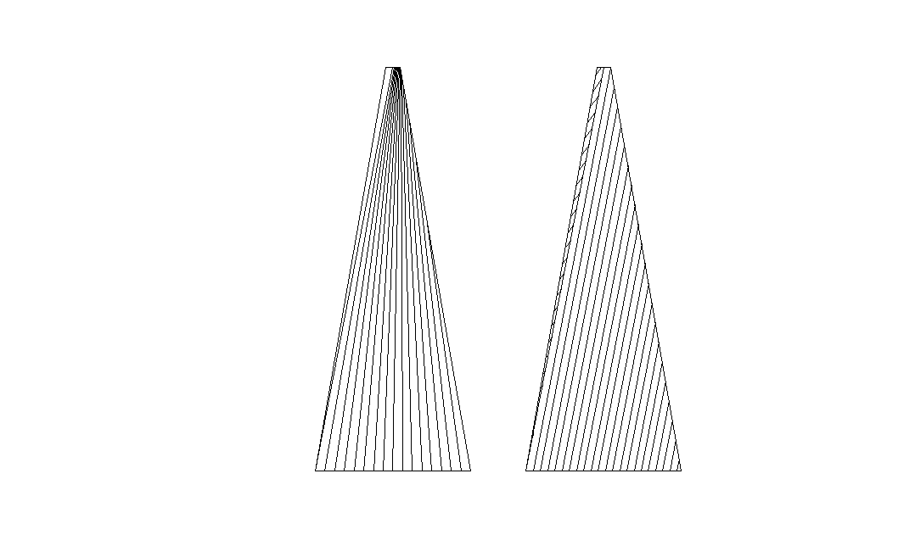
Figure 5. A comparison of detector designs, a. fibers with the same central angle relative to the axis of the cone (previous design), b. fibers laid parallel to each other (this design).
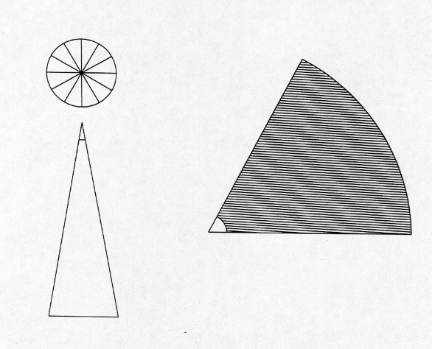
Figure 6. Design two, pattern development for fibers that are kept parallel to each other.
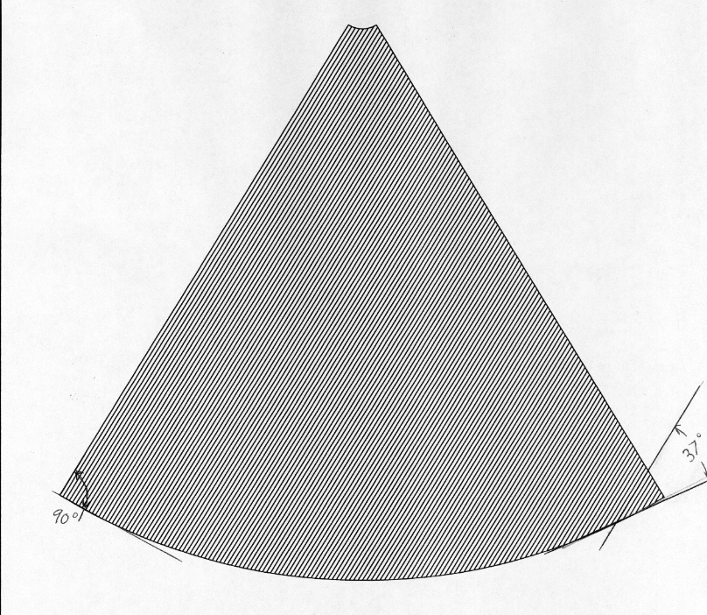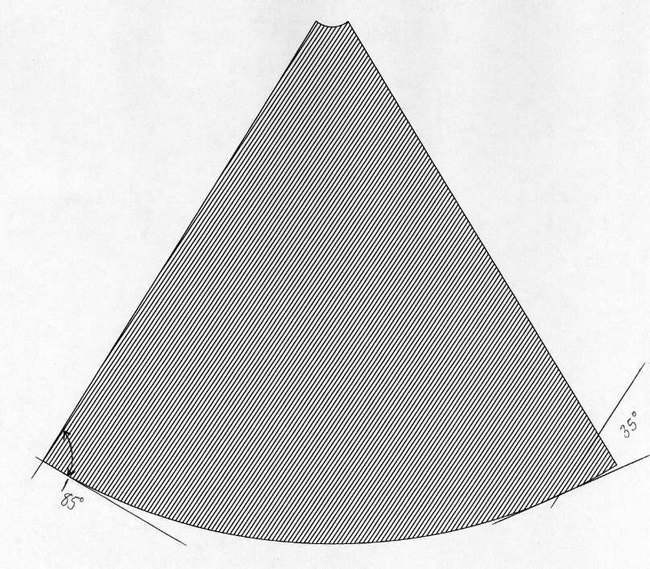
Figure 7. Development drawings showing the change of angle of the fibers.
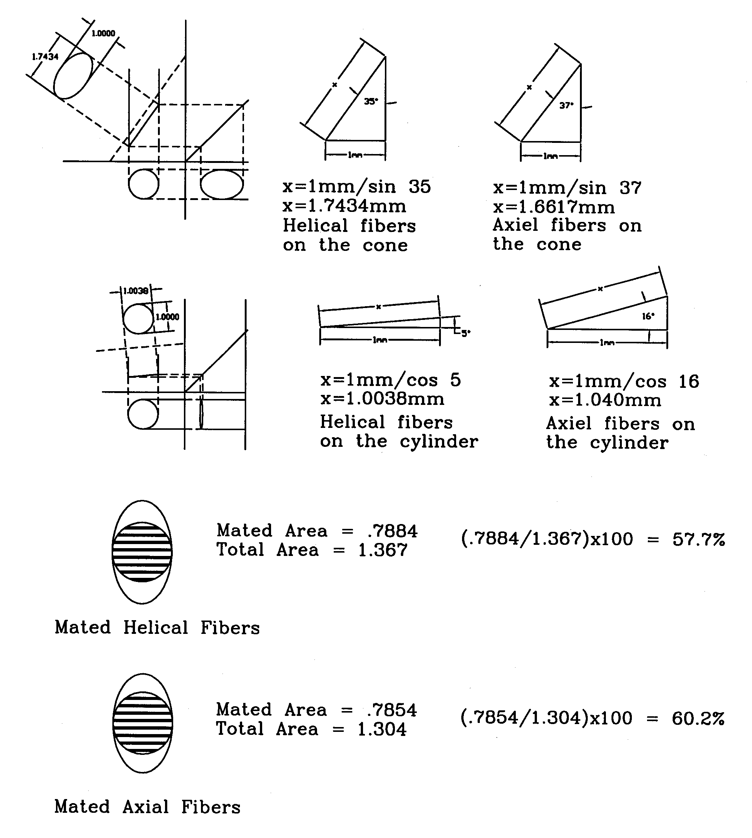
Figure 8. Light loss calculations for the second detector design option.

DESIGN 3

The last option was a re-birth of our original idea, the cylinder and cone with two axial layers of fibers and the four helical layers of fibers. Even though we would loose fibers as we traversed down the cone, creating gaps, there was a possibility that the six layers combined would cover all gaps. The first step was to determine the number of fibers placed side by side on the larger diameter, then the number of fibers placed side by side on the smaller diameter. The circumference was calculated to determine the number of 1mm fibers that would fit. In addition an AutoCAD model was created for a visual picture. This procedure was done for all six layers since the increasing diameter due to the fiber thickness would hold more fibers at each consecutive layer. The number of fibers lost was then calculated by subtracting the number of fibers from the small diameter from the number of fibers on the large diameter. Figure 9. Next, I divided the overall length of the cone into evenly spaced increments, and determined the number of fibers that would stop at each increment. I made each value divisible by four so that one quarter of the development could be designed and drawn. This would allow for ease of manufacturing. Figure 10. Finally, with this information, the developments were drawn. Each layer had quite a few gaps, however, the number of gaps was reduced in each super layer. There were no gaps with all six layers overlapped. Figure 11-13. To determine the percentage of coverage, the gap area had to be calculated. In the first layer, the gaps were triangles created by the loss of a fiber. These triangles had a 1mm base where the fiber was. The height was determined from the model, and changed towards the forward end of the cone. Using the area of the triangle, A = ½ bh, the area of gaps was calculated for a single layer, a super layer (consisting of two layers of same direction fibers), three layers (one of each direction of fiber), two super layers and finally five of the six layers. The model of all six layers showed no holes. The area for the cone development was then calculated. The ratio of gaps to total area was determined. The single layer had 88.02% coverage. The super layer had coverage of 99.20%. There was 99.89% coverage, 99.86% coverage and 99.99% coverage for the three layers, the two super layers and the five layers respectively.

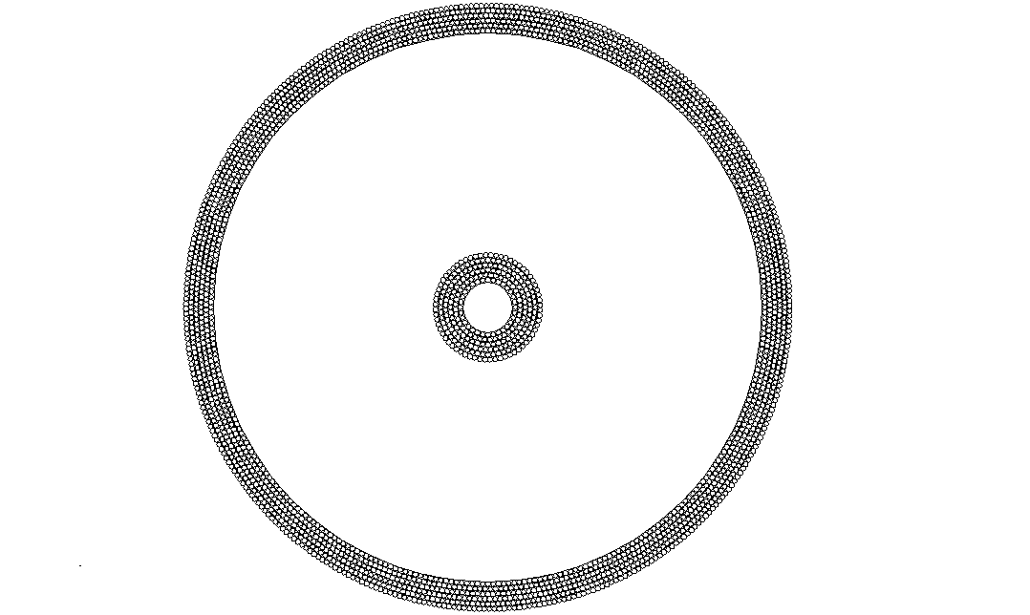

Figure 9. Cross section showing the number of fibers needed for the large and small end of the cone. The number of fibers lose is the difference between them.
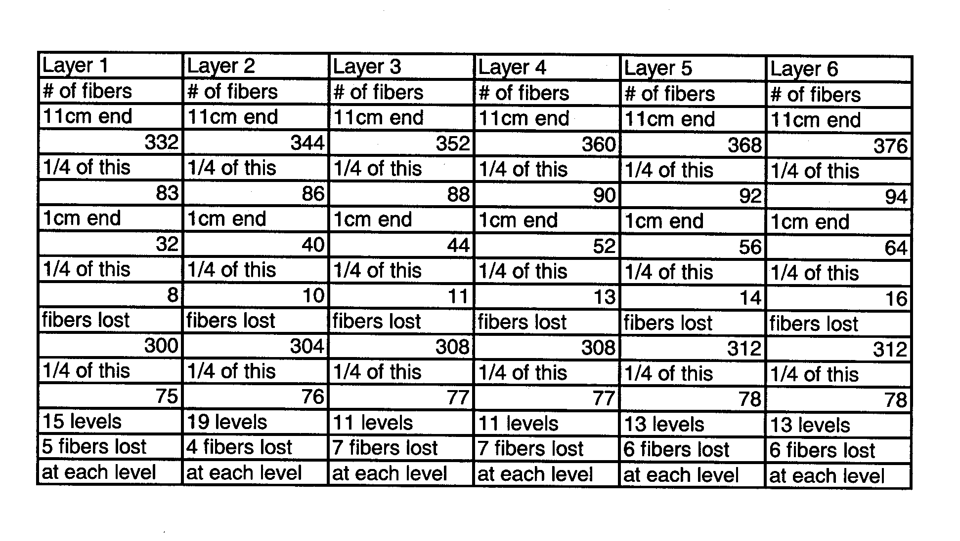
Figure 10. The calculations for fiber placement of the cone.

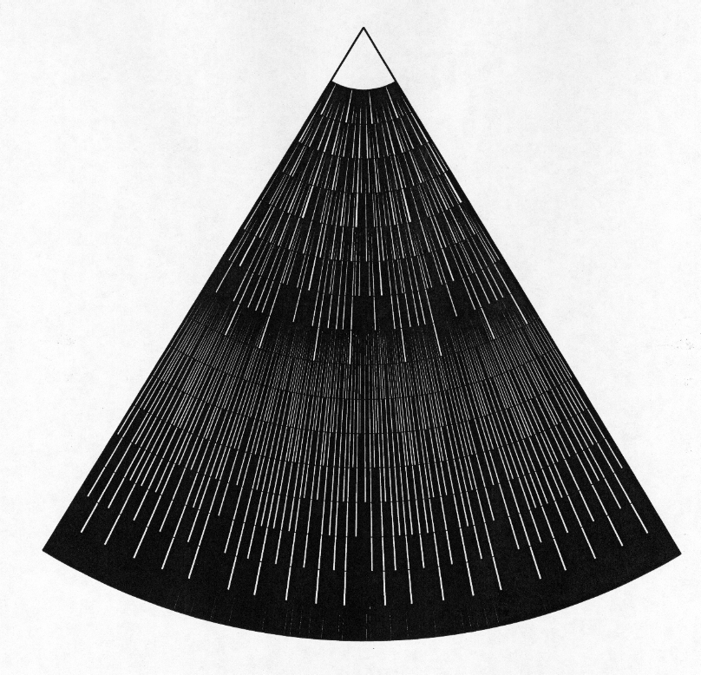
Figure 11. One layer of fibers covering 88.02% of the cone.
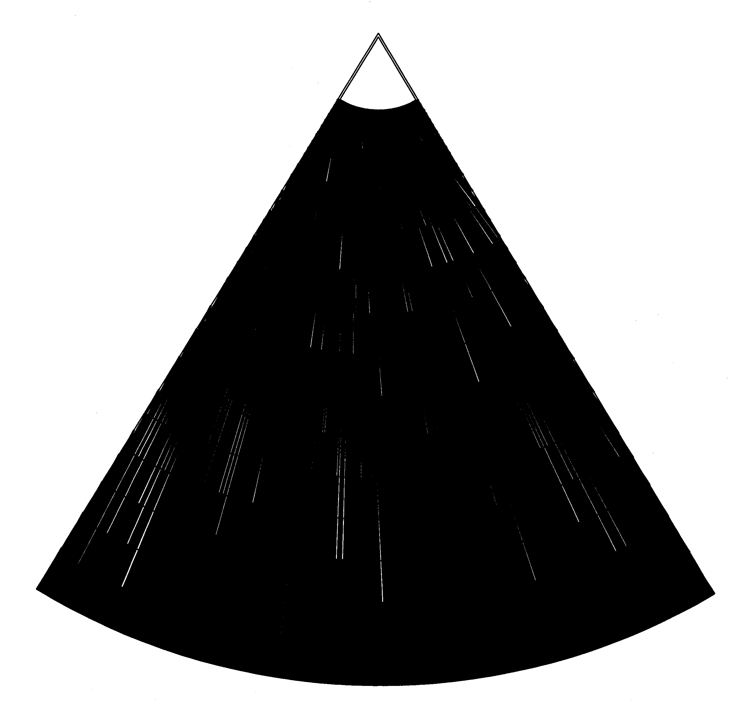
Figure 12. One super layer of fibers covering 99.20% of the cone.
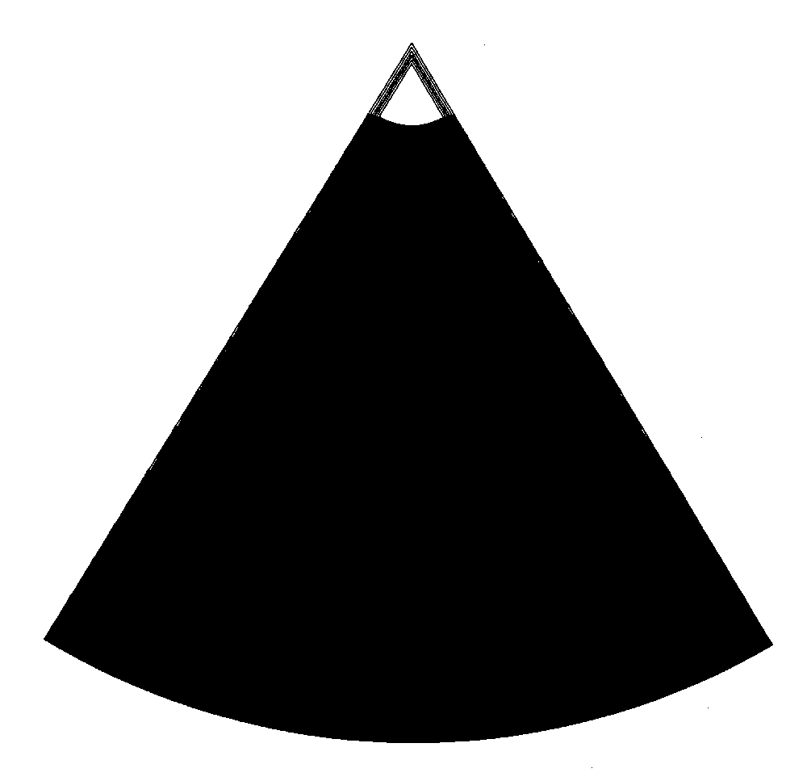

Figure 13. All six layers of fibers covering 100% of the cone.

FIBER RESOLUTION CALCULATIONS

With working developments, mathematical calculations were needed to describe the fiber resolution and percentage of coverage. I calculated the resolution for the cylinder using the smallest helical and largest helical angles. The maximum angle was determined by the fact that no fiber could wind around the detector more than once. The maximum helical rotation was π. This gave us a fiber angle of 30 degrees for a 30cm cylinder. Looking at three, and six layers of overlap, the resolution was calculated. The resolution in the x direction (axially) was limited by the fiber width or width of fiber overlap. This value for our detector was 1mm for three layers and .5mm for all six layers. The y value was calculated by trigonometric relationships. Figure 14. The y value resolution was 2mm for three layers and 1mm for all six layers. I decided to calculate resolution as a function of angle. Figure 15. As the angle decreased, the y value increased so the overall resolution decreased. Figure 16. First the geometry of the cylinder was calculated and drawn using AutoCAD. Figure 17. Then the geometry of the cone was calculated and drawn. Figure 18. The overlapping fiber angles for the small end of the cone were around 16 degrees. This produced a y value of 3.86mm for three layers and 1.93mm for all six layers. The problem was that the angle of overlapping fibers near the large end of the cone was around 2 degrees. This produced y values around 57mm for 3 layers and 28mm for all six layers.
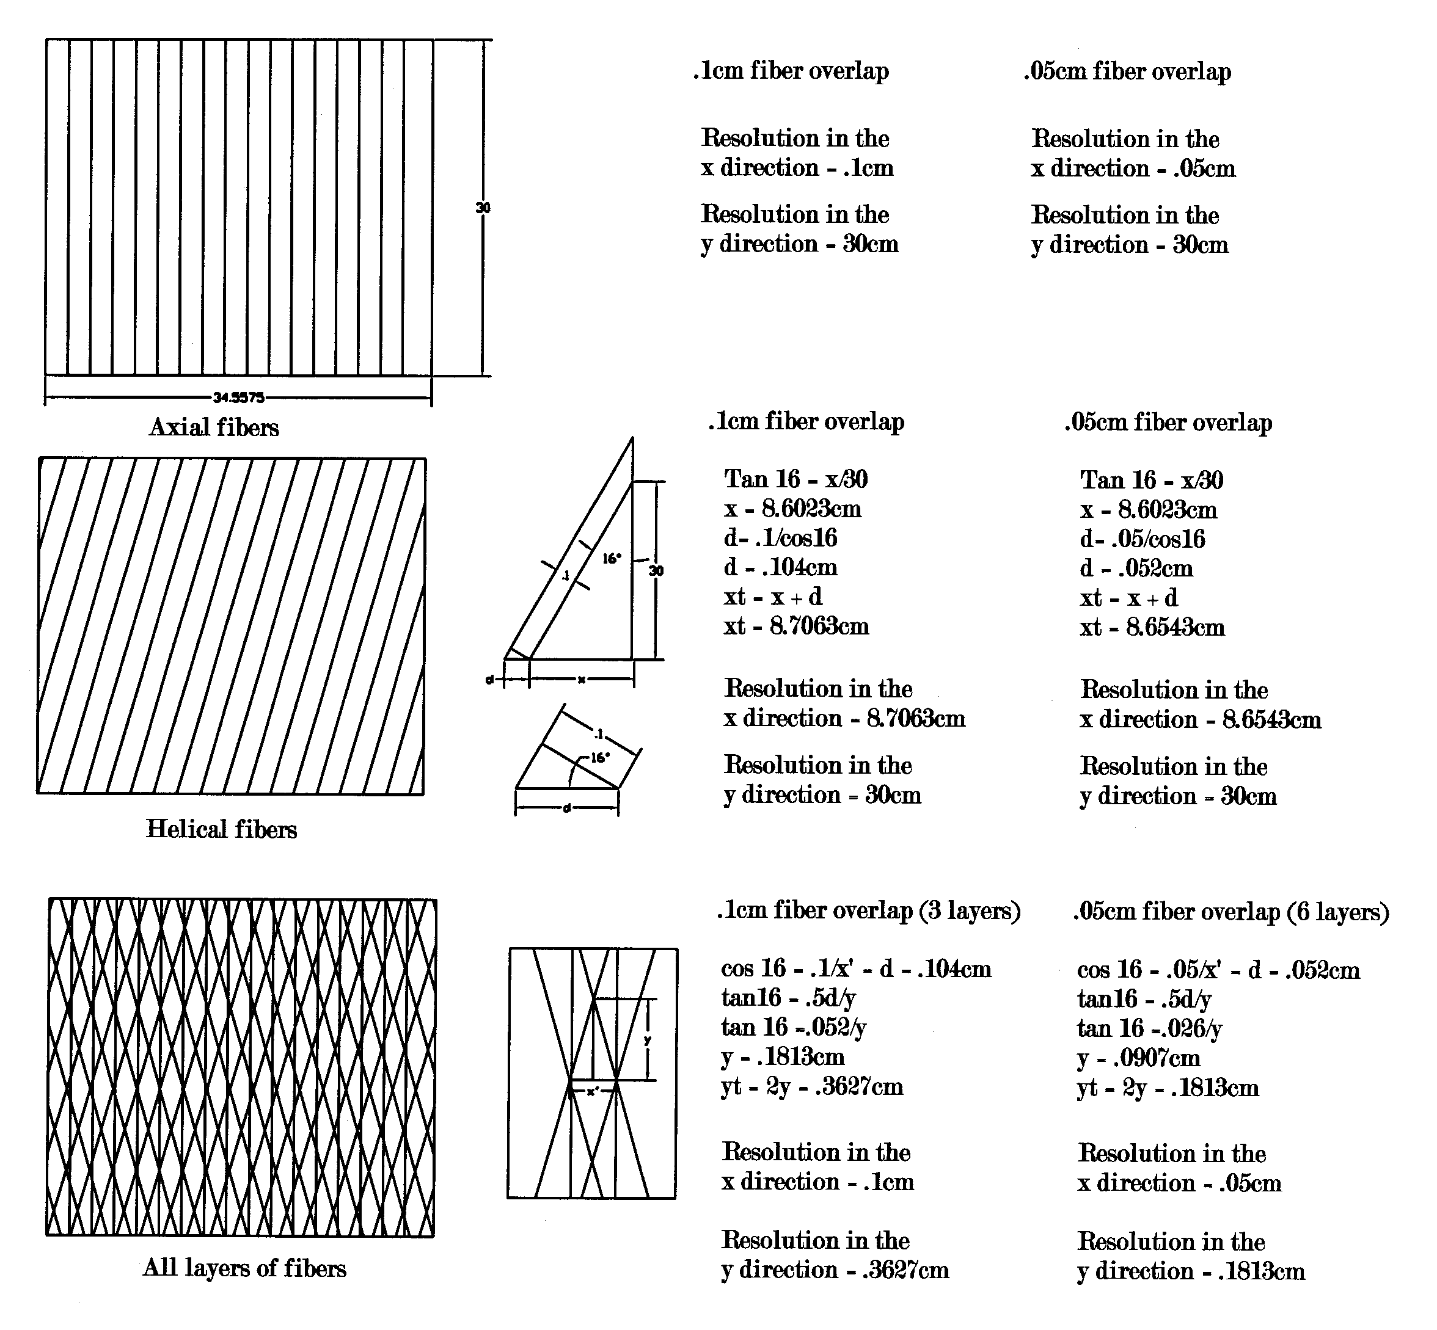

Figure 14. Calculations for fiber resolution for both one layer of fiber overlap and two layers of fiber overlap.

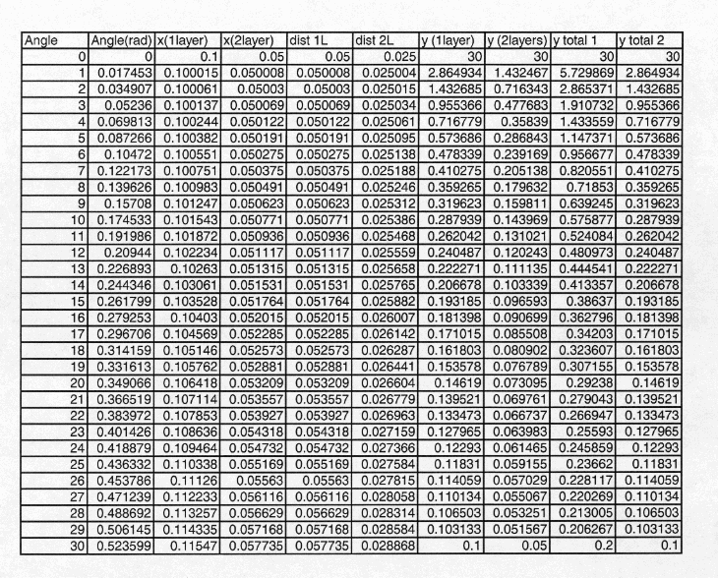

Figure 15. Data showing fiber resolution as a function of angle between fiber layers. The y total 1 column is the resolution for 1 layer of fibers. The y total 2 column is the resolution for two overlapping layers of fibers.

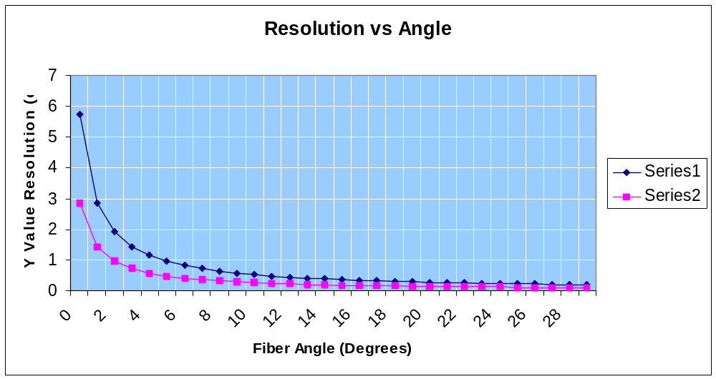
Figure 16. Graph to show fiber resolution as a function of angle between fiber layers.

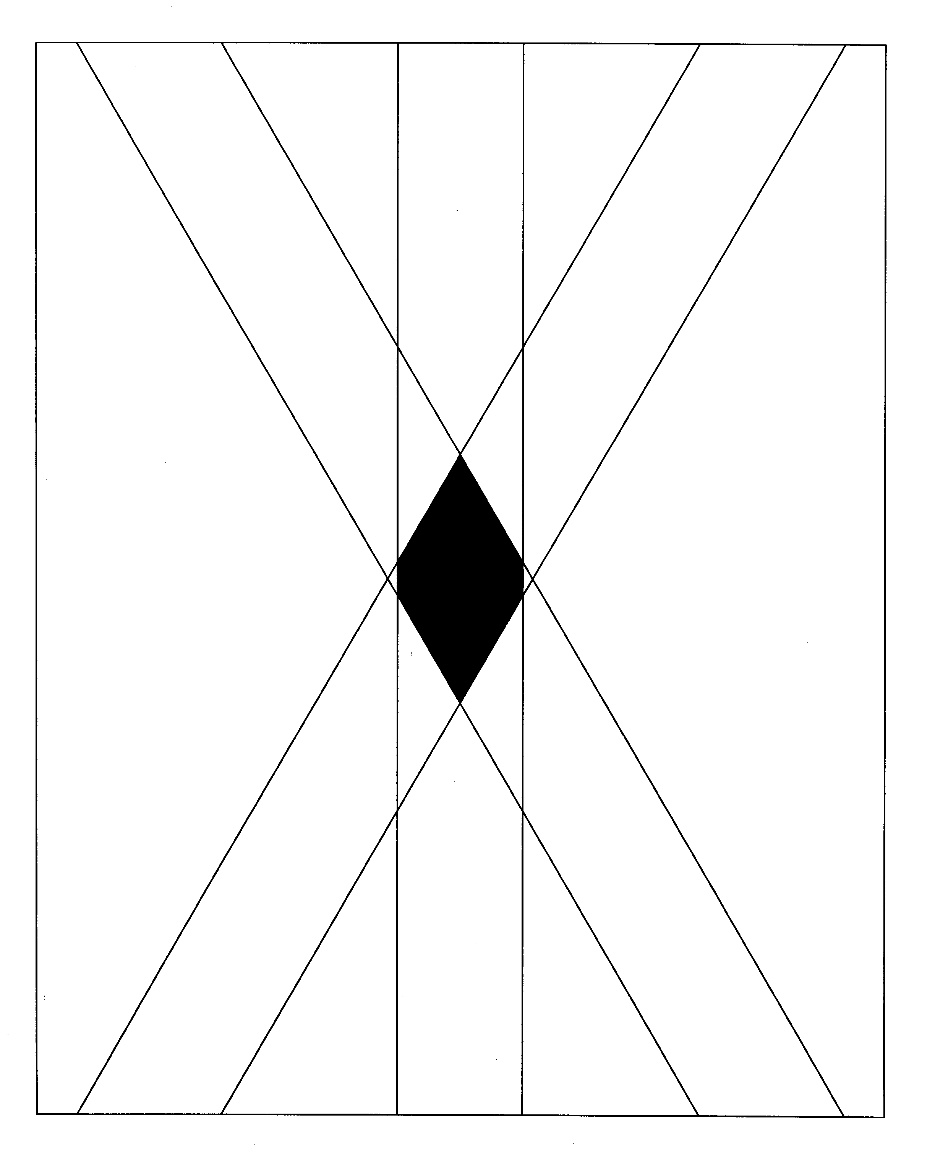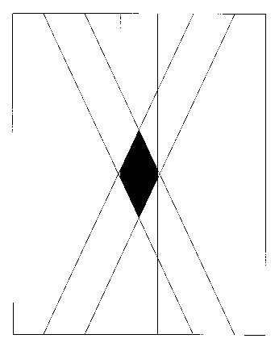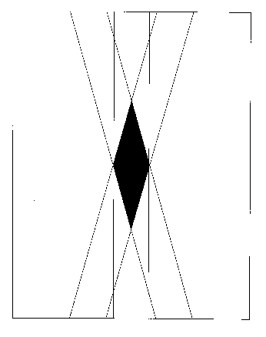
a b c
Figure 17. Graphic representation of fiber resolution in the cylinder for: a. maximum angle of 30 degrees, b. angle of 25 degrees, c. angle of 16 degrees.

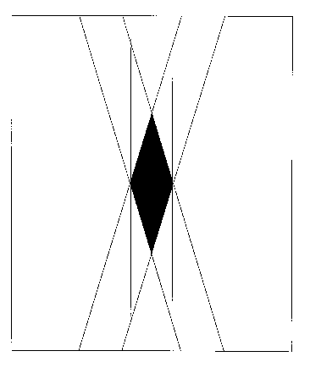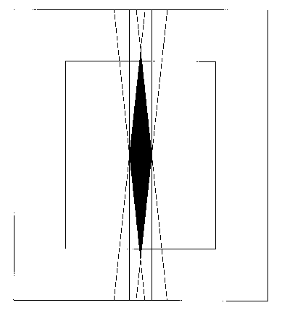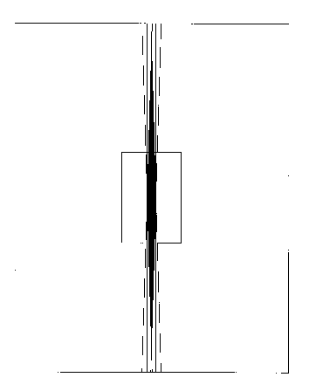

a b c
Figure 18. Graphic representation of fiber resolution in the cone for: a. the small diameter end (16 degrees), b. the middle of the cone (8 degrees), c. the large diameter end (2 degrees). The squares in the center of figures 12 b and c represent the .5 cm high rectangle enclosing figure 12a.

CONCLUSION

It is clear from these designs and calculations, that the plan for a conical section has to be abandoned. The shortcomings can be summarized as either a) not providing complete coverage, b) fibers with changing angles thus making an online reconstruction impossible and c) leading to an unacceptable resolution for certain areas.

