GlueX-doc-1532-v2

Straw Tube Acceptance Checks
Version 1-19 May 2010

- Visually inspect each tube thoroughly making sure there are no blemishes such as glue spots or dents. If there are, circle them with a permanent marker so that they can be easily spotted during future inspections, and put them in the rejection box.
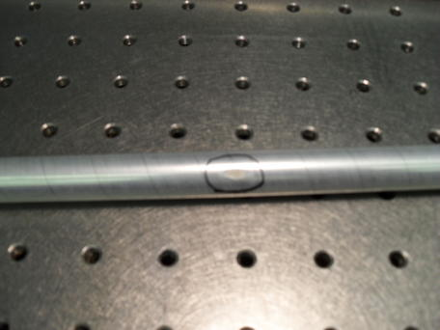
- Roll the tube across a clean, flat table to make sure it is completely cylindrical. If the tube favors one side by rolling to a certain position, reject it.
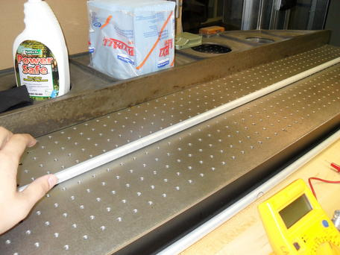
- Push the tube lightly up against the straightedge to see if the tube is bowed. Rotate it to make sure that it is not bowed in any direction. If the tube separates from the straightedge, try to fit the 0.1” dowel in between the tube and the straightedge as this is the maximum amount of bow that can be tolerated. If it fits without pushing the tube away, reject the tube.
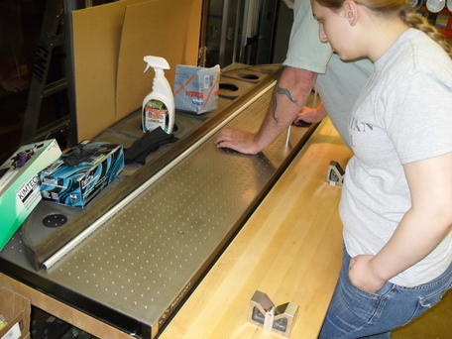
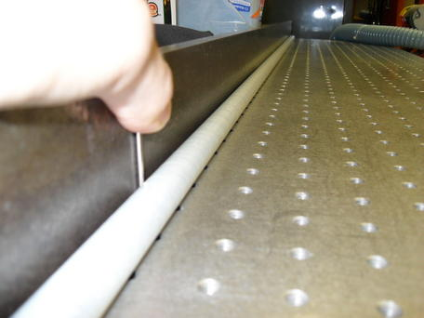

- Allow the tube to fall slowly through the 0.7” aperture in the donut onto a pad on the floor. If the cross section of the tube is oval at any point, the tube will stick in the aperture. Reject the tube if gravity (and a small amount of wiggling to make sure it is not something about the angle of the donut) is not sufficient to make the tube fall through.

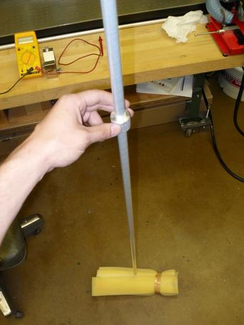
- Finally, give each tube one more visual check before putting them in the box of good straws. Stack them neatly, being careful not to crush any of the other tubes.

