GlueX-doc-1532-v7
Modified: 29-Sep-2011

Straw Tube Acceptance Checks

General Procedures: All handling of straws is carried out wearing rubber latex gloves. Do not touch the straws with bare skin.

Training Procedure: New personnel will be given this document to read. A trained person will then demonstrate how to check a straw. The trainee will then be shown samples of various rejected straws and given an explanation of why they failed. Finally, the trainee will inspect several straws under supervision. All work occurs in the preparation room that has limited capacity. No written documentation of training is maintained.

Caution: Do not handle the straw unless wearing latex gloves.

Safety Issues: No more than three people should be in the room when this procedure is being carried out to avoid poking people with the straws.

Q&A Tests: This procedure is the Q&A test to accept straws. Resulting straws are accepted or rejected.

Data Recorded: A record of accepted and rejected straws is maintained.

Straws are removed from the Lamina storage matrix, checked, and then reinserted into the matrix. Logs are kept per package on the number and types of rejections of the straw tubes.

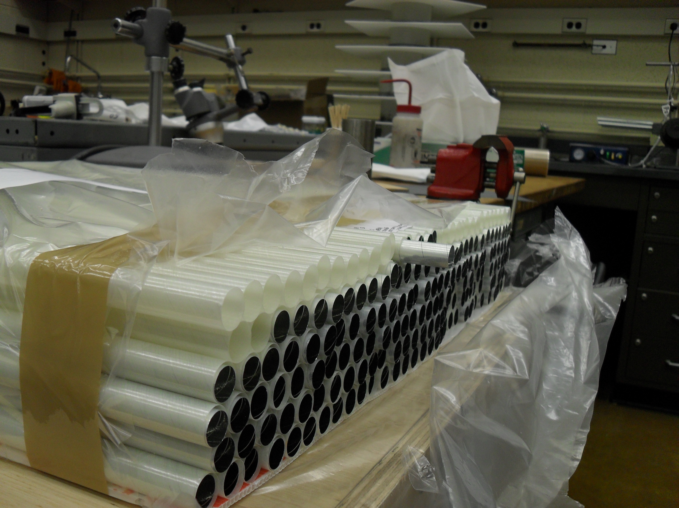

- Measure the resistance along the length of the straw using a multimeter and clip probes, one clipped onto either end of the straw. If the resistance exceeds 140 Ohms, reject it. If between 120 and 140 Ohms, put the straw into the reserve storage matrix. Otherwise, continue.

- Visually inspect each tube thoroughly making sure there are no blemishes such as glue spots or dents. If there are, circle them with a permanent marker so that they can be easily spotted during future inspections, and put the tube in the rejection box.
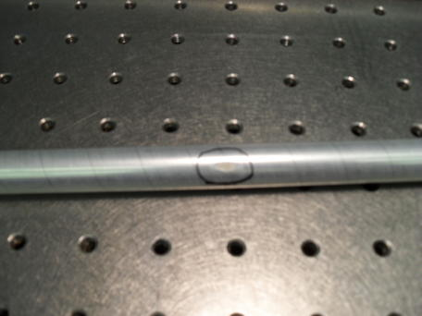
- Roll the tube across a clean, flat table to make sure it is completely cylindrical. If the tube favors one side by rolling to a certain position, reject it.

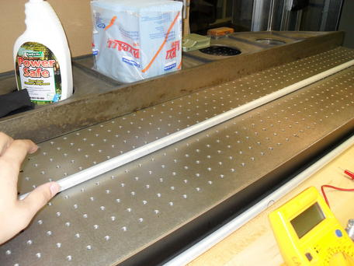

- Push the tube lightly up against the straightedge to see if the tube is bowed. Rotate it to make sure that it is not bowed in any direction. If the tube separates from the straightedge, try to fit the 0.1” dowel in between the tube and the straightedge as this is the maximum amount of bow that can be tolerated. If it fits without pushing the tube away, reject the tube.
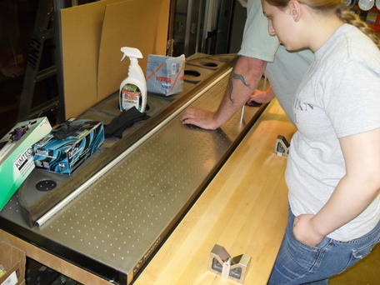
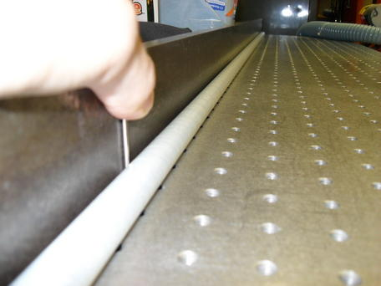

- Allow the tube to fall slowly through the 0.625” aperture in the donut onto a pad on the floor. If the cross section of the tube is oval at any point, the tube will stick in the aperture. Reject the tube if gravity (and a small amount of wiggling to make sure it is not something about the angle of the donut) is not sufficient to make the tube fall through.

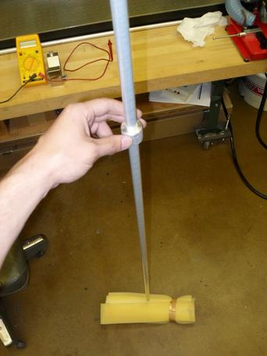
- Finally, give each tube one more visual check before putting it into the ‘good’ tube matrix.

