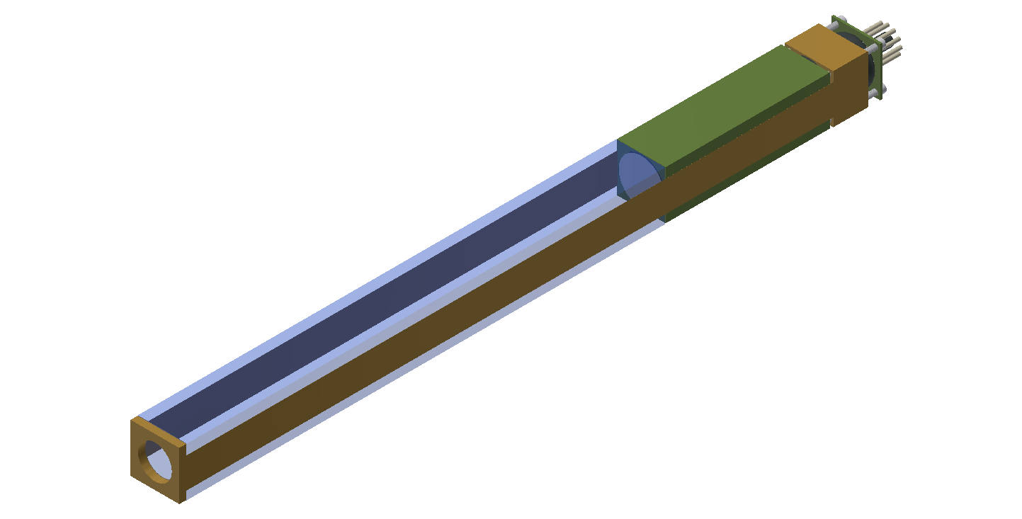
Figure 6. 3D model depicting CompCal module design.
2.2 Module Components
The CompCal modules consisted of a single PbWO₄ crystal connected to one HA4125 PMT and optically coupled together with the base attached to the PMT to provide high voltage supply and signal output. The remaining components were used to attach these three main pieces together and ensure structural integrity. This module binding was accomplished with brass fittings at the front and end of the module that would cause tension between the crystal at one end and the housing for the PMT at the other by means of two brass straps that went along the sides of the module itself. The straps were then brazed to the sides of the fittings to create a strong connection.
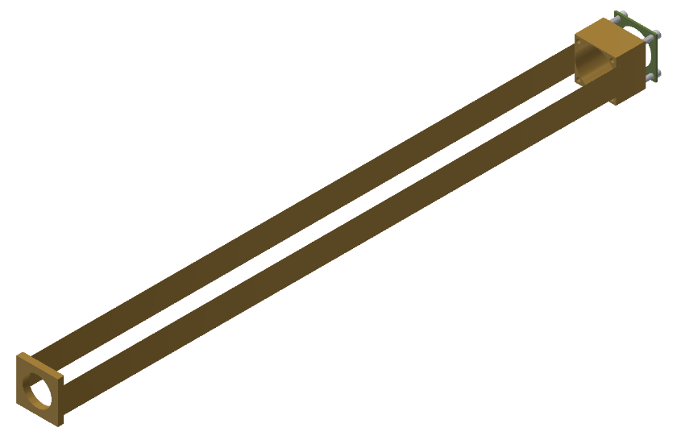
Figure 7. Brass strap and retaining plate.
2.2.1 Rear Module Assembly
The initial prototype modules included the front and rear retaining fittings, the PMT housings which were made from G10 fiberglass laminate, and the rear PMT pressure plate which was also made from G10. Four set screws were applied to the rear fitting to generate the tension in the straps and a retaining plate was attached to the back of the PMT with four small screws to keep it in contact with the back face of the crystal. These set screws and retaining screws utilized the same tapped holes in the rear fitting so as to minimize the number of machining steps and to negate the necessity of a second component to connect the retaining pressure of the PMT and the tension holding the module together.
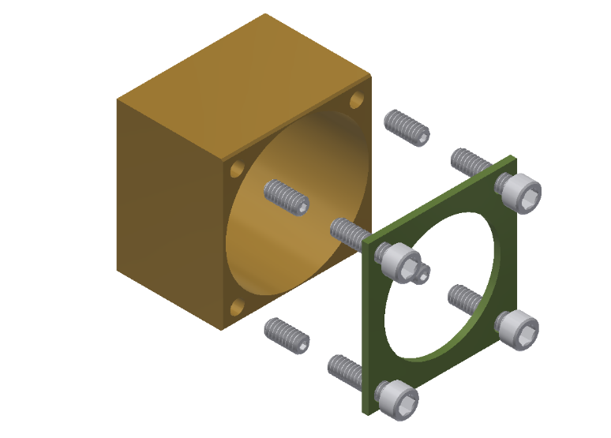
Figure 8. Model showing the retaining plate and tension set screws.
2.3 Module Wrapping
One crucial issue that was apparent from before the assembly process began was that it would be necessary to optically isolate each module from its neighbors. It was imperative to ensure that all light generated by events in the modules would be contained as close to one hundred percent as possible. This was significant for the success of the detector in order to eliminate any cross talk between modules as a result of light leakage. The material selected was a new polymer Enhanced Specular Reflector film (ESR) manufactured by 3M™ and was able to achieve 98.5% reflectivity across the visible spectrum. This design called for the material to be form fitting to the outside edges of the scintillator crystals in order to minimize the air gap between the reflector and the crystal walls. This required the material to be pre-shaped prior to the final assembly. In order to ensure that there was no light leakage during the production runs further measures were taken in the form of a layer of black Tedlar sheeting which was wrapped around the crystal on the outside of the ESR layer.
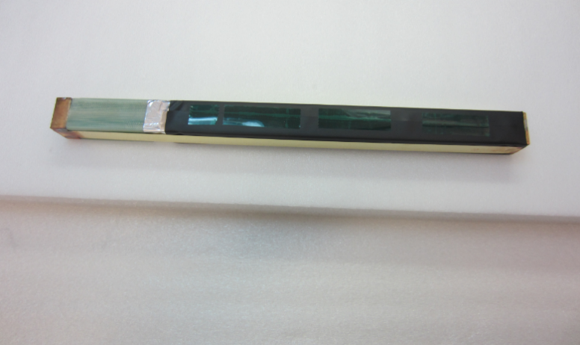
Figure 10. Prepared module before PMT instalation.
2.5 Module Stacking and Absorber Installation
The next phase of the detector assembly began with the assembly of the external frame of
the detector, this consisted of the main base plate which consisted of a one inch aluminum plate with a cage frame that the side panels would be placed onto after the internal components were installed. The side copper cooling plates and the base plate were installed next and the modules were stacked on the base plate which had spring loaded tensioners on the corner joints to squeeze the modules together between the sides and ensure good thermal contact between the all cooling surfaces and the internal modules. These plates were tied into the cooling loop being fed from an external chiller which was necessary to keep the detector modules at a constant temperature. The same cooling loop was also tied in parallel into the twin cooling fans which operated in connection with a radiator to blow chilled, dry nitrogen over the bases of the modules. The modules were stacked into the frame plates in a 12 X 12 grid pattern with a 2 X 2 hole left empty in the center of the detector to allow the beam to pass through without impinging on any material during the experimental run. The hole was supported by a two piece aluminum pipe that also provided a mounting point for the tungsten absorber on the front face of the detector that shielded the inner ring of the detector from high energy impacts.
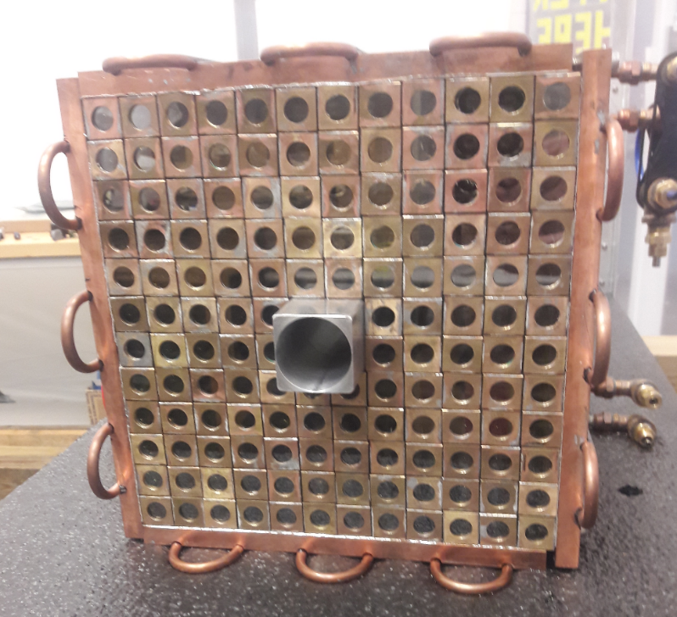
Figure 11. Front end of CompCal detector showing the beam hole support pipe.
This absorber had a two piece shutter design which allowed it to be opened and closed for calibration of the individual modules that it shielded. The calibration beam could be sent through twelve small holes that opened when the front face of the absorber was slid to one side. It was opened by pulling on two thin ribbons that were fed through the side panels of the detector once they were attached, and a pin was installed in the top of the absorber to ensure that it would not over travel and obstruct the holes after it had been opened.
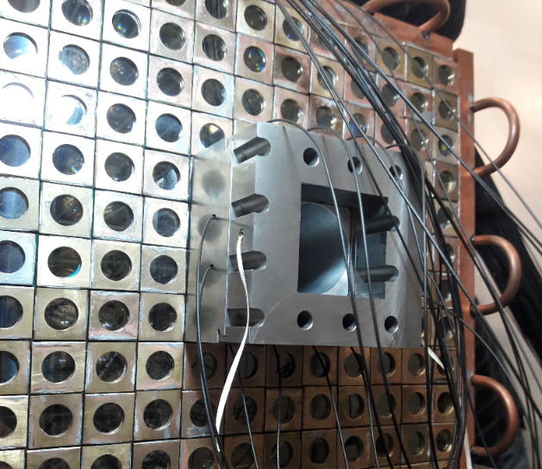
Figure 12. Front end of CompCal detector showing the two piece absorber installed.
Following the installation of the absorber, the bases were attached to the modules and the cables were routed through supporting frames to the back panel of the detector where the feedthroughs for the signal and high voltage were located.
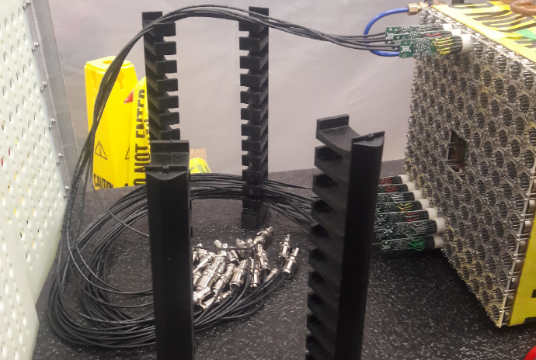
Figure 13. Rear end of CompCal showing base instalation and rear doors.
2.6 Light Monitoring System
The only internal component that still needed to be installed at this point was the light monitoring system (LMS). The LMS consisted of optics including an aspherical lens to correct the conical dispersion of the LED and a diffusion grating to homogenize the light (DG10-600 - Ø1"). These components along with the LED were housed in a one inch optical tube and then connected to a bundle of fiber optic cables. The fiber
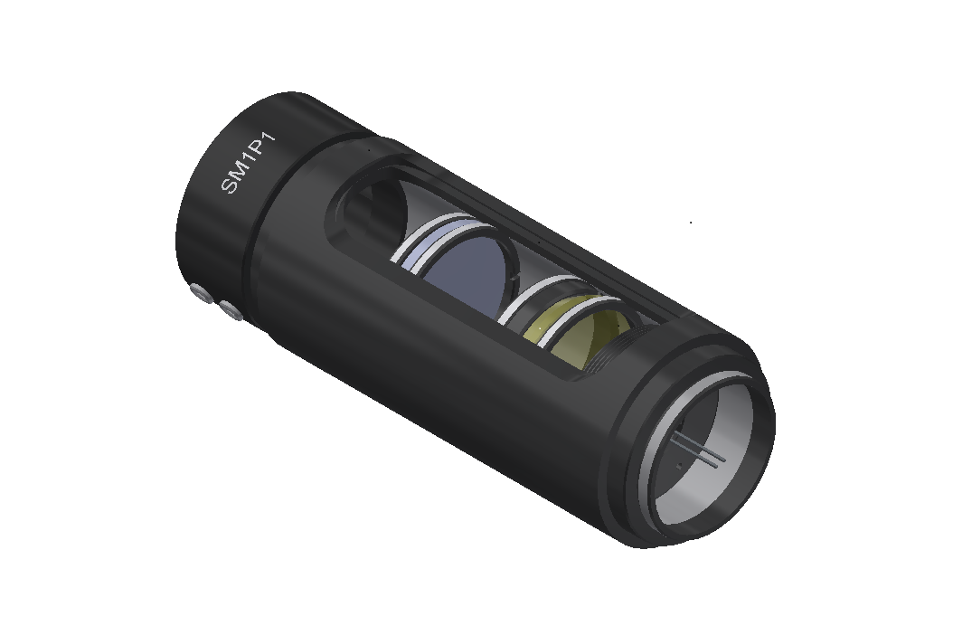
Figure 14. LMS optical assembly with aspherical lens and diffusor installed in front of LED.
bundle was hand built using one hundred and sixty one meter long fiber segments. The fiber was a 250 µm plastic core design manufactured by Edmund Optics with stock #57-096. Each was cut with a hot razor knife and had their cladding removed from the ending two inches. They were then bundled together by hand, cemented, and polished on the bundle side end The other end of the fibers were attached to the individual modules of the detector using a small acrylic cap with a hole drilled through each to hold the fiber inside. Each cap also had a small shroud of heat shrink material placed on each and tape patch was used to cover the front opening of the module to produce a light tight seal. Two reference PMTs were placed on a sheet of Delrin which was placed on the side of the detector away from the beamline when the detector was put into its retracted home position. Each PMT had a single fiber from the LED attached to their front face as well as one of the YAP:Ce scintillator sources. Both of the sources were cemented into place and their PMTs were wrapped in Tedlar to isolate them from any light leakage from outside. The electronics for the LED were also placed on the same sheet along with the optics.
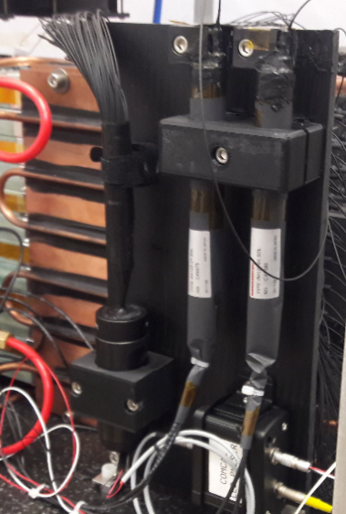
Figure 15. Light monitoring system with fiber bundle installed and front end of detector with fiber terminations made and light sealed.

