**Specifications of Lead Tungstate Crystals for FCAL-II**

**(April 30, 2019)**

The specifications of the PWO crystals for FCAL-II includes four areas. The definitions of these requirements and the testing procedures are described below.

* Visual properties.
* Geometry.
* Optical properties.
* Radiation hardness.

**1. Visual Properties**

Some parameters of the crystal quality such as possible discoloration, cracks of any sort can easily be seen by eyes. The visual inspection includes two steps: (1) firstly check each crystal under the regular light; (2) then inspect the crystal again with a green laser light in a dark room. The crystals that fail any of one of these two steps are not acceptable and should be rejected before further tests. A checklist for the visual properties includes following:

* The manufacturer label number is written on the front face of the crystal with a marker that can be easily removed with 50 % alcohol solution. All surfaces of the crystal should be free of chemical films, polishing residues, stickers/labels, or markers of any type (see Appendix I).
* The size of any visible defects such as chips, scratches, or surface flaws should not be larger than 5 mm and the total numbers of defects should be less than 30 per crystal.
* Transparent and colorless. The crystal should be visually clean without any discoloration signs, yellow, brown, or pink tints (see Appendix II).
* No cloudy regions inside the crystal volume (see Appendix III). Crystals should be checked with the green laser beam.
* Chamfers on front and rear faces of the crystal should be uniform. The size of the chamfers should not exceed 0.7 mm.
* All faces polished.

**2. Geometry**

Each crystal module will have simple rectangular shape with the size of 20.5 x 20.5 x 200.0 mm3 (see Fig. 1)



The dimensions of each crystal are shown in Fig 1 and are specified in the following Table:

|  |  |  |
| --- | --- | --- |
|  | Length (mm) | Tolerance (mm) |
| a | 20.5 | |a - 20.5| ≤ 0.05 |
| L | 200.0 | |L - 200.0| ≤ 0.1 |

**Tolerances for dimensions:**

* All transversal dimensions should be within +0.05 mm, -0.05 mm except for the length of the crystal;
* The longitudinal dimensions should be within +0.1 mm, -0.1 mm

**Planarity:**

* Planarity for all faces should be kept within 0.020 mm for all faces.

**Angular tolerances:**

* All angular tolerances should be kept within 0.050 mm across a length of 25 mm, except for the back face, which is specified below.

**Perpendicularity:**

* On the back face (opposite to the front face where the manufacturer number is labeled), we will attach a PMT with the length of 80 mm. Therefore we have a special requirement for this face. The Perpendicularity for this face should be kept within 0.20 mm across the length of the crystal 200 mm.

**Chamfers:**

* Chamfers should be made on all 12 edges, with the cut to the limit of 0.3-0.7mm x 45°. The surface finish of chamfers can be left at a roughness of 0.5 μm (lapping)

**Surface Finish:**

* Surface finish for all faces should be "Polished Finish" with the Roughness less than 0.020 μm. It should be done on a polishing machine equipped with a special polishing cloth and using diamond abrasive of grain 3 μm in emulsion. From the surface finish provided by the previous operation (lapping), about 10 minutes are necessary to reach the required surface finish.

**3. Optical Properties**

**Longitudinal transmission** (absolute values):

≥25% at 360 nm;

≥55 % at 420 nm;

≥65% at 620 nm

**Transversal transmission**:

* The non-uniformity of the transversal transmission 𝛅𝜆 at the transmission value of 50% should be 𝛅𝜆≤5 nm for 5 measurements every 3 cm, starting at 1.5 cm from the front face.

**Scintillation Light yield:**

* Light Yield ≥12 photoelectrons/MeV, measured at T=18° C and in a 100 ns gate, with 60Co source at 3 cm from PWO front face, with a Phillips XP2262B photomultiplier covering the rear face, with a n=1.5 silicon coupling grease, wrapped on 4 sides and face in 1 layer of Tyvek.

**Decay time:**

* LY(100 ns)/LY(1000 ns)>90% at T = 18o C.
* Afterglow ≤0.5% of peak amplitude with a 60Co counting rate of a MHz.

**4. Radiation Hardness**

* Induced absorption for full crystal saturation: μ≤1.5 m-1 at 420 nm for lateral 60Co irradiation, >3 krad, rate of 5-15 krad/h at 18 oC.
* No recovery time constant shorter than 1 hour.
* Radiation hardness tests will be performed at Jefferson Lab.

# Appendix I

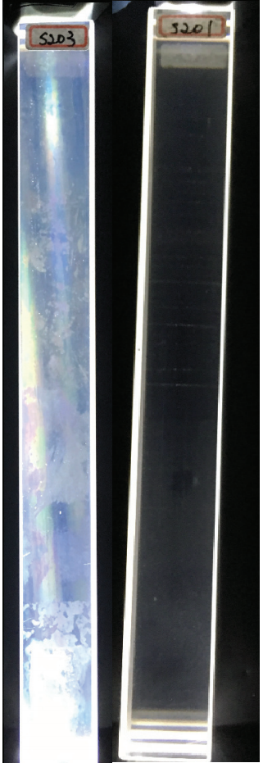

A crystal with chemical film on surface is shown on the left (not acceptable)

Clear crystal is shown on the right (acceptable)

# Appendix II

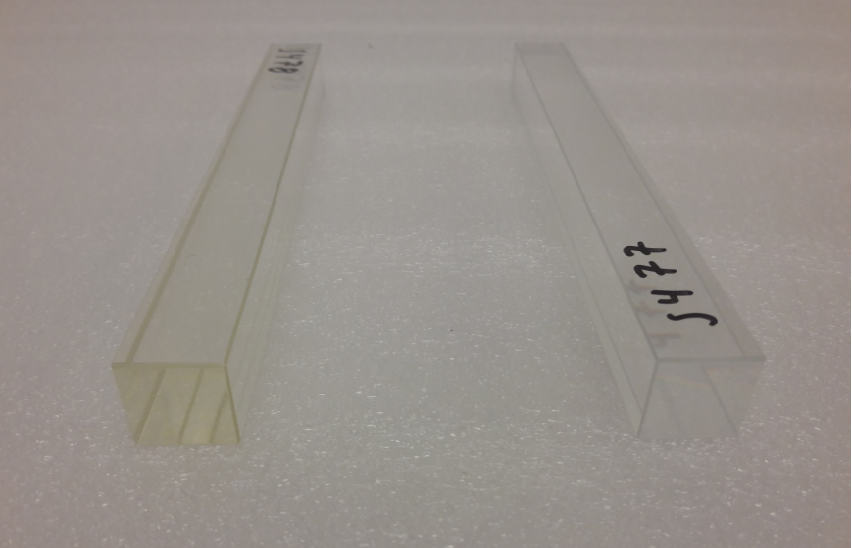

Crystal with yellow discoloration is shown on the left (not acceptable)

Clear crystal is shown on the right (acceptable)

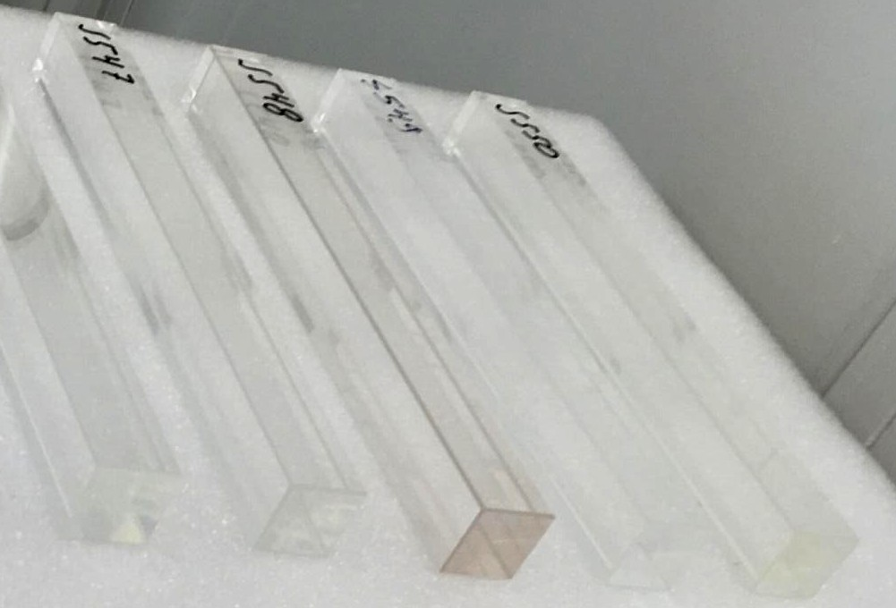

Crystal with brown discoloration is shown in the middle (not acceptable)

# Appendix III

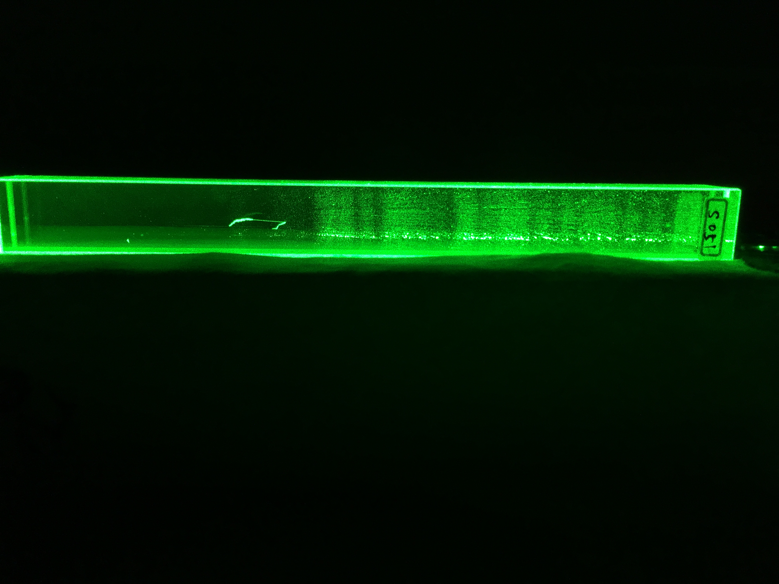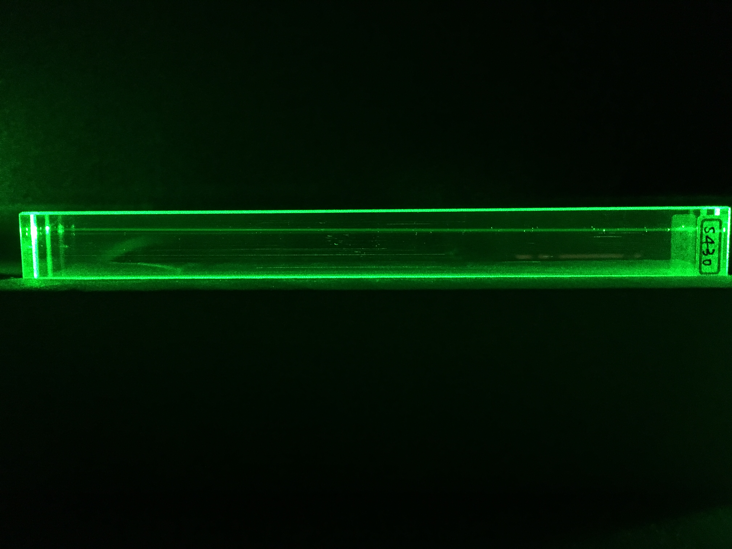

The crystal with a cloudy region inside the body of crystal is shown in the top photo (not acceptable)

A clear crystal is shown on the bottom photo (acceptable)