- Wear Nitrile gloves during crystal wrapping
Crystal Wrapping Procedure
- Components needed for wrapping a c rystal, crystal, pre-shaped ESR reflective foil, and Tedlar.
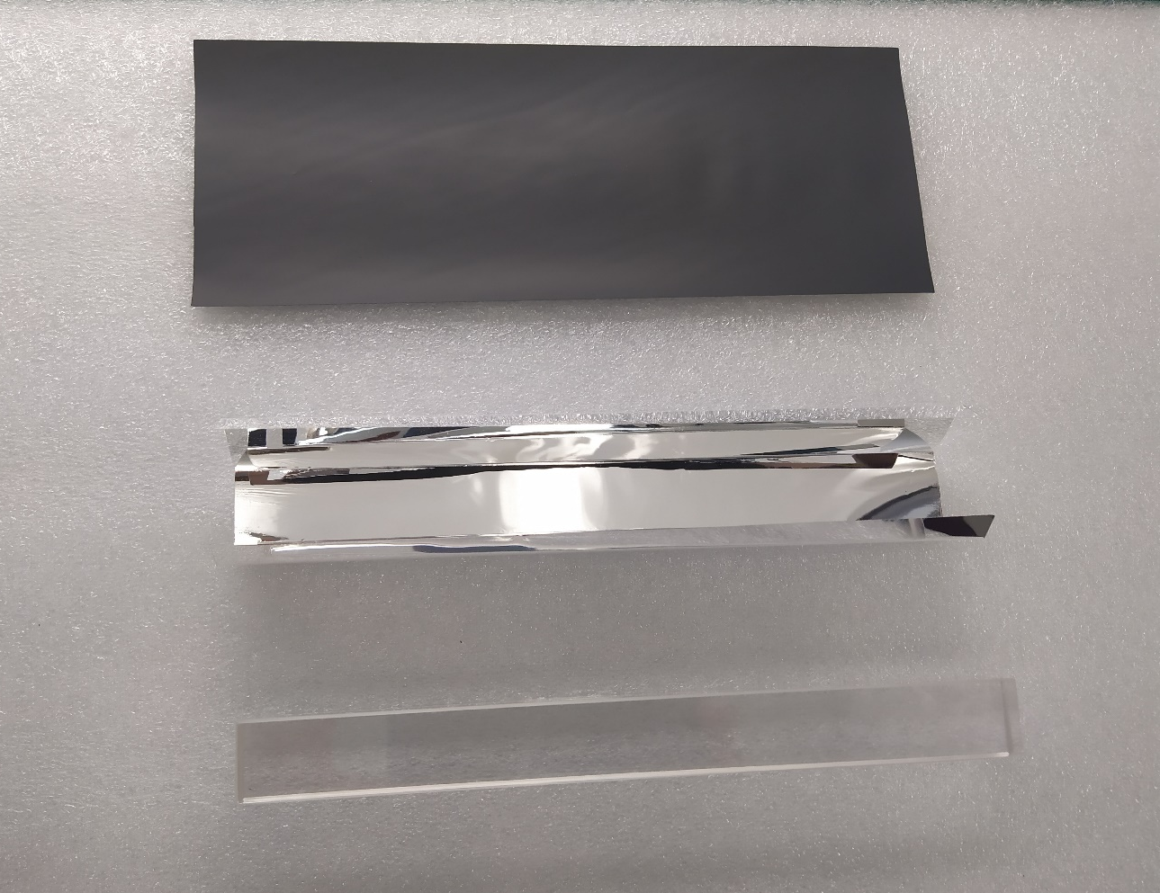
- Remove dust from ESR, use air duster
- Place crystal into the ESR reflective foil .
- Tape closed the ESR form with green 3M tape
- Place Crystal wrapped with ESR onto Tedlar, leave about ~3mm of material past the front end of the crystal
- Tape closed the Tedlar with green 3M tape.
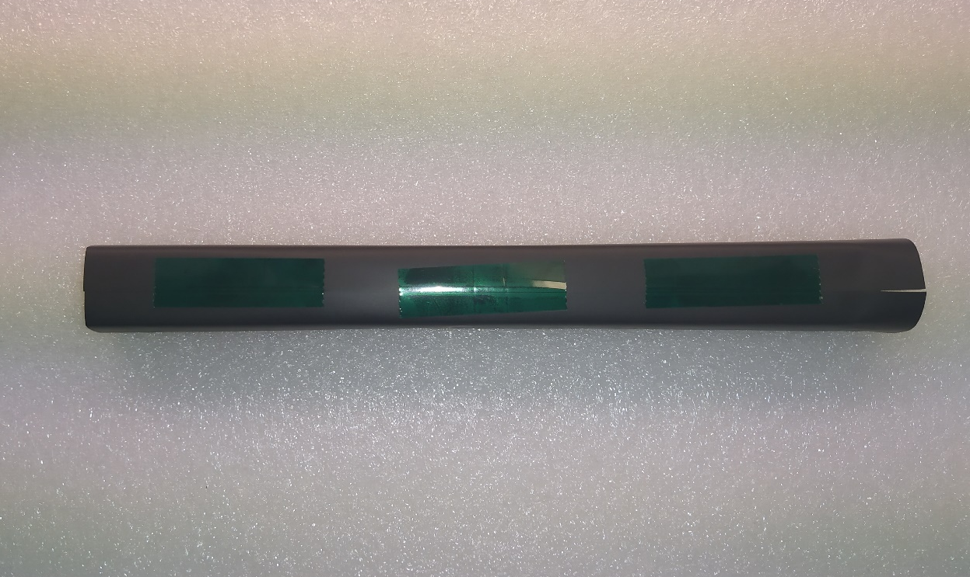
- Mount the wrapped crystal in the vertical clamps.
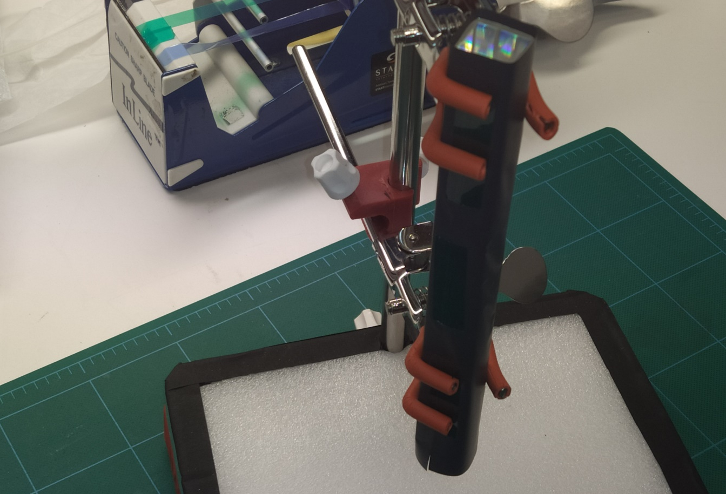
- Place front end reflector on crystal endcap and cut 4 slits in the corners of the wrapper.

- Fold and tape edges of the Tedlar with green 3M tape on the corners.

- Trim off the excess of the tape, take the wrapped crystal from the vertical clamp.
