Crystal Wrapping Procedure

This procedure is a part of the FCAL 2 module fabrication OSP (ENP-20-98871), which is amended in order to allow to wrap calorimeter modules in the user office in CEBAF center

July 15, 2021

- Wear Nitrile gloves during crystal wrapping
- Make sure that the crystal is clean. Cleaning is done using a (50 % / 50 %) solution of isopropanol with distilled water in the TEDF high bay lab and is not a part of the wrapping procedure.
- Components needed for wrapping: a c rystal, crystal, pre-shaped ESR reflective foil, and Tedlar.
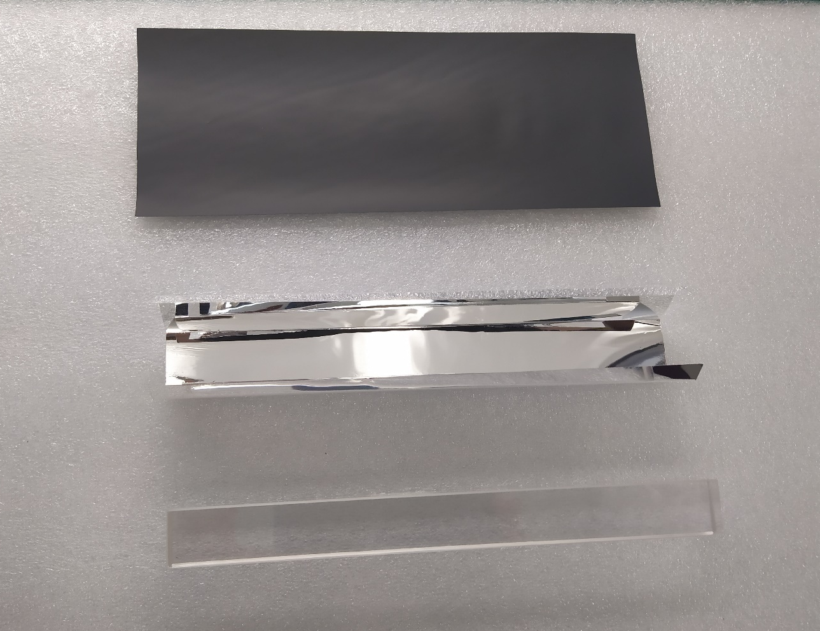
- Remove dust from ESR using a clean wiper (use air duster if needed)
- Place crystal into the ESR reflective foil .
- Tape closed the ESR form with green 3M tape
- Place Crystal wrapped with ESR onto Tedlar, leave about ~3mm of material past the front end of the crystal. The ESR tape joint should be placed face down on the Tedlar, i.e., the ESR joint should be covered by Tedlar (the ESR and Tedlar joints should be positioned back-to-back on the wrapped crystal).
- Tape closed the Tedlar with green 3M tape.
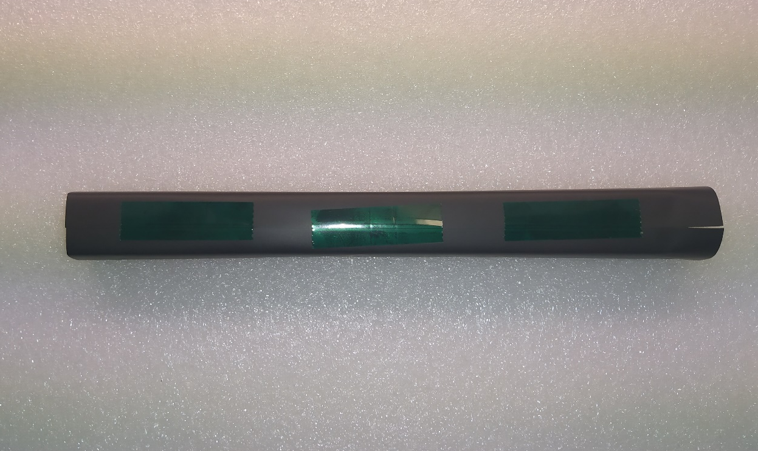
- Mount the wrapped crystal in the vertical clamps.
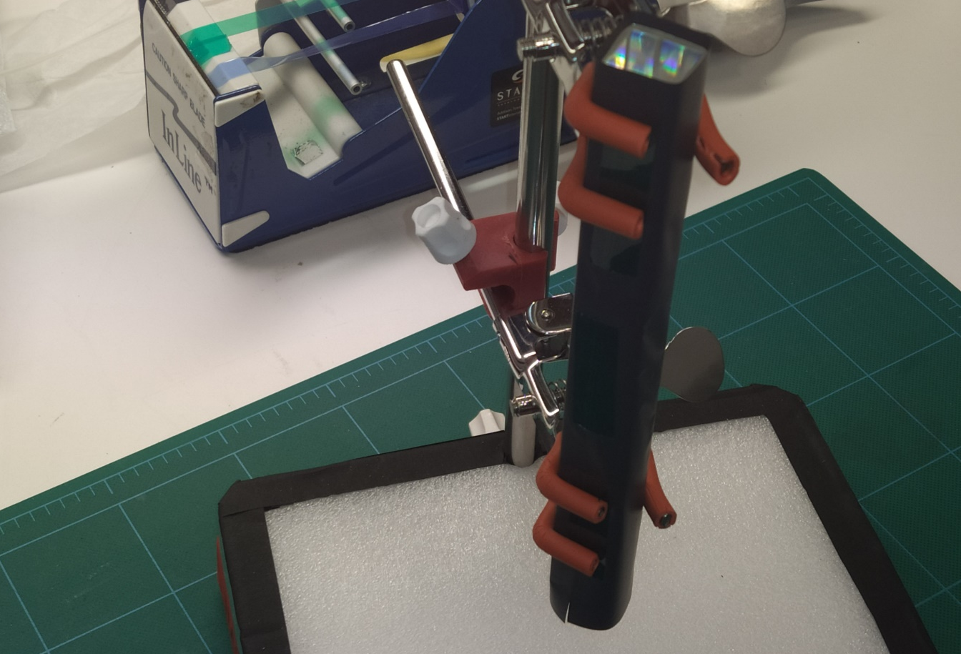
- Place front end reflector on crystal endcap and cut 4 slits in the corners of the wrapper.

- Fold and tape edges of the Tedlar with green 3M tape on the corners.

- Trim off the excess of the tape.
- Take the wrapped crystal from the vertical clamp. Use sharpie to write the crystal number and the date on Tedlar of the wrapped module. Write the crystal number to the FCAL insert construction wiki page (TBD)

