FCAL Insert Module Assembly
Feb 14, 2022

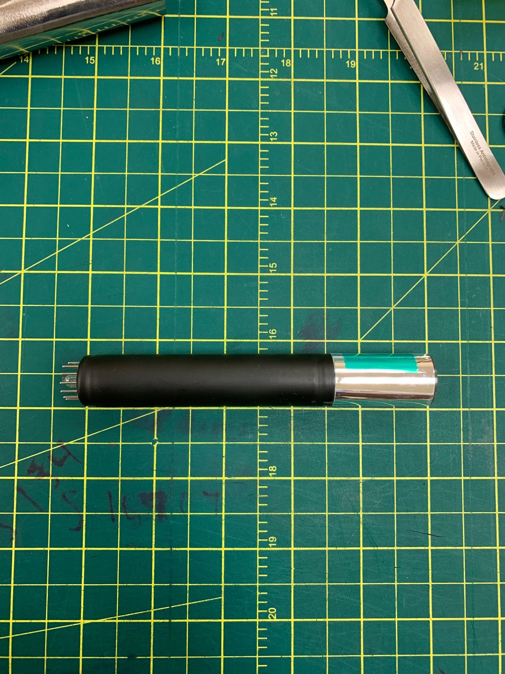

- Wrap the light guide on the PMT in an ESR sleeve. Ensure that the ESR is wrapped tightly around the guide.

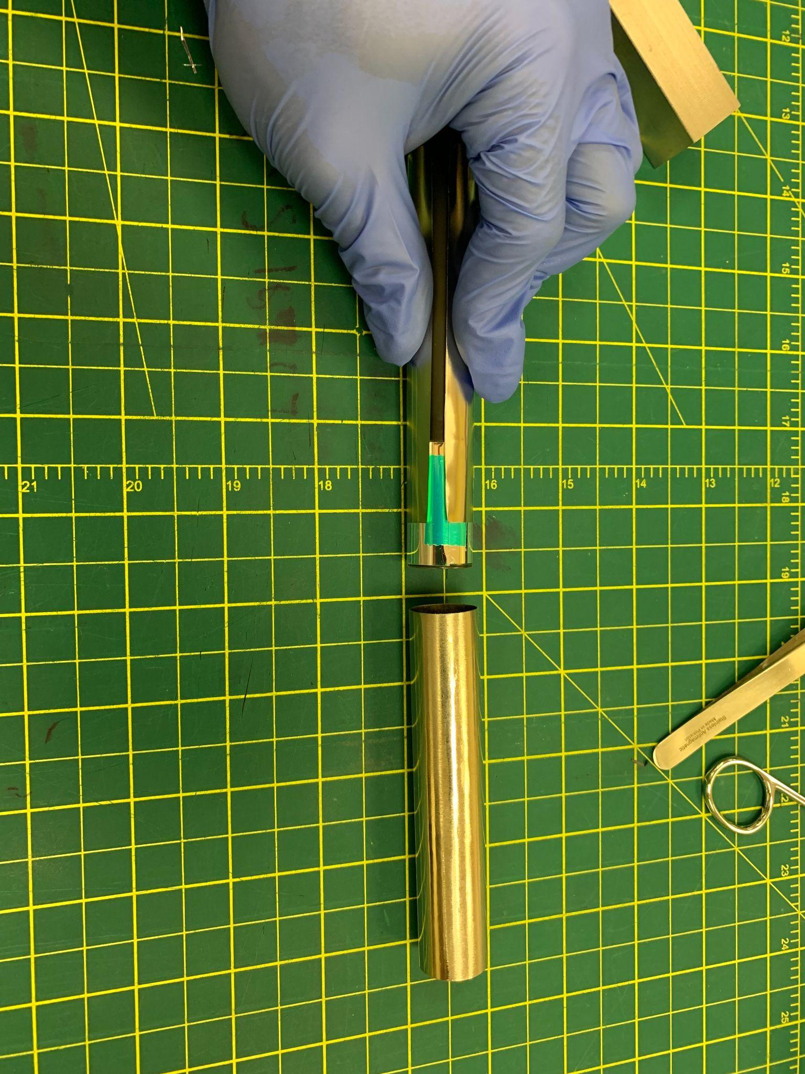
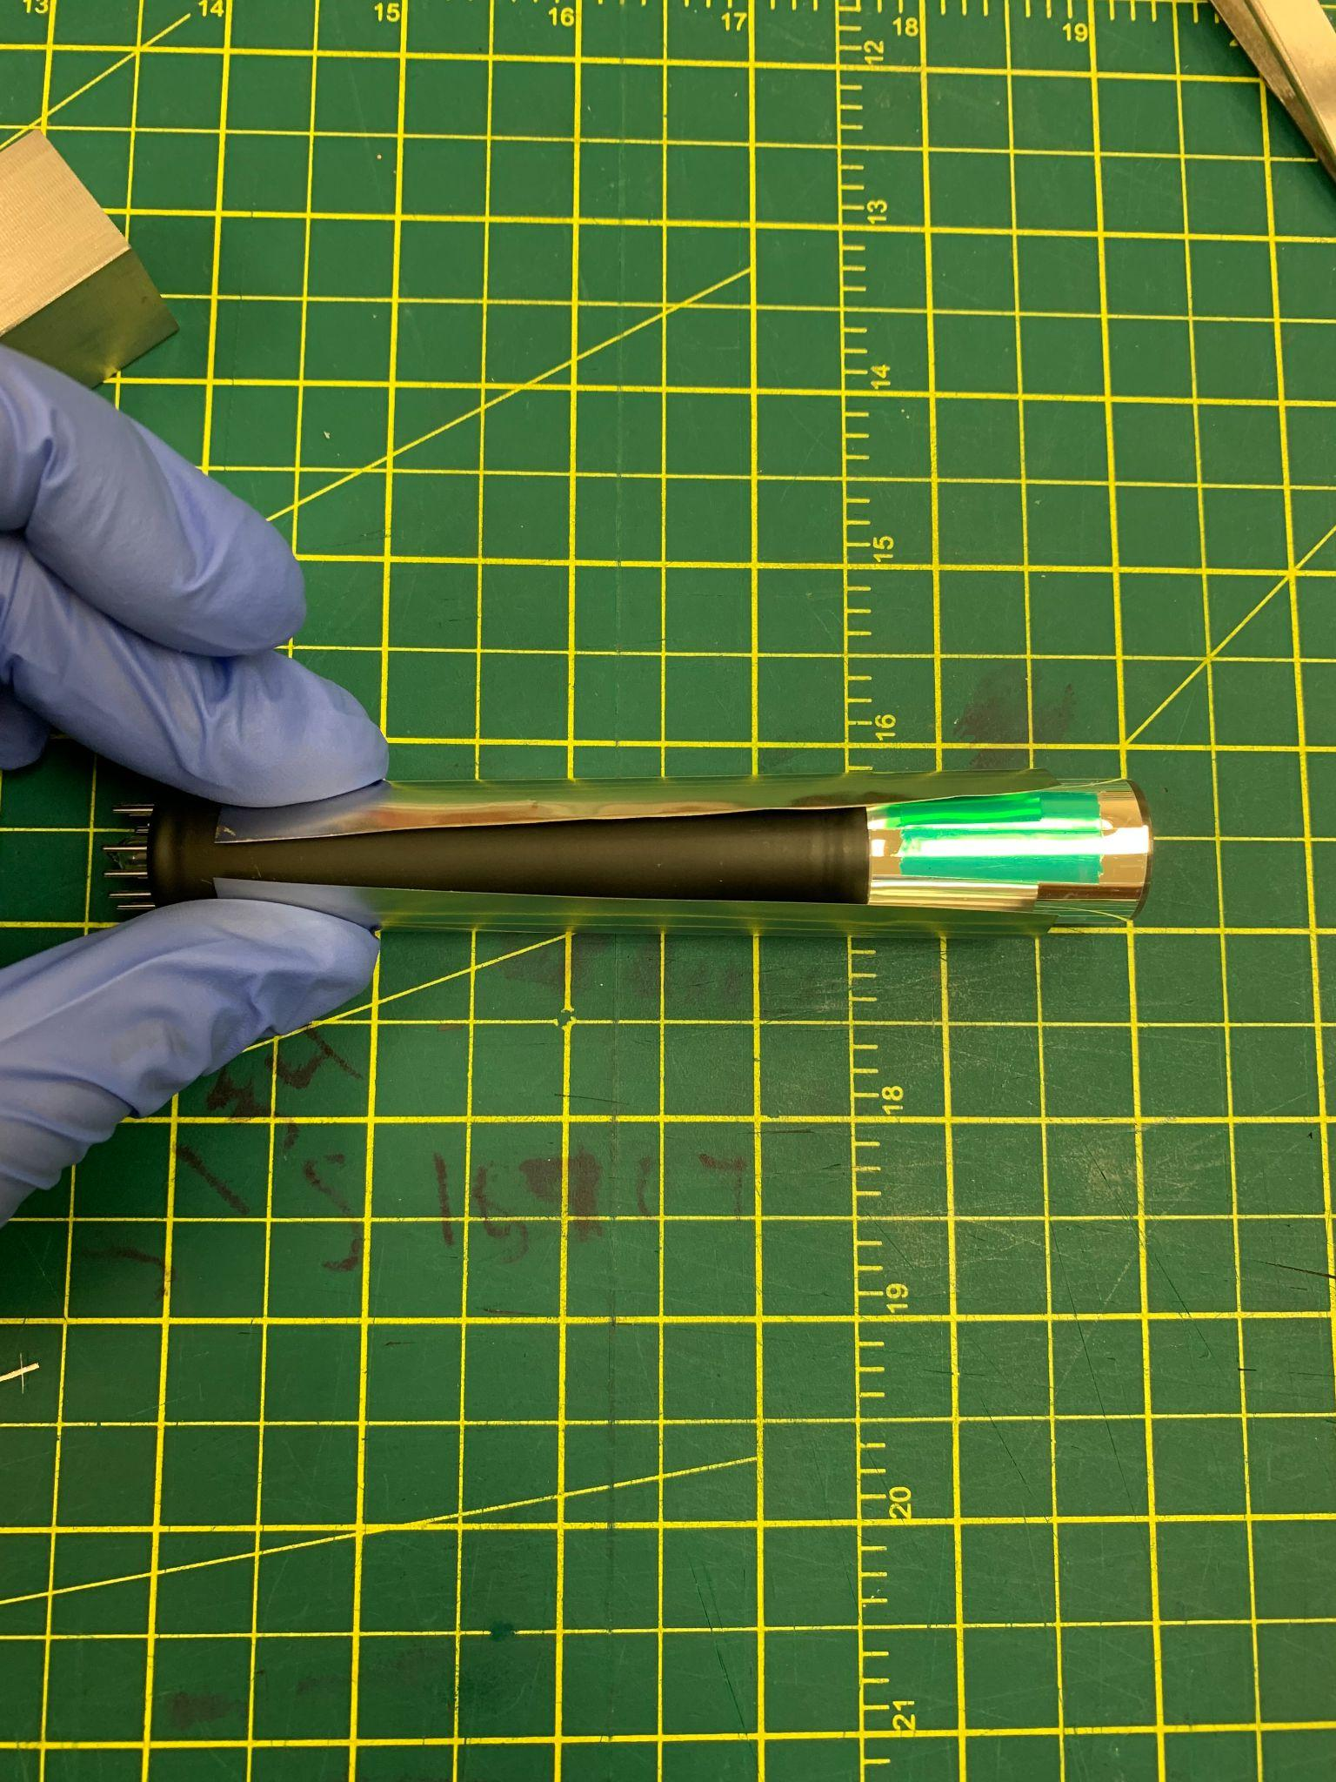

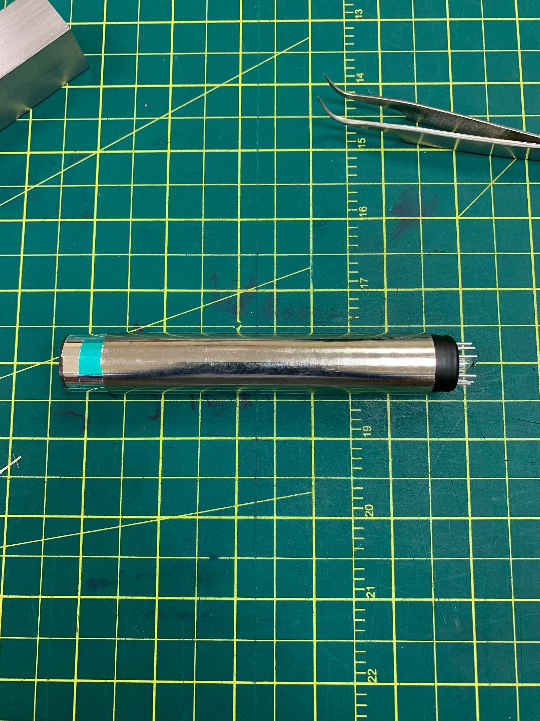

- Wrap the PMT in mu-metal and put it into the housing cylinder. Ensure that the PMT does not get scratched from the mu-metal from this process.

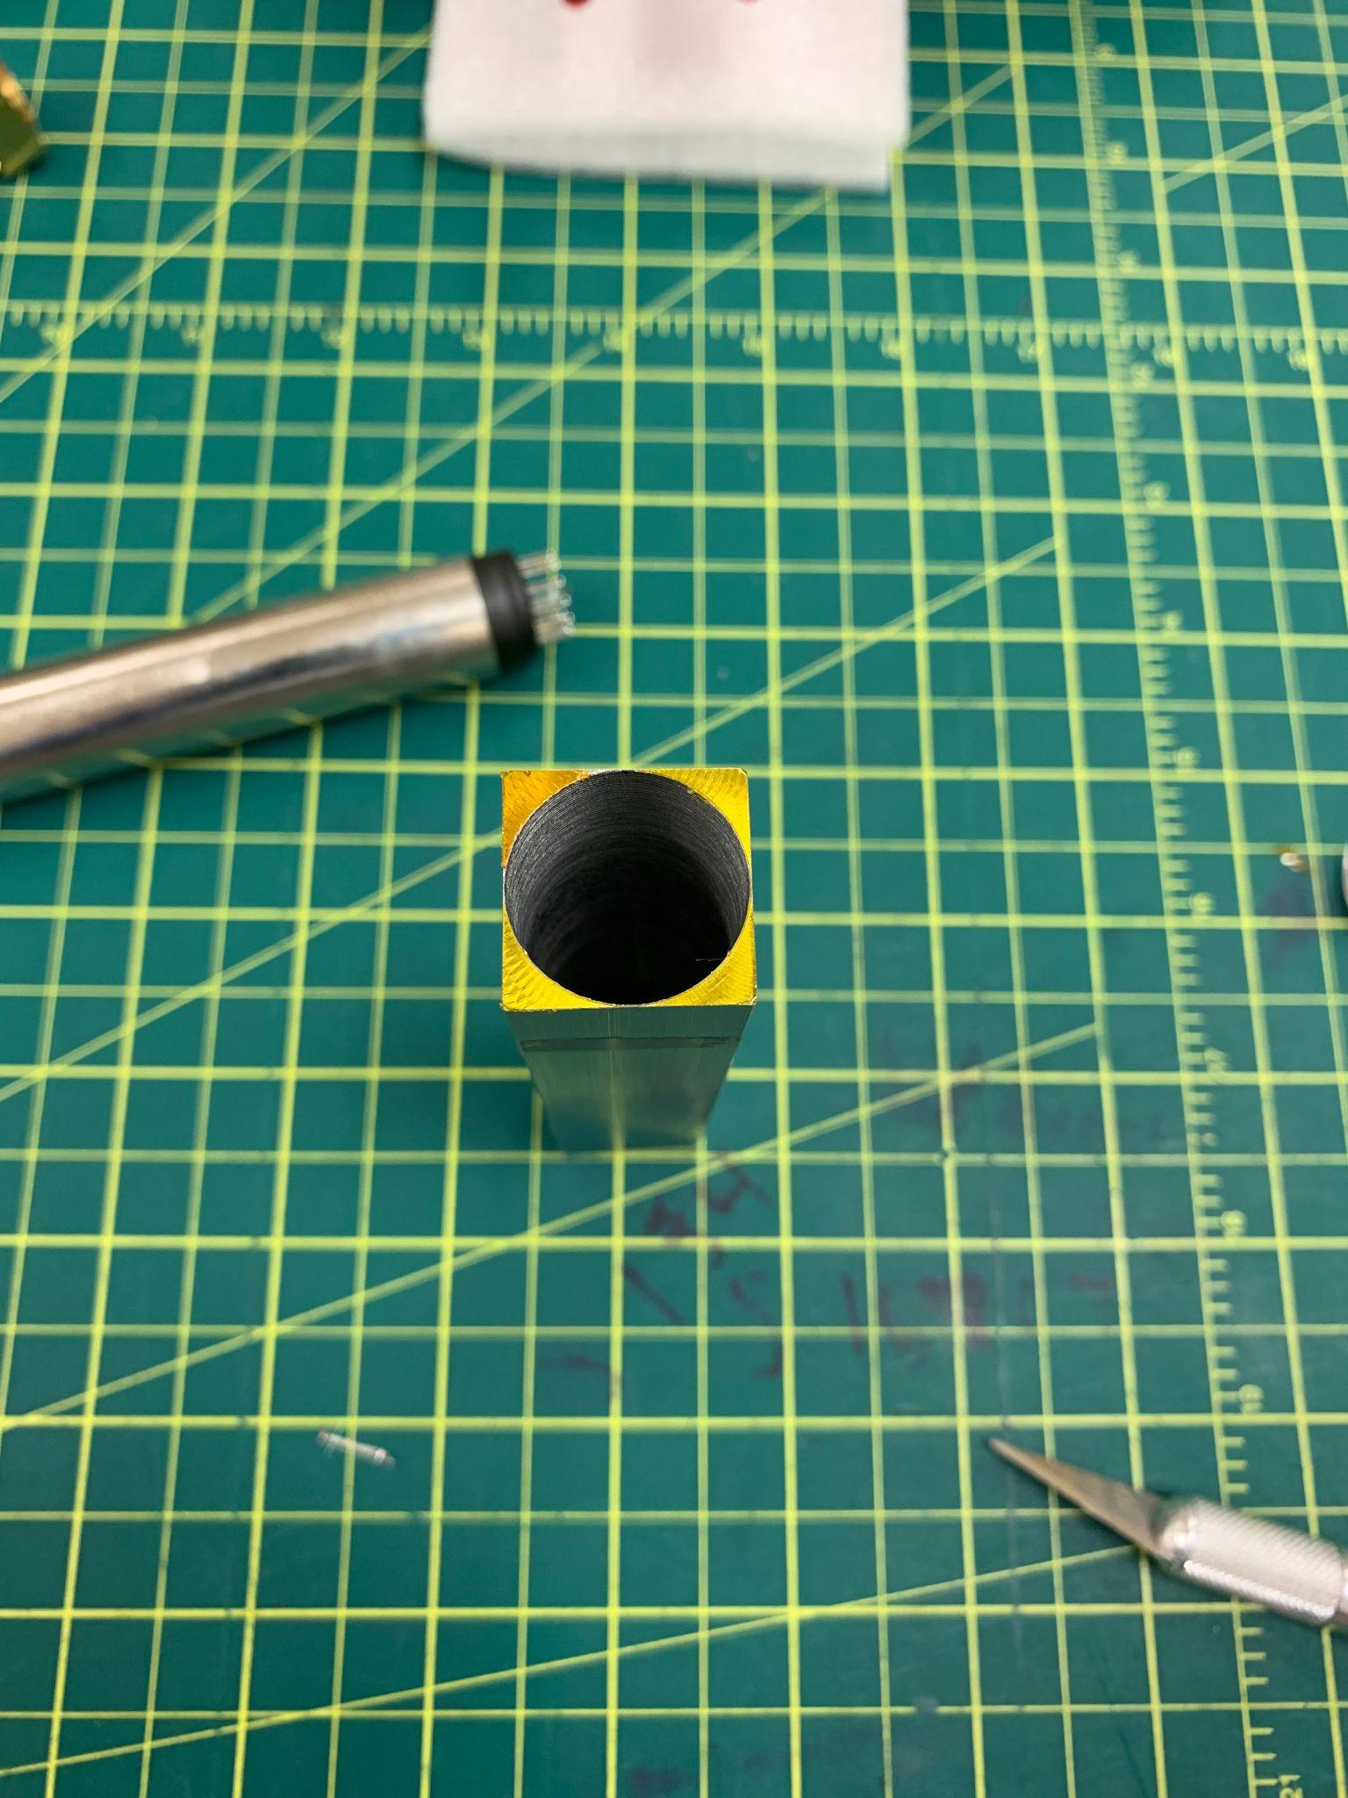

- Adhere kapton tape to the corners of the PMT housing. Begin by placing a strip of tape on the side of the housing with no screw holes. Then, cut out the circular shape whilst the tape is on the housing. Then, cut off excess tape from the sides of the housing.

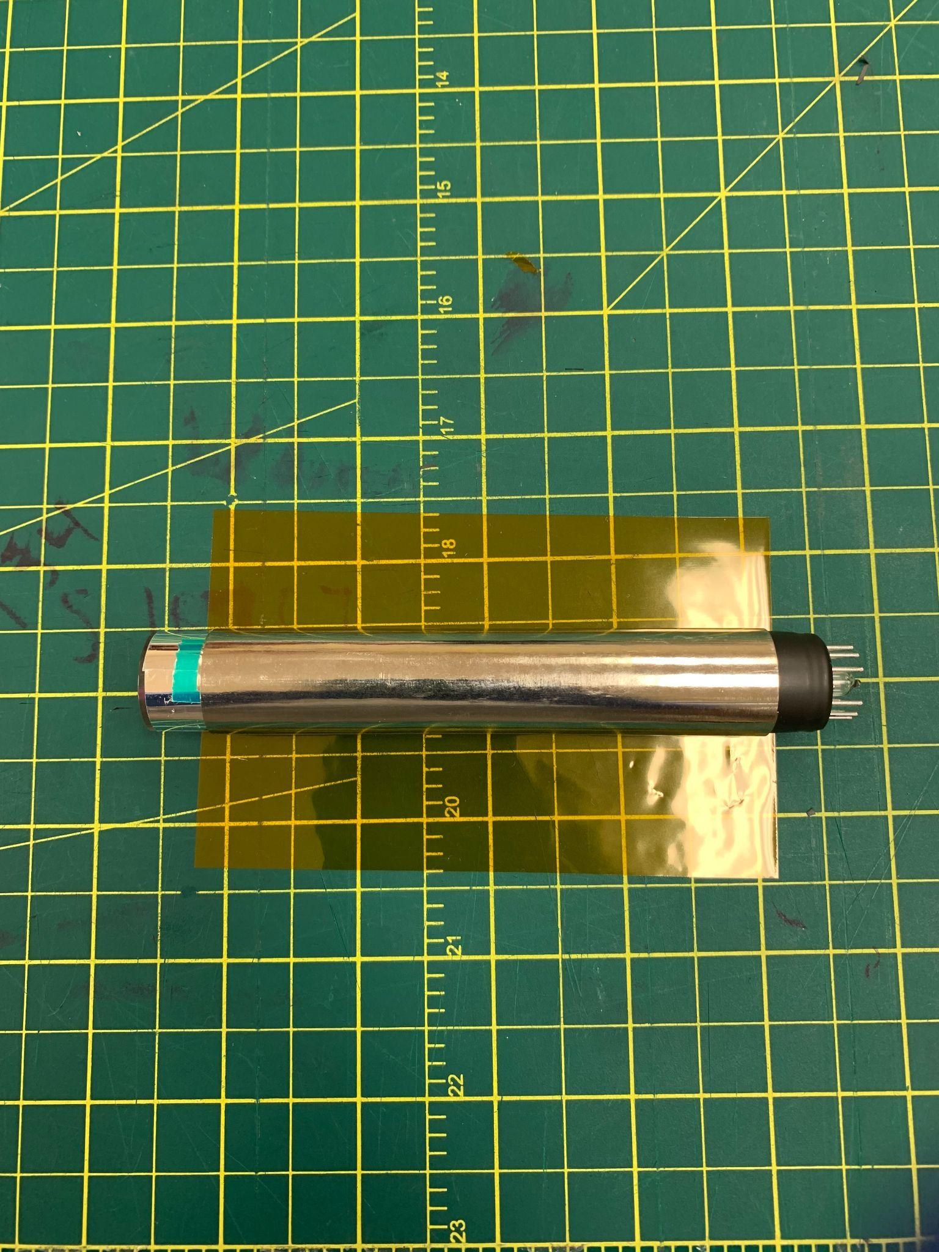
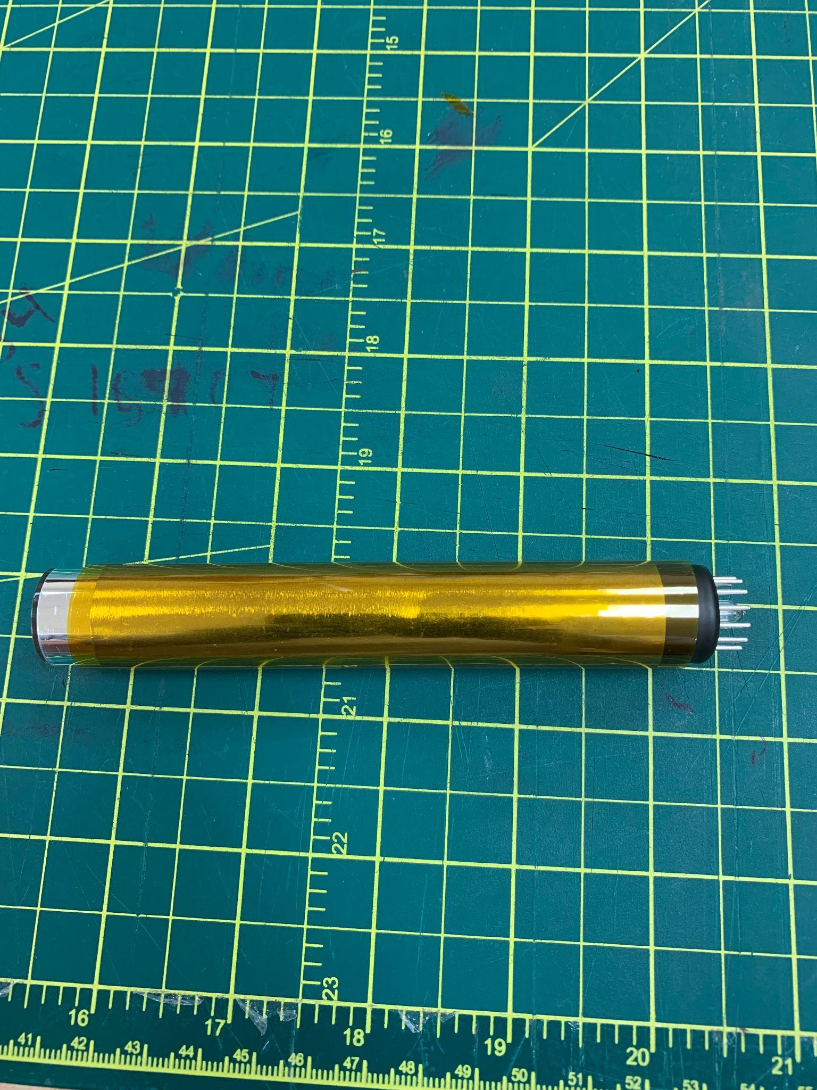

- Wrap the PMT in kapton (not tape). Make sure that there are no wrinkles in the kapton.

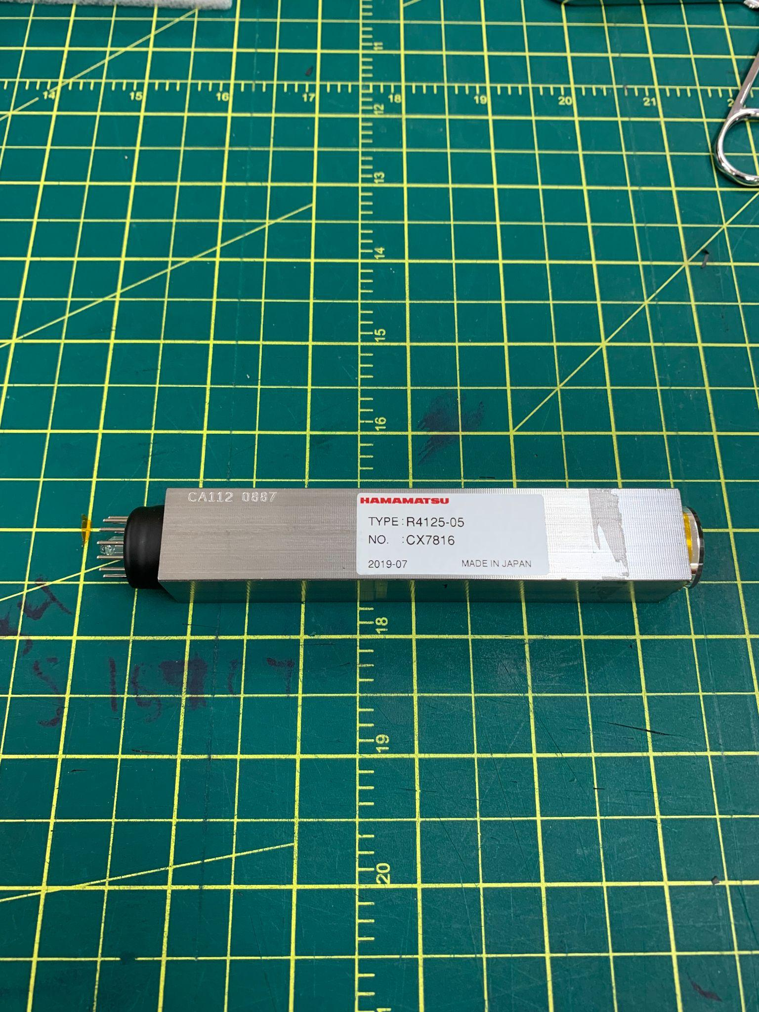
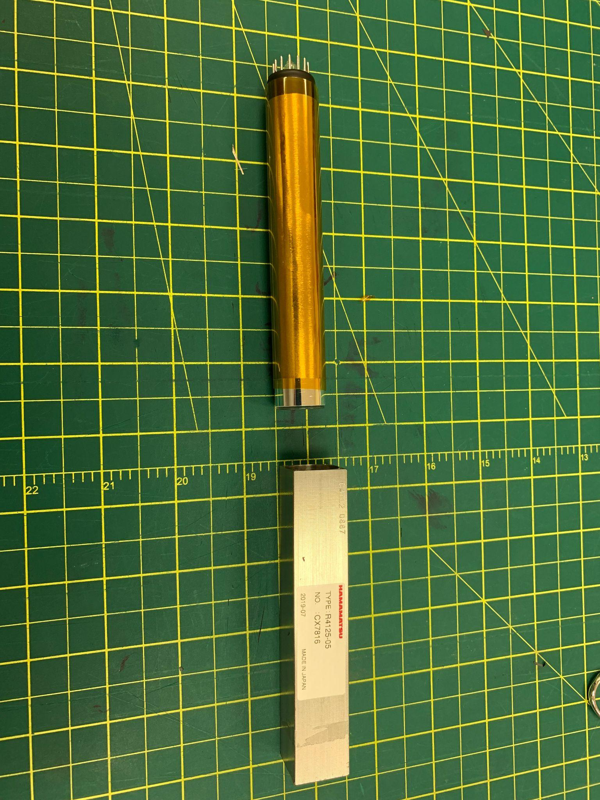

- Insert the PMT into the housing. Once again, ensure that the kapton does not wrinkle or tear during this process.

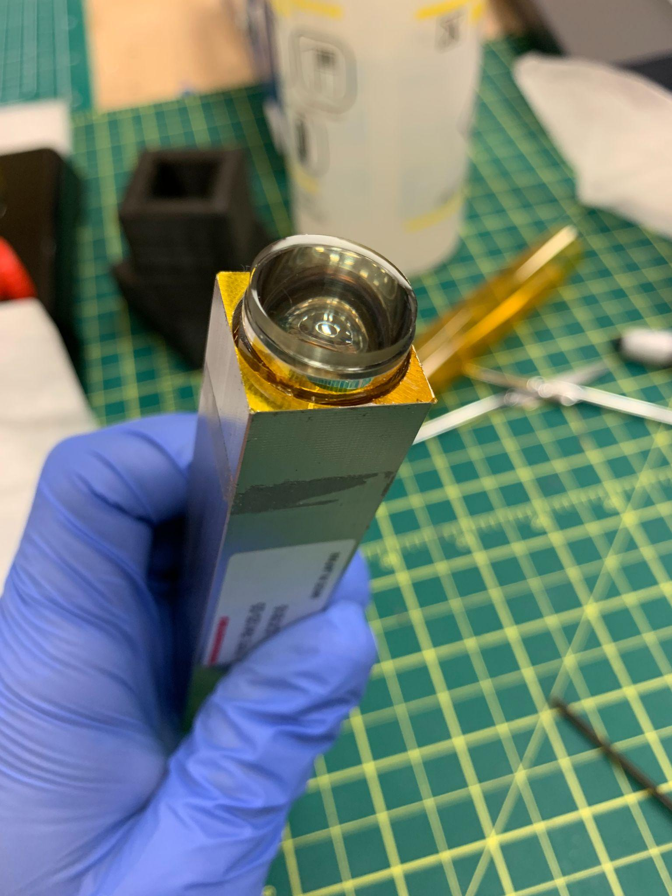
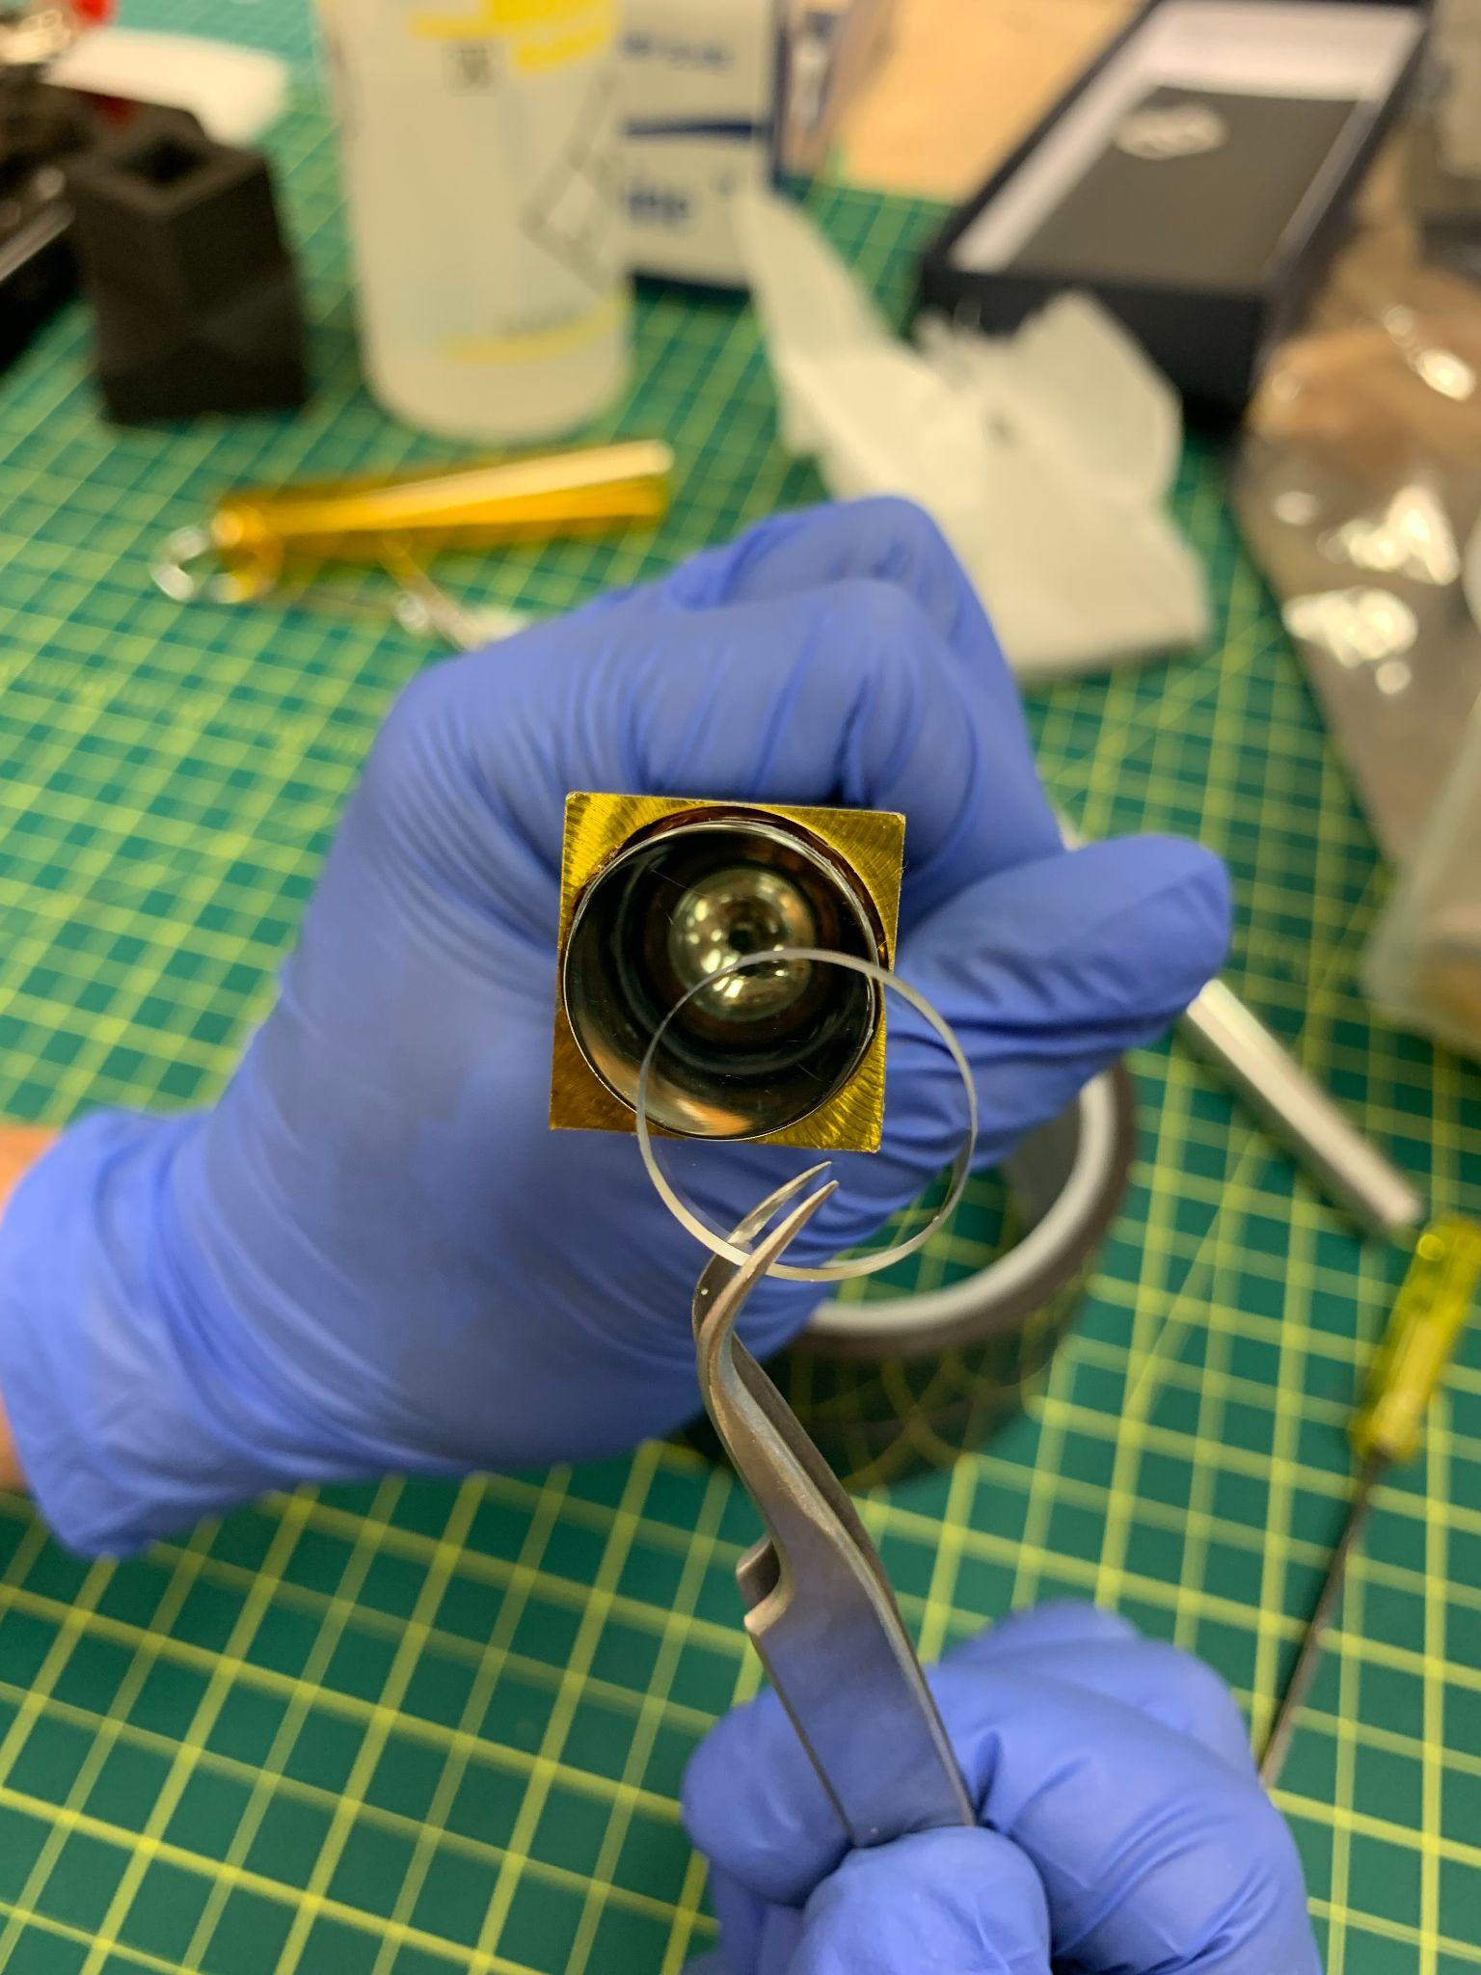

- Put a silicon cookie on the PMT. When placing the cookie, try to make sure that the cookie has minimal dust on it. Once the cookie is in place, roll all the air out from underneath the cookie.

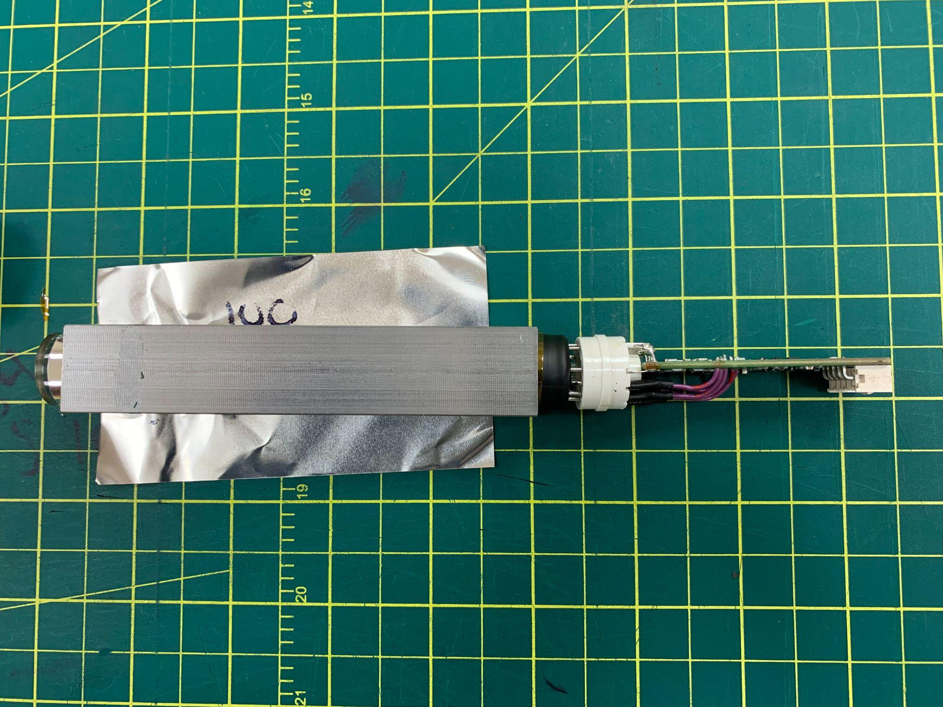
- Check the orientation of the PMT with a dummy voltage divider. The divider must be almost completely vertical. It is okay if it has a slight angle, but it is important that the divider is mostly vertical.

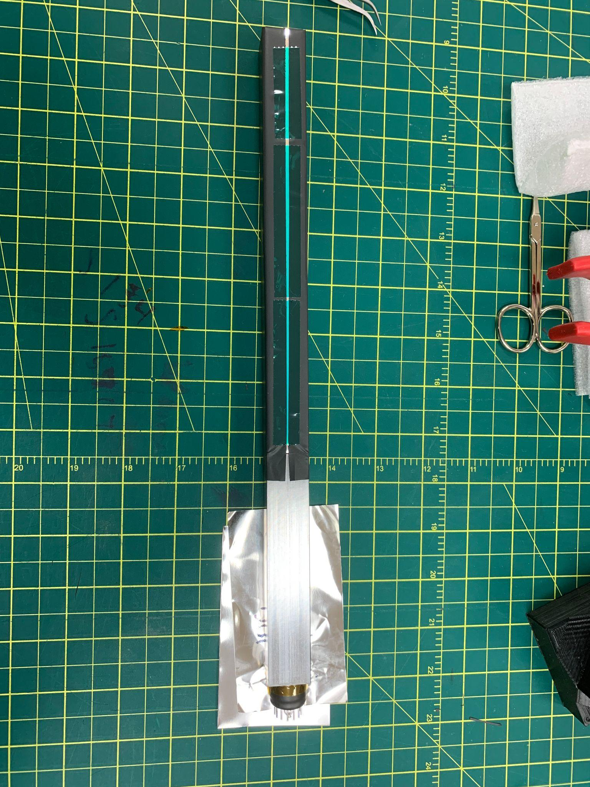
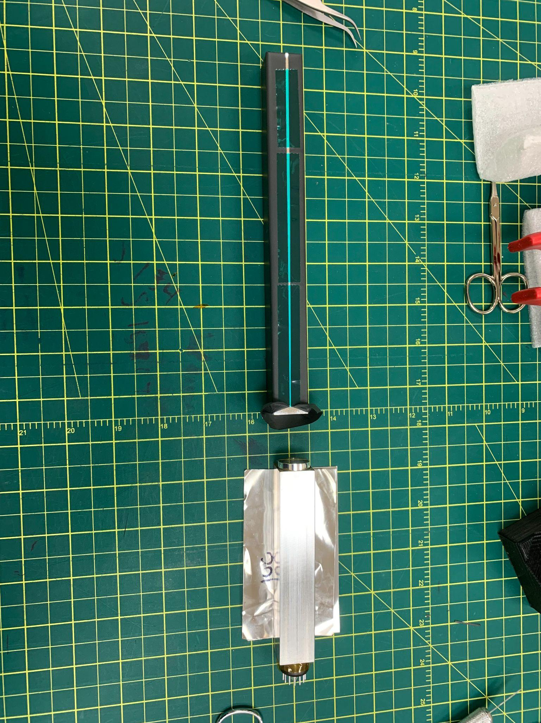

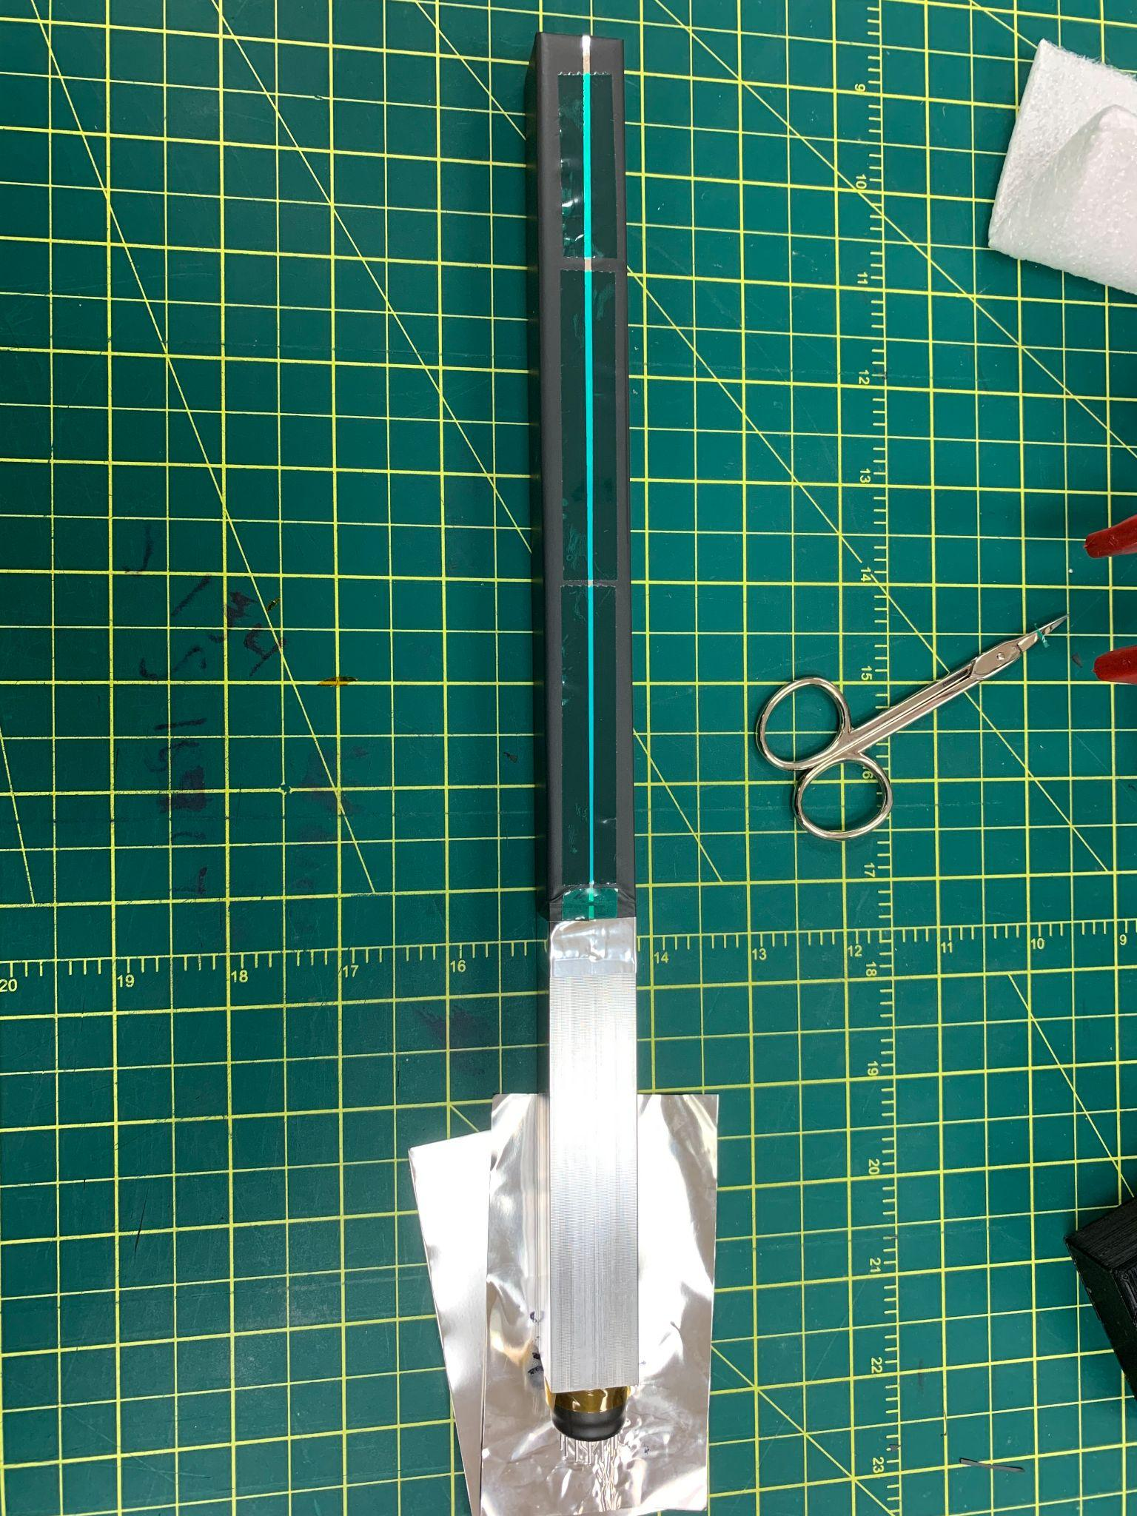

- Adhere the PMT to the crystal. First, open up the end of the crystal and join the PMT to the crystal. Once the PMT is in place, stretch the tedlar over the PMT and use silver tape to hold this bond. The PMT should be tight and firm.

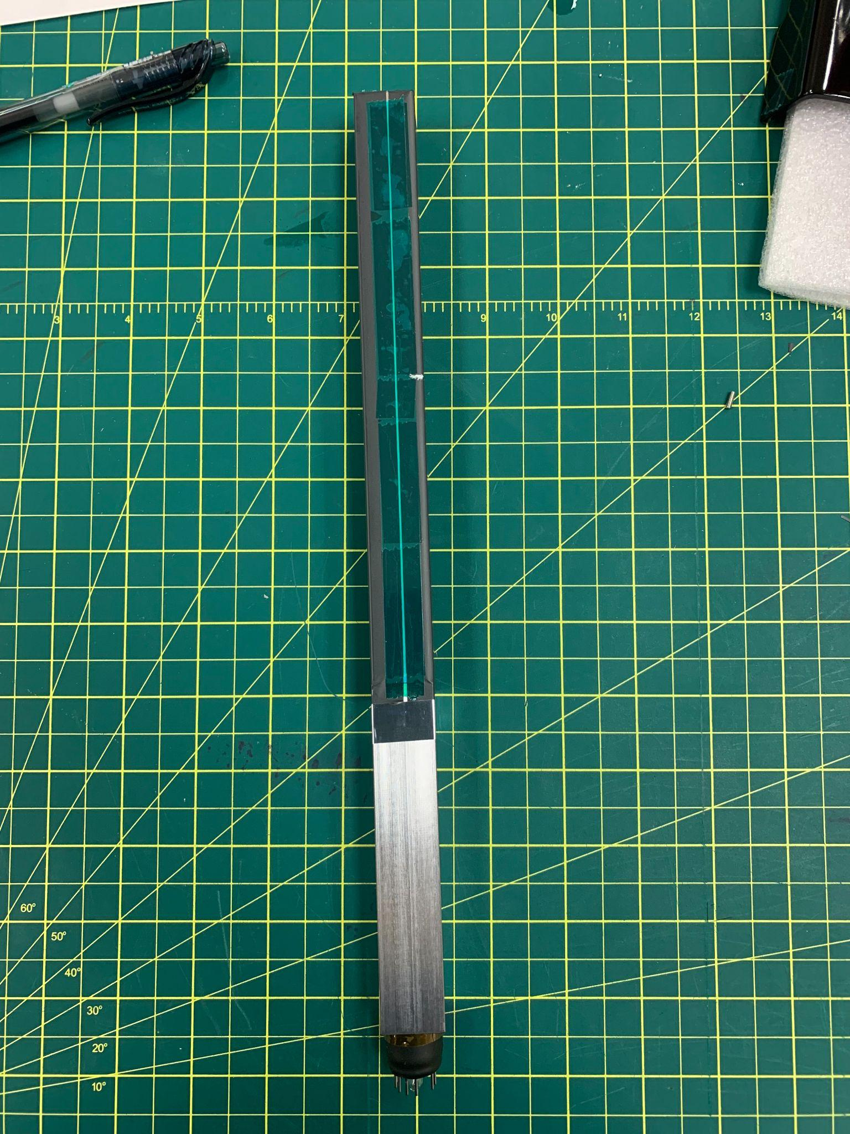
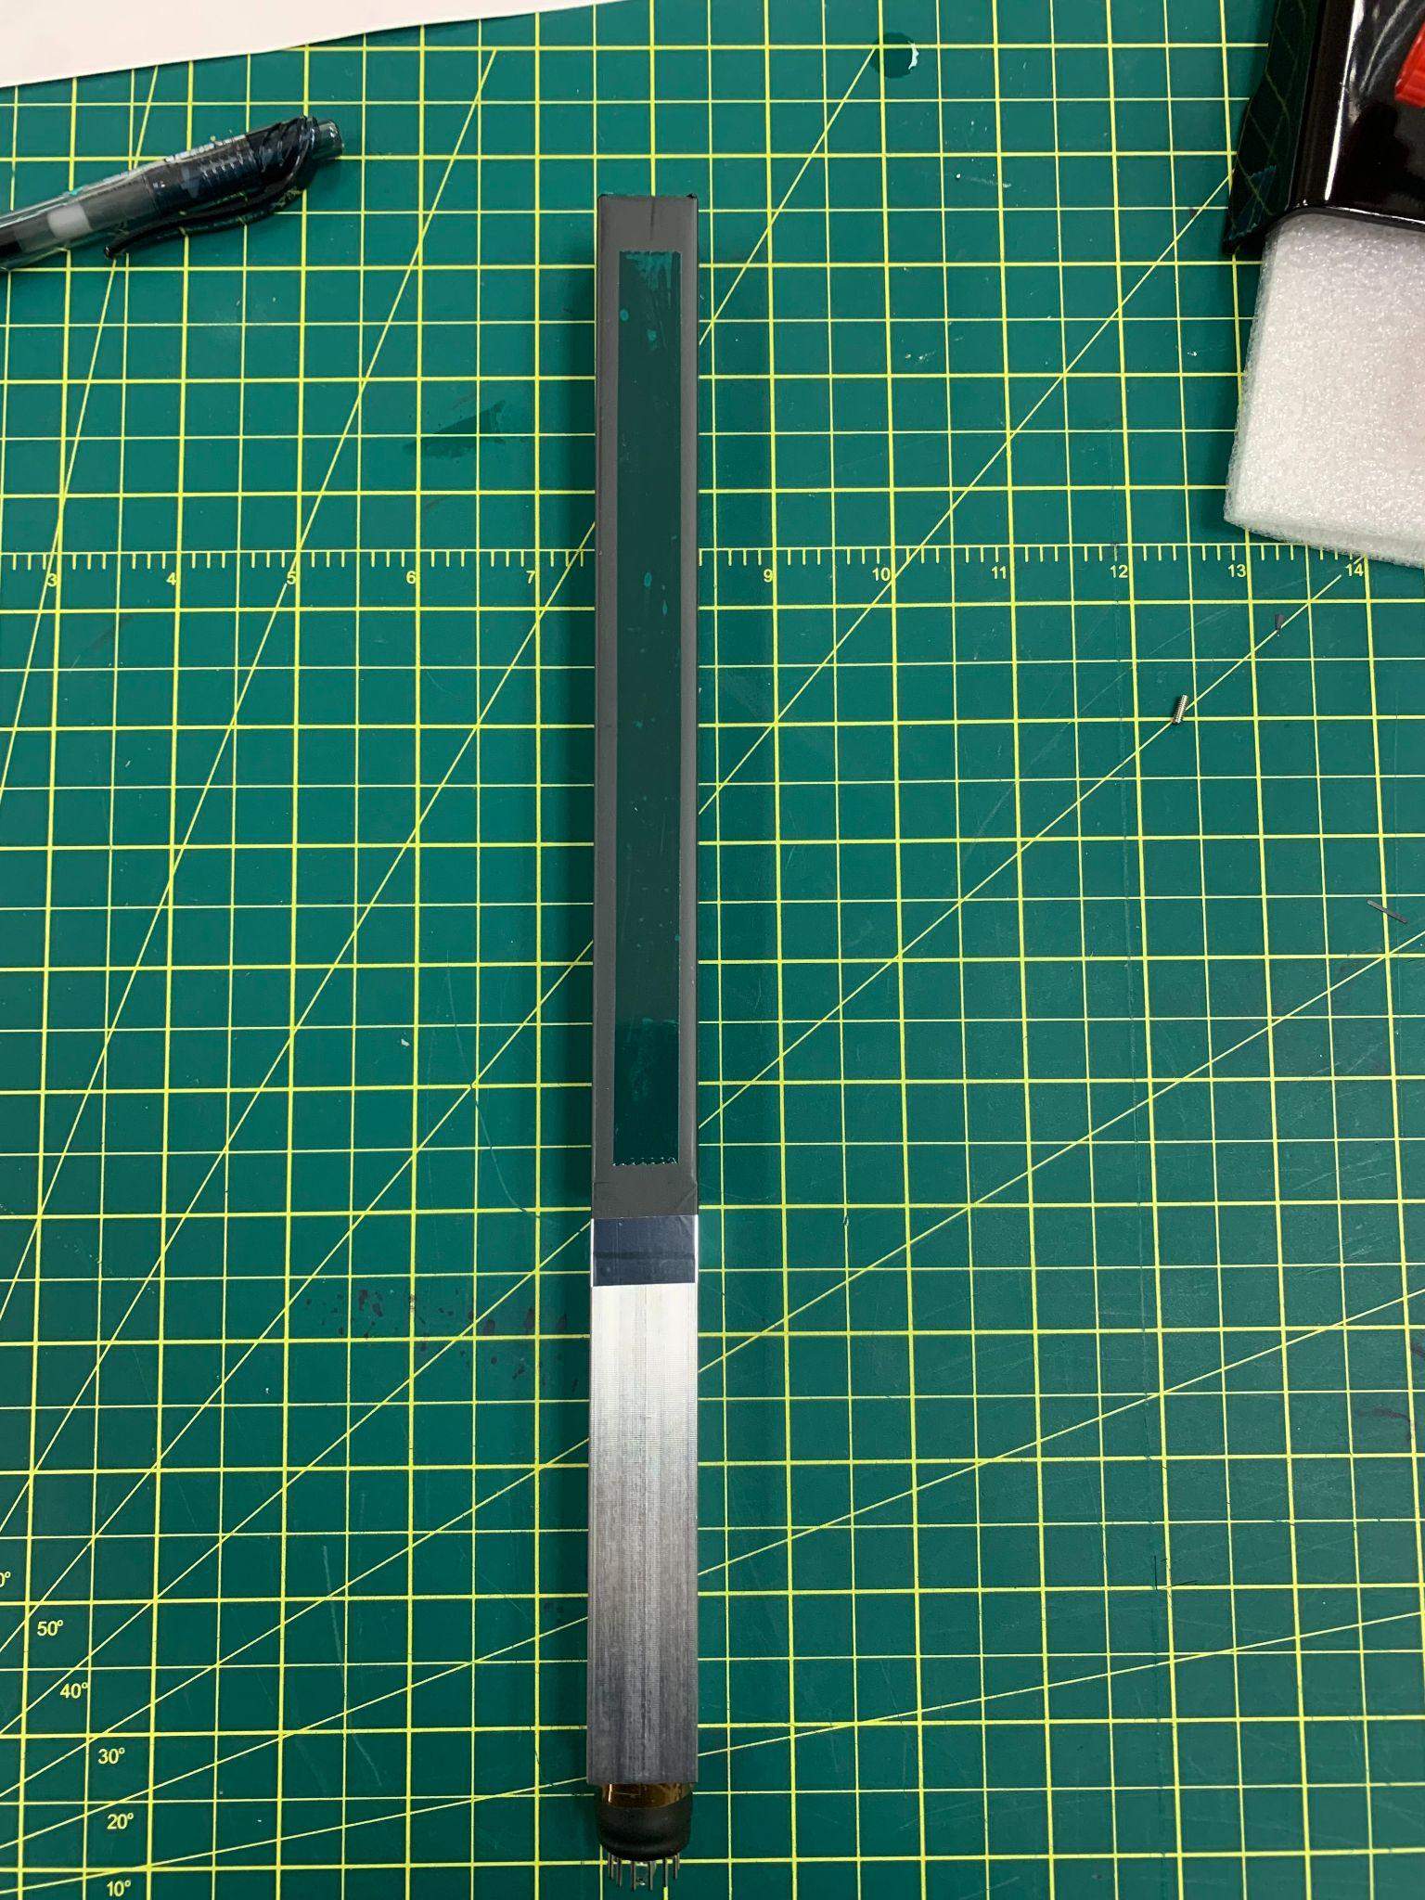

- Shim the crystal by placing an extra layer of tape on the seam of the tedlar and another on the left side of the crystal with respect to the seam.

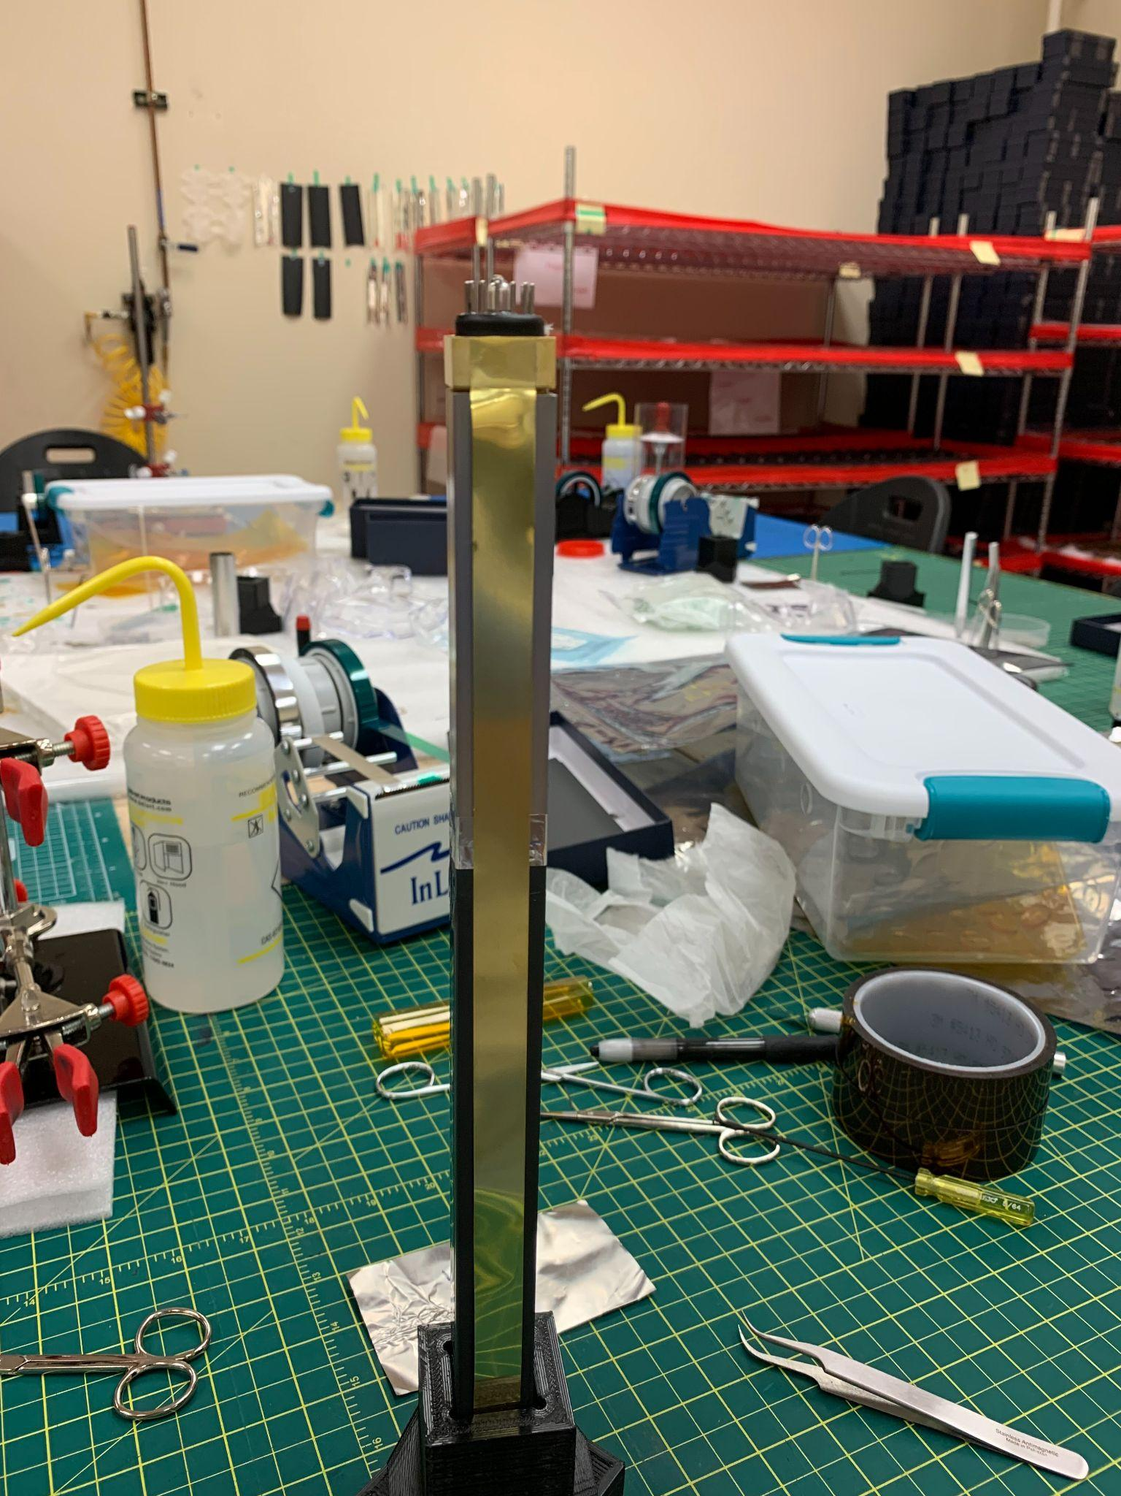
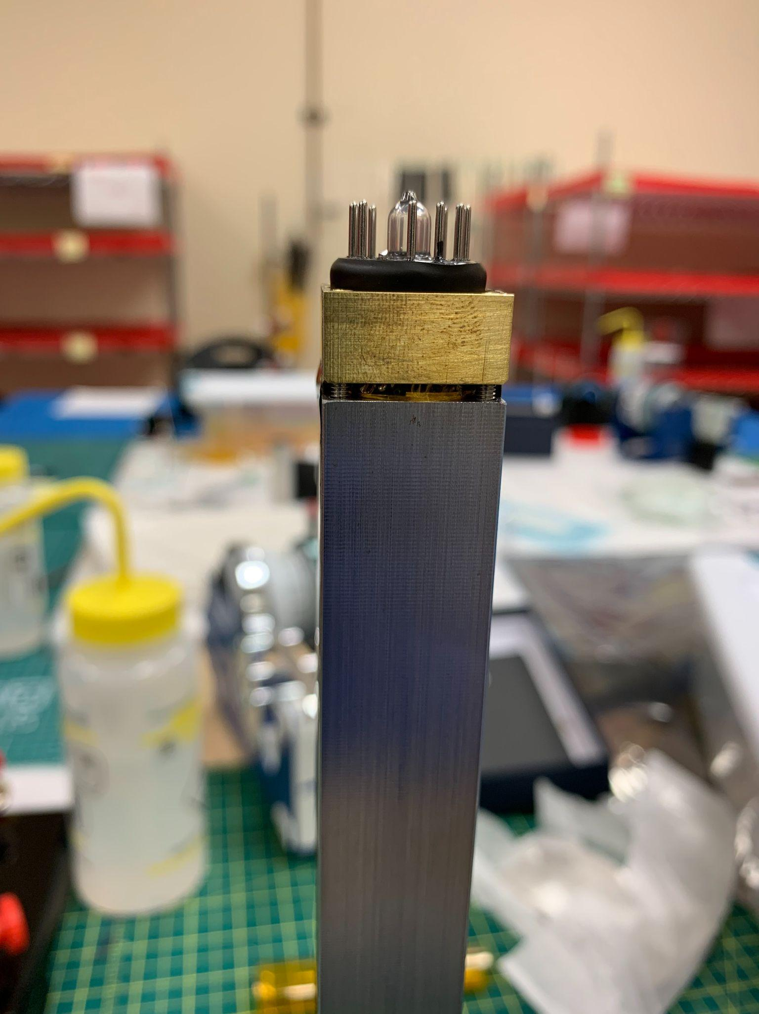

10. Put the brass strap on the module. To do this, take four small screws and place them in the four screw holes. Tighten them with an allen wrench until the wrench has some resistance. The gap between the brass strap and housing should be uniform.

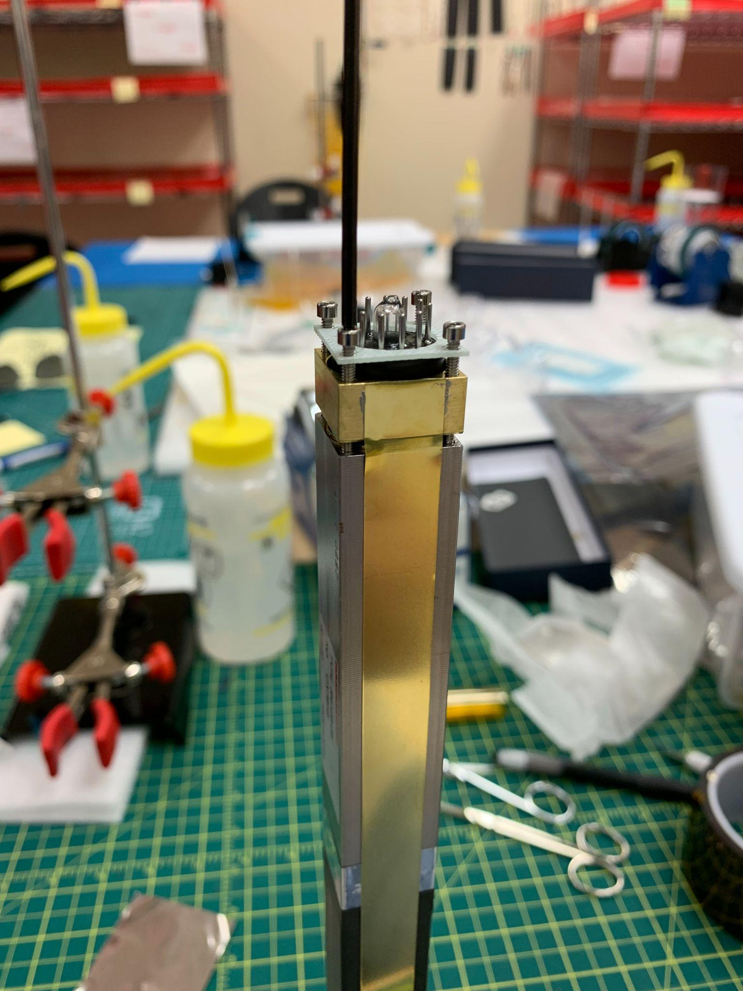
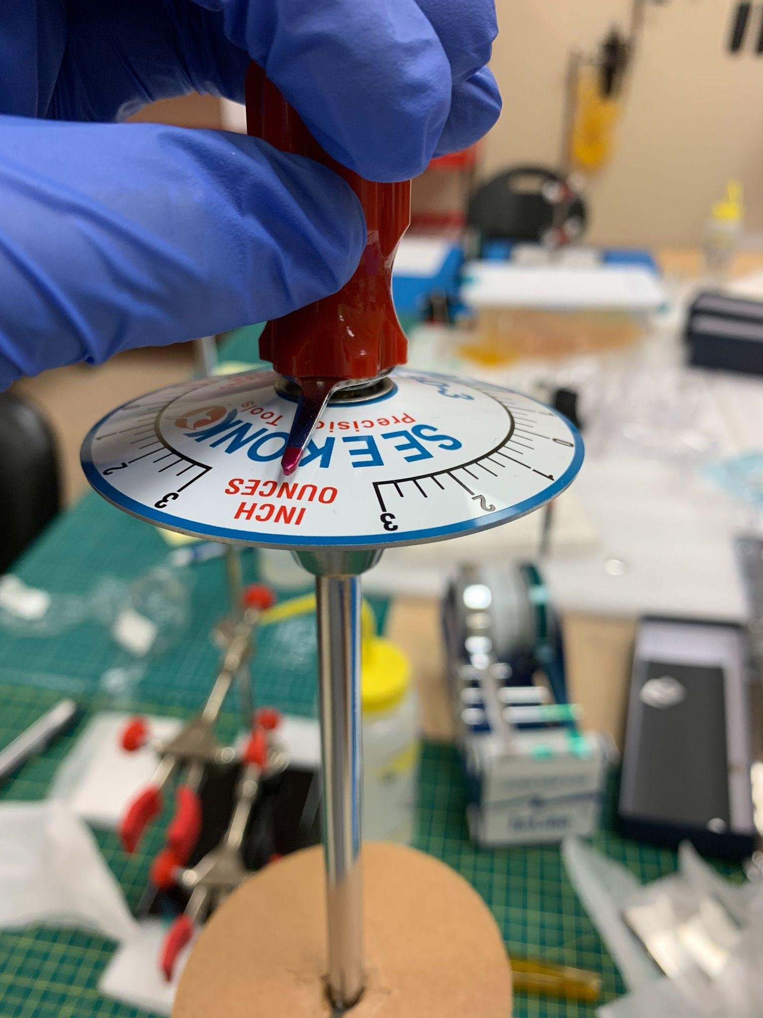

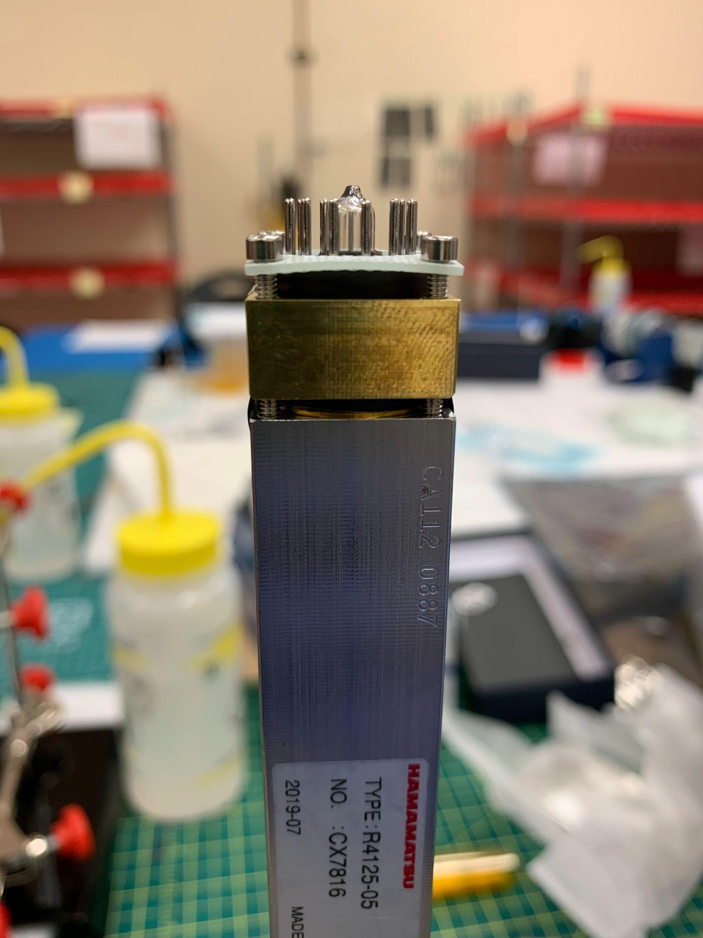

11. Screw the crown onto the module using a torque wrench. Tighten the screws until the torque wrench is about halfway past three. The crown should be slightly bent.

