Removing FCAL cables

- Somov, A. Martinez, V. Murakhovskiy, B. Friedman, J. Cardenas, P. Sanford

Protection: Wear hard hat when working below the FCAL platform

Objectives:
We are reusing some cables of the inner part of the FCAL which have been removed from the detector to connect the ECAL modules. The list of the cables and connections to crates and the detector are listed in: https://halldweb.jlab.org/wiki/index.php/Rearranging_FCAL_cables
The cable removal procedure is described below:
Step 1
The cables are bundled in a group of 16 and, each bundle is connected to a single flash ADC module. Disconnect cables of each bundle that should be removed from the flash ADC. Pull the bundle to either the top or bottom trays (the cables are delivered to the detector using 4 cable trays. 2 position at the bottom and 2 on the top of the FCAL platform). The map of cables connected to flash ADCs is given in

https://halldweb.jlab.org/wiki/index.php/Rearranging_FCAL_cables

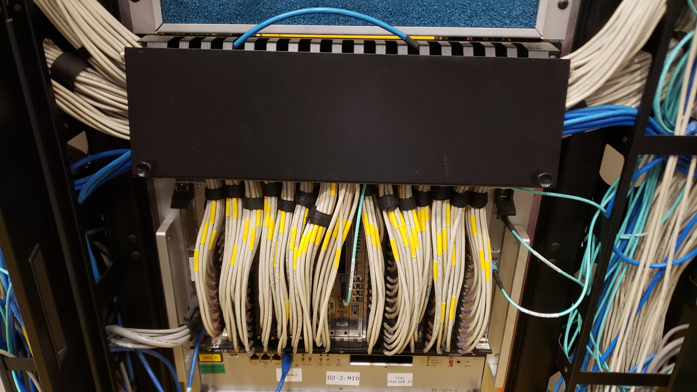
Figure 1. Bundles from this crate go to the top cable crate.
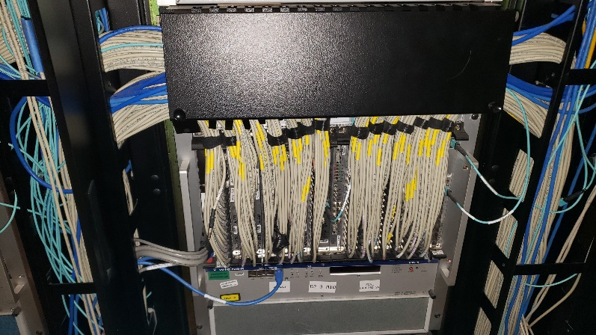
Figure 2. Middle cable crate. Bundles from this crate go to the bottom cable crate.

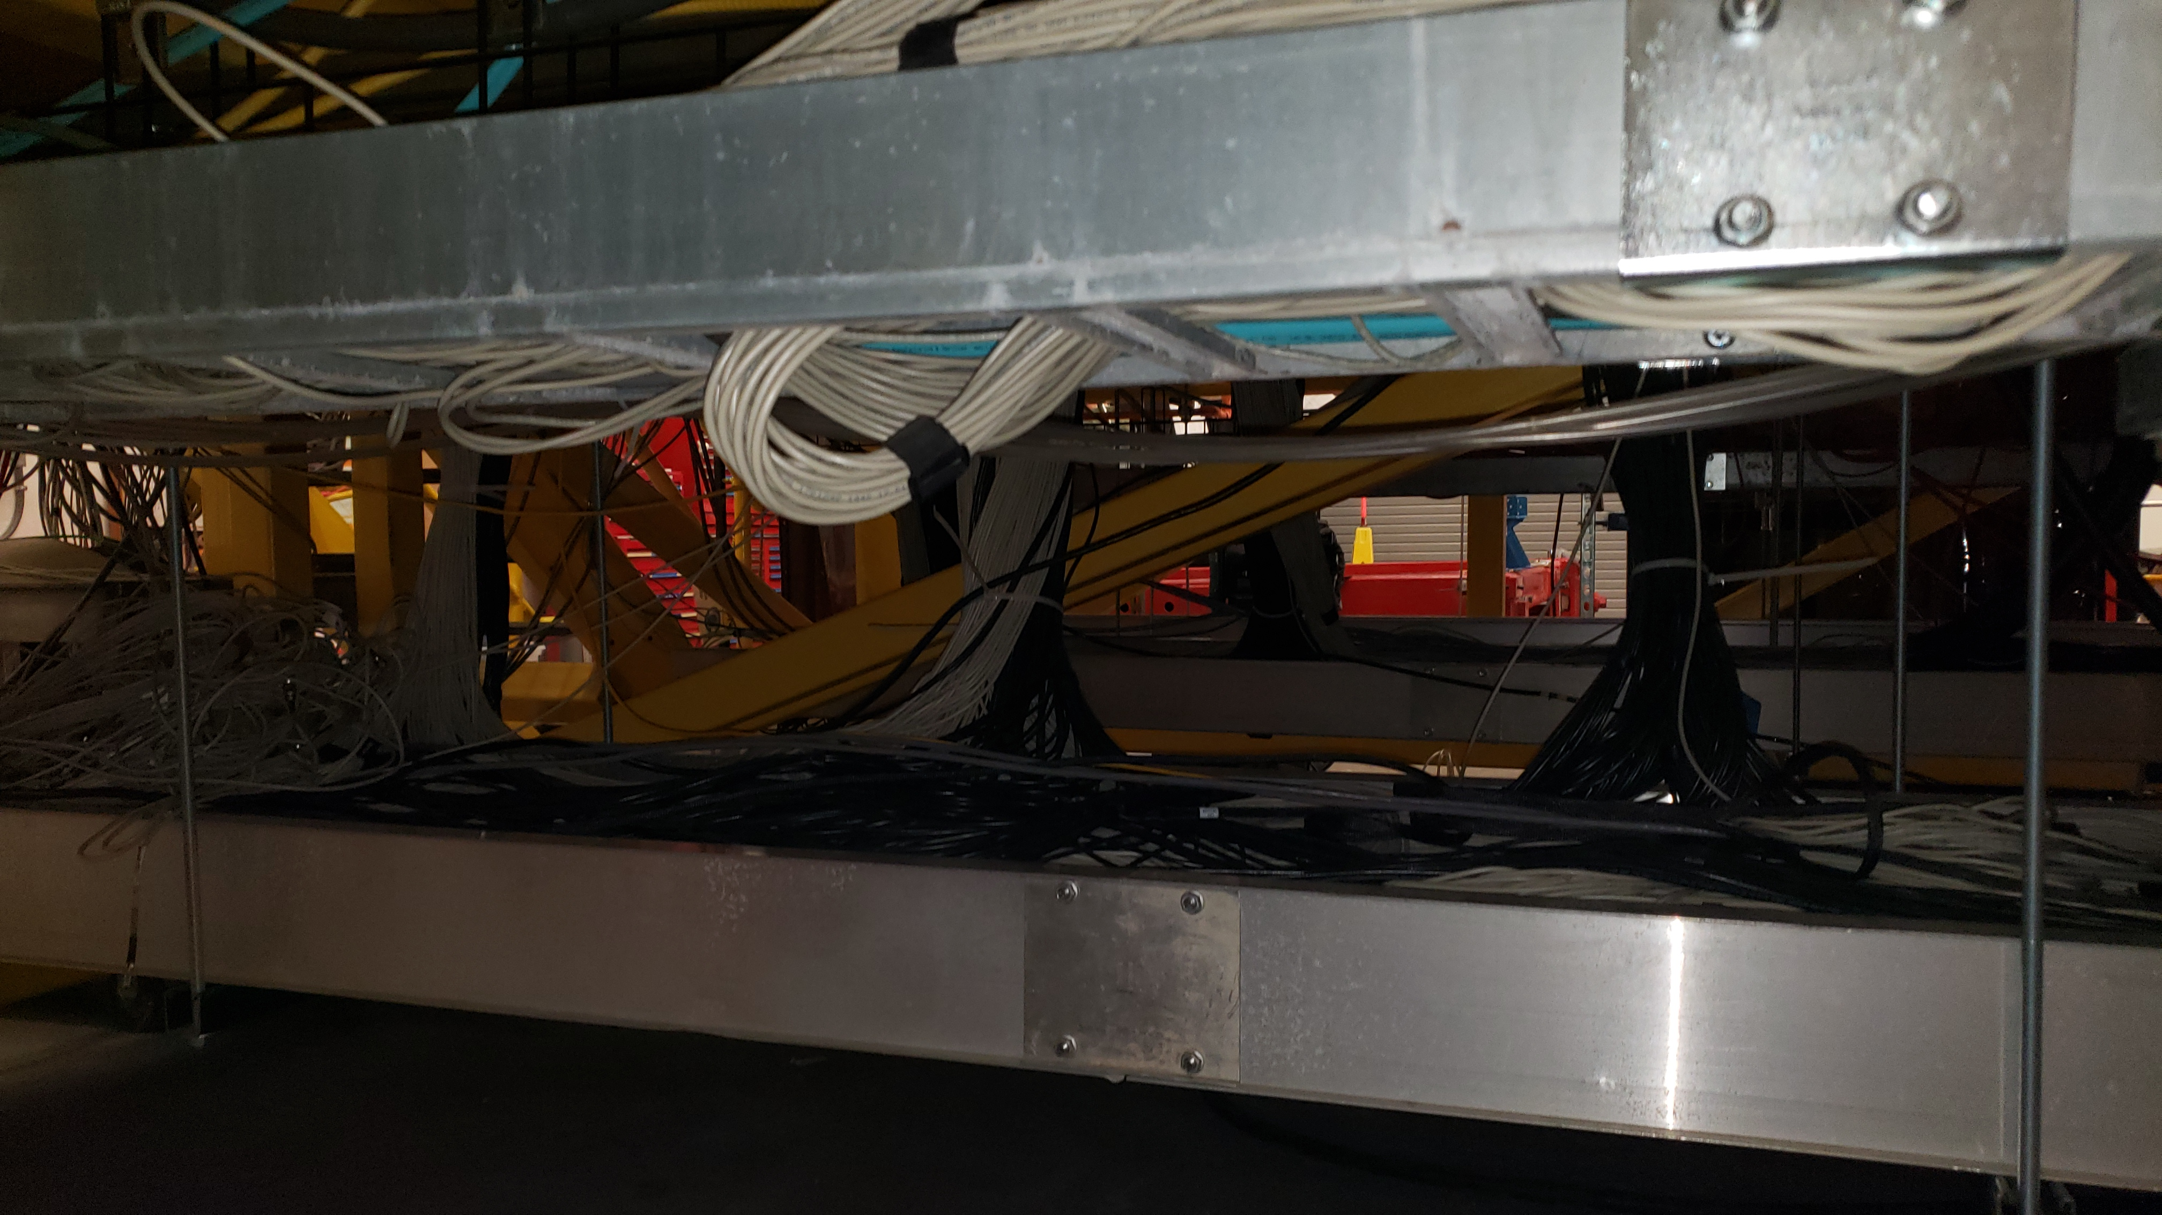
Figure 3. Cable tray at the bottom of the FCAL platform.

Step 2

Disentangle the cable bundles positioned at the bottom of the cable tray shown in Fig. 3.

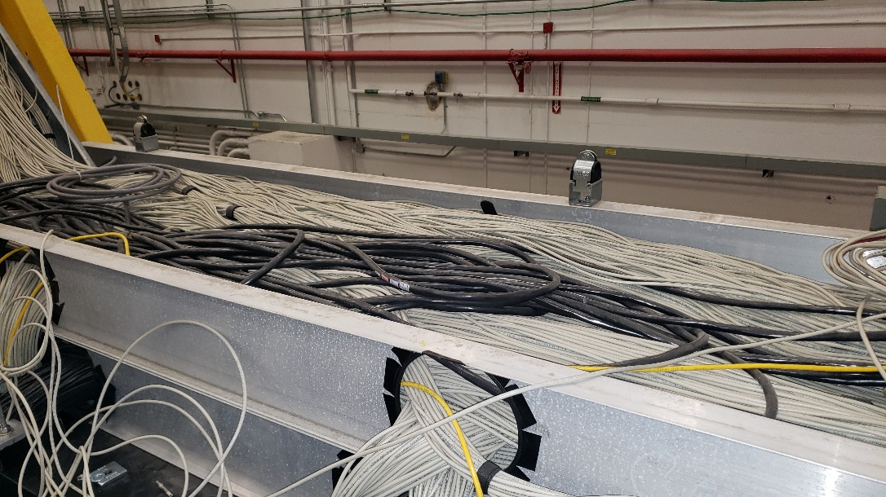

Figure 4 Cable tray at the top of the FCAL platform.

Step 3

Pull the cables up to the labyrinth shown in Figure 5.

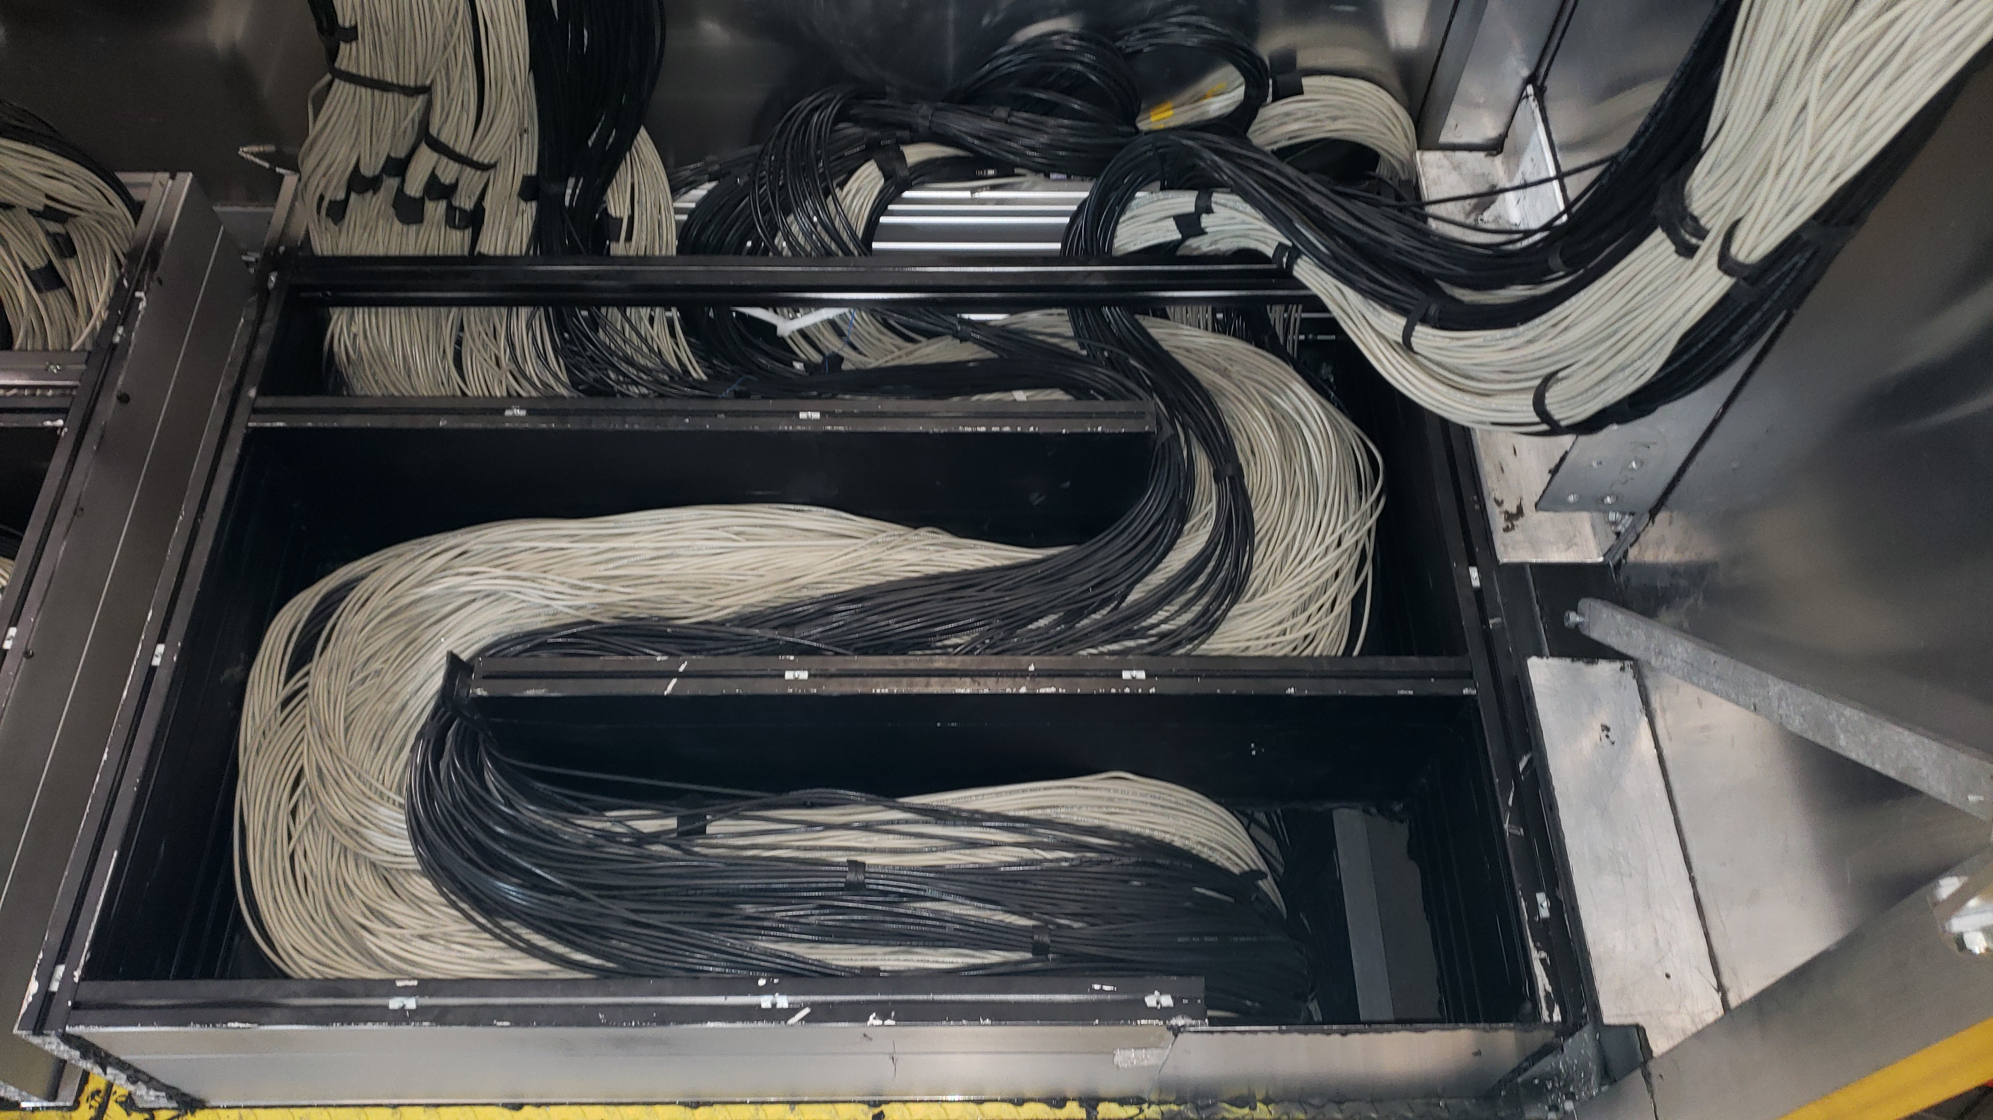

Figure 5. Cable labyrinth.

Step 4
Disentangle and remove the bundle from the labyrinth.

Step 5
Follow the same procedure as in steps three and four, except the cables go to the top cable tray.

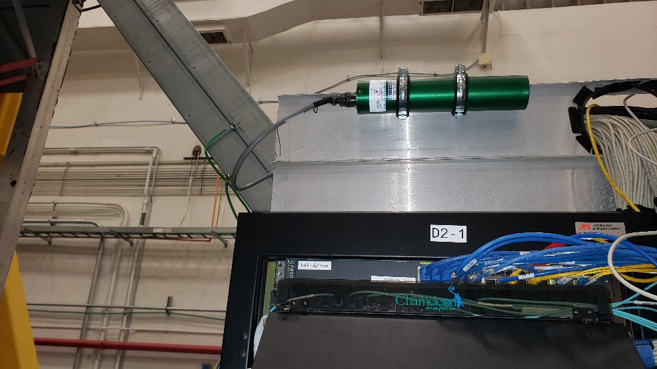
Ramp
Figure 6 Ramp on the top cable tray

Notes
The cables must be pulled and released from the cable tray on the top to the cable tray ramp shown in Figure 6. Removing cables from the top frame will be performed by the technician crew.

Step 6
Remove the labels from the cables. Rink the test cables and relabel. This will be discussed in a separate procedure. The work will be performed in the ramp to the experimental hall. All cables must be surveyed and released by the RadCon group.

