FCAL 2 Cable Labeling Procedure

A.Somov, V. Berndinokov, A. Asaturyan, H. Voskanyan, I. Jaegle,
H.Beauliere, M. Bilakhia, M. Blatchfors, H. Cardenas, C. Cassidy, B. Friedman, M. Kaban,
A. Martinez, V. Murakhovskiy, P. Nazzaro, B. New, P. Sanford, D. Silfast, Q. Stefan

Jefferson Lab, 2023

Location: Work will be performed in the ESB and experimental Hall D

Step 1

The labels for the modules are inputted to Excel from the paper documents outlining which cables are to be moved, taken out, and added. The positions subsequently assigned are defined in a scheme (shown below) to organize the cables into their places in the setup. An example of the label on the signal cable connected from the flash ADC to the patch panel on the ECAL dark box is shown below:

where X and Y stand for the column and row of the ECAL module and are followed by the crate (flash ADC slot, channel)

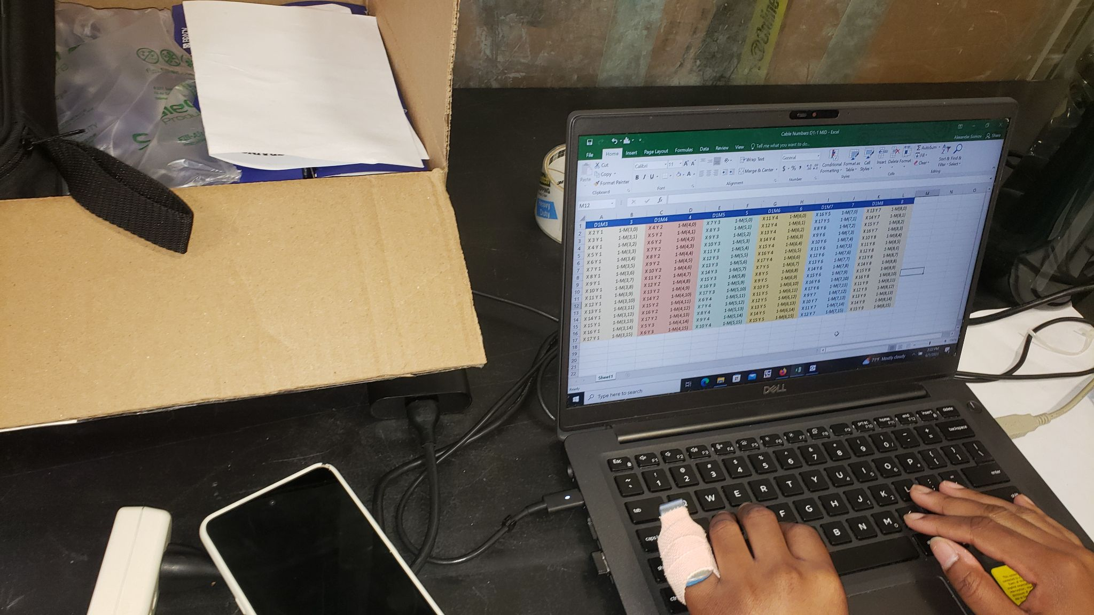

We used a flash drive to import the Excel file into the labeling machine: below is another picture of the process creating the setup.

Step 2

Once the flash drive is inserted into the label printer, the arrows below indicate the configuration on the printer to print to the specifications of the Excel spreadsheet.
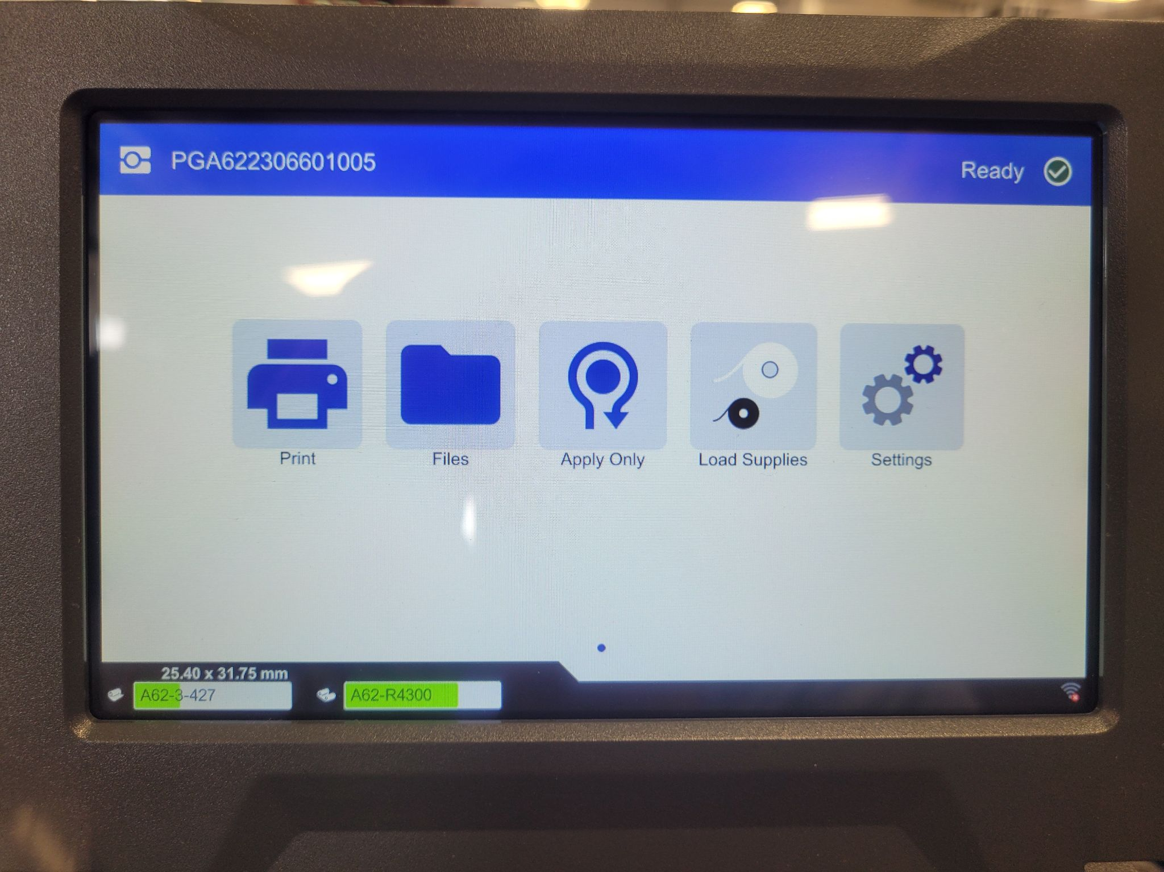

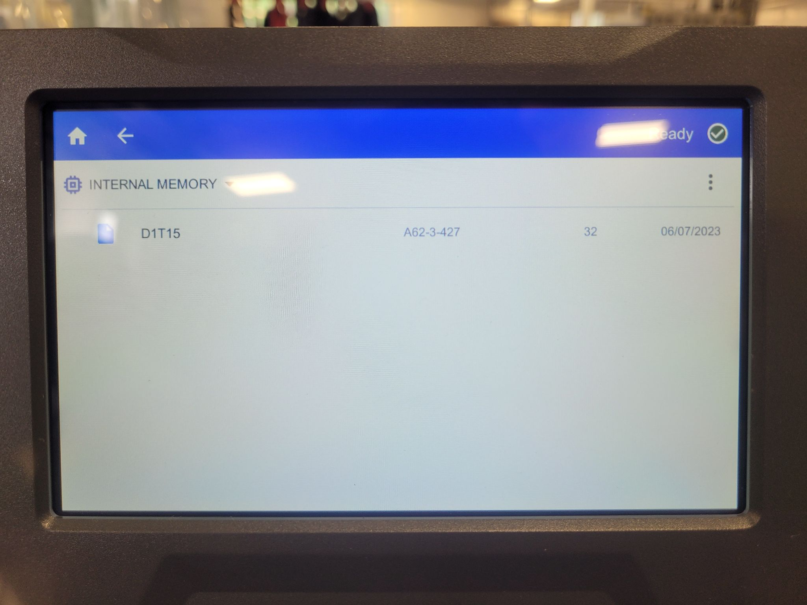

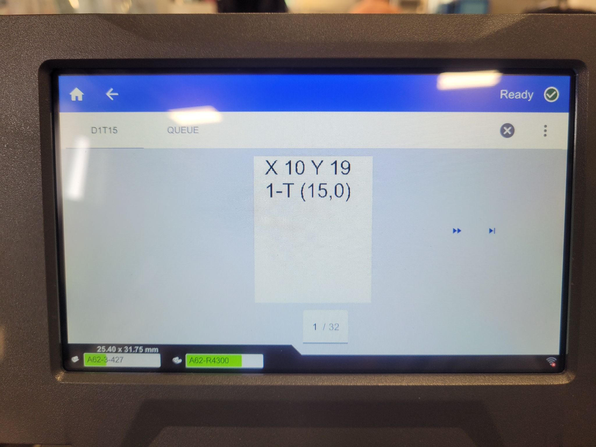

Step 3

Cut the zip ties from the single cable bundle and straighten both ends of the cables.

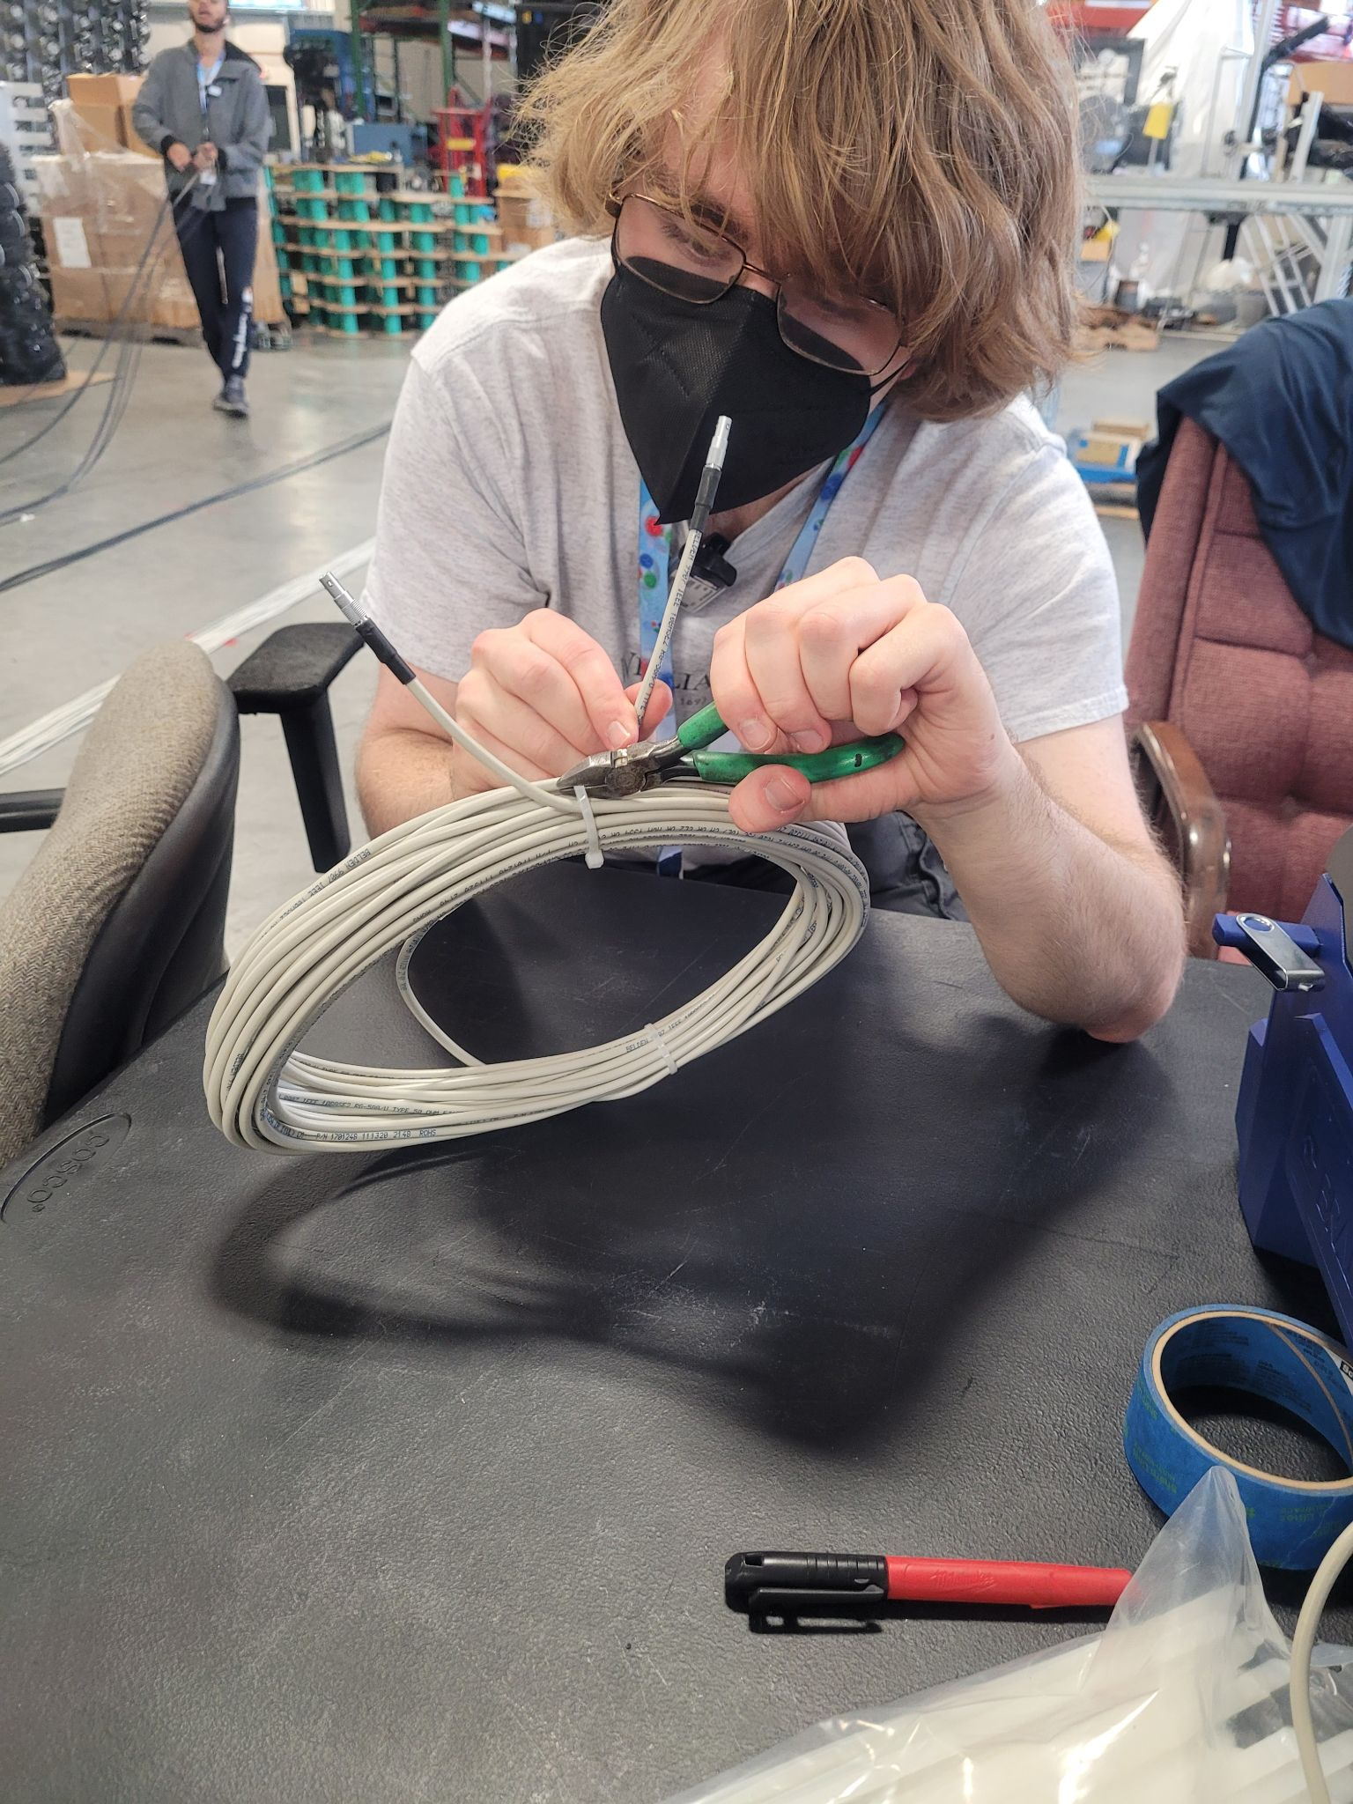

Step 4

Push the cable into the opening of the wrapper (the clear tray shown below), lining it up with the edge of the machine to ensure consistent label placement.
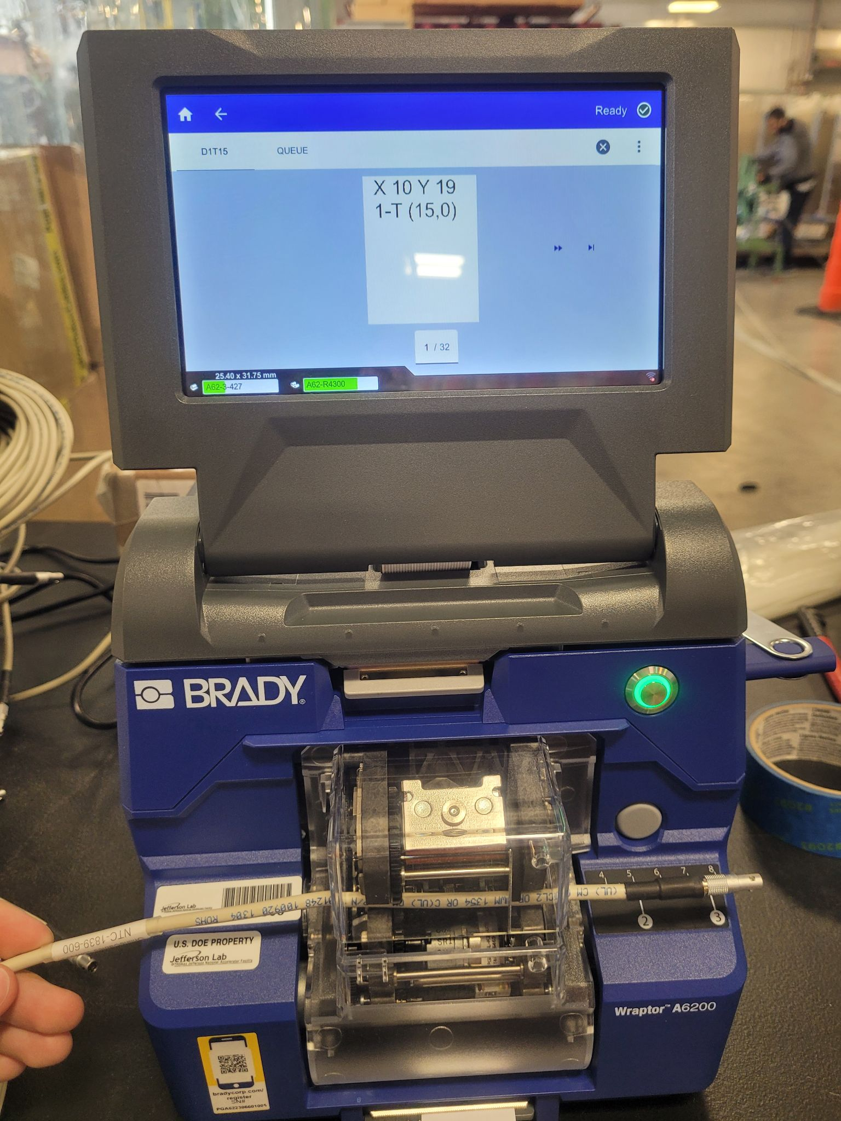
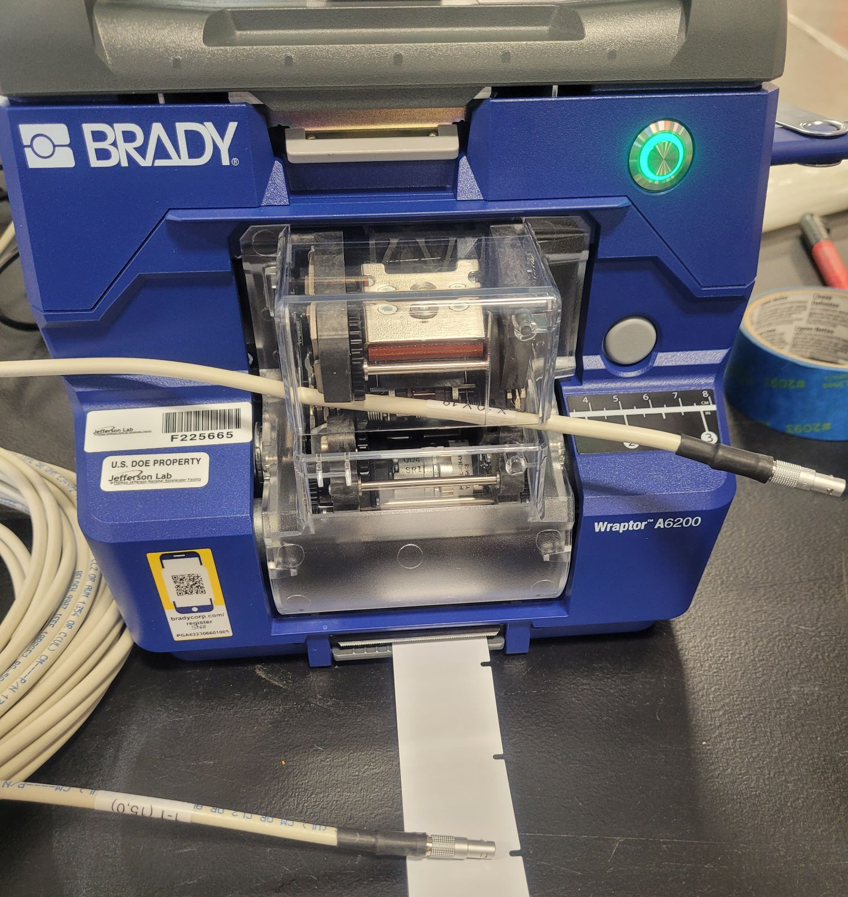

Step 5

The cables then must be checked to make sure that the labels are appropriate to what has been planned: a mistake in labeling would be inconvenient later.

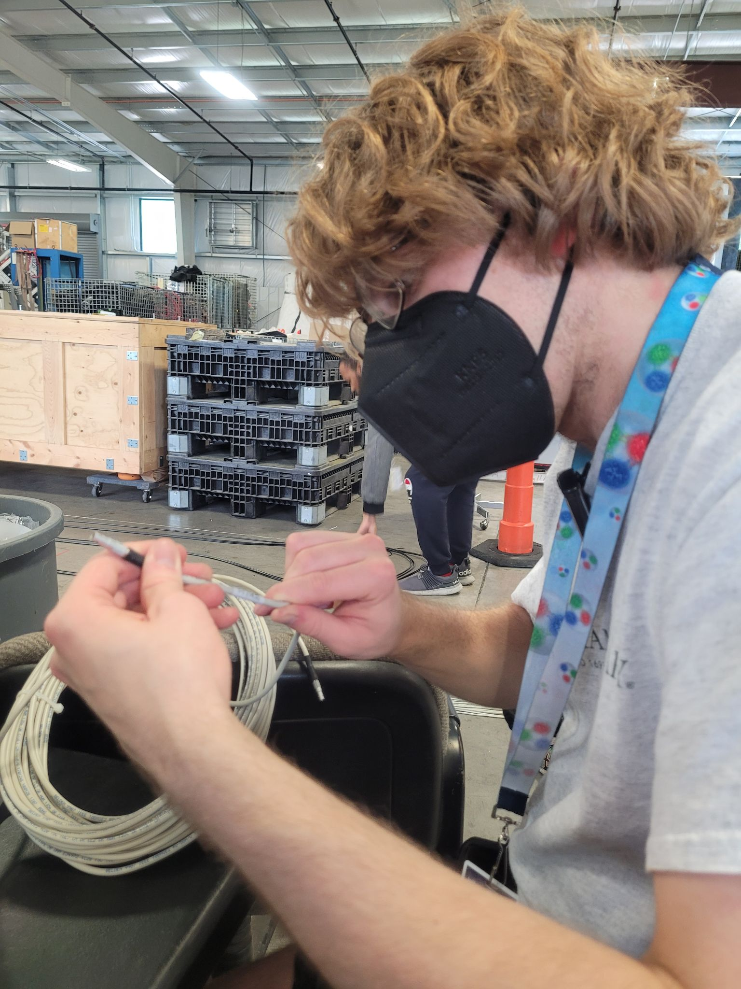

Step 6

Line the labeled cables and begin to stretch them along a straight line. Bundle the cables in a group of 16.

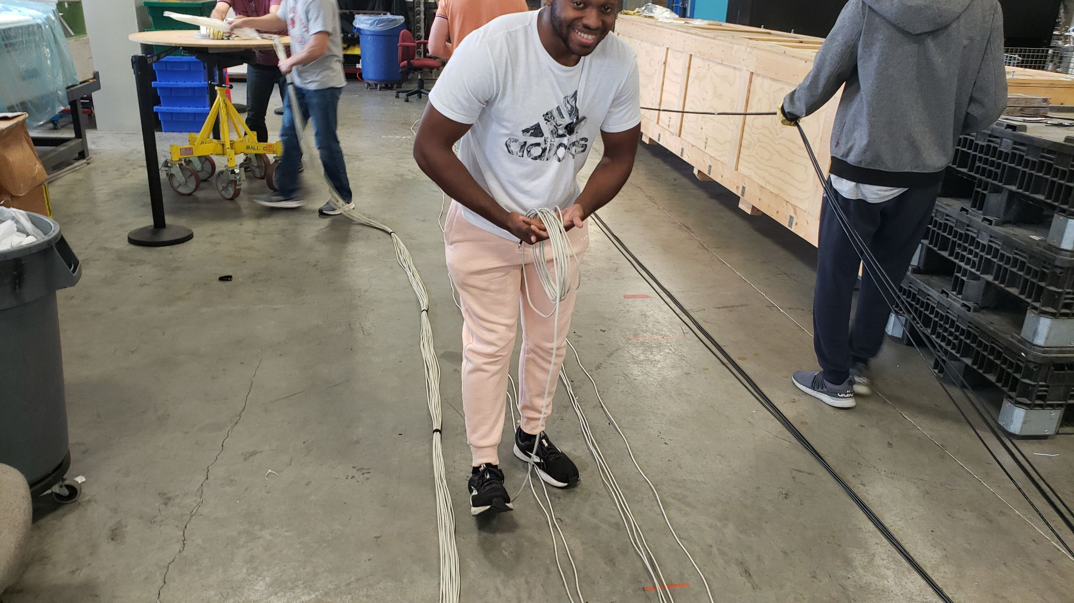
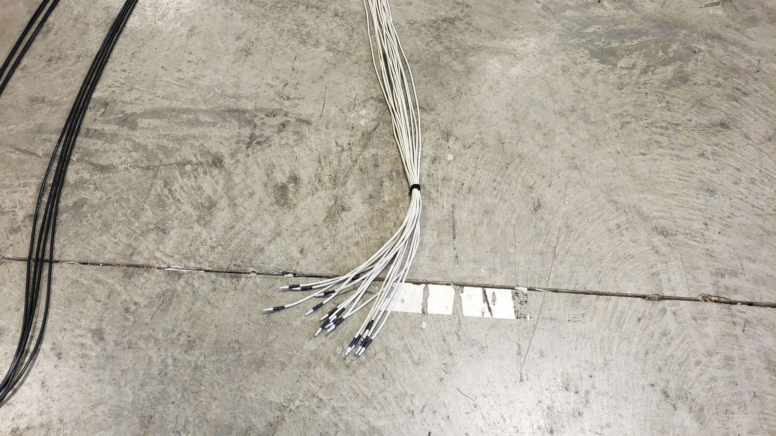

Step 7

Velcro the bundle from both ends as well as the center

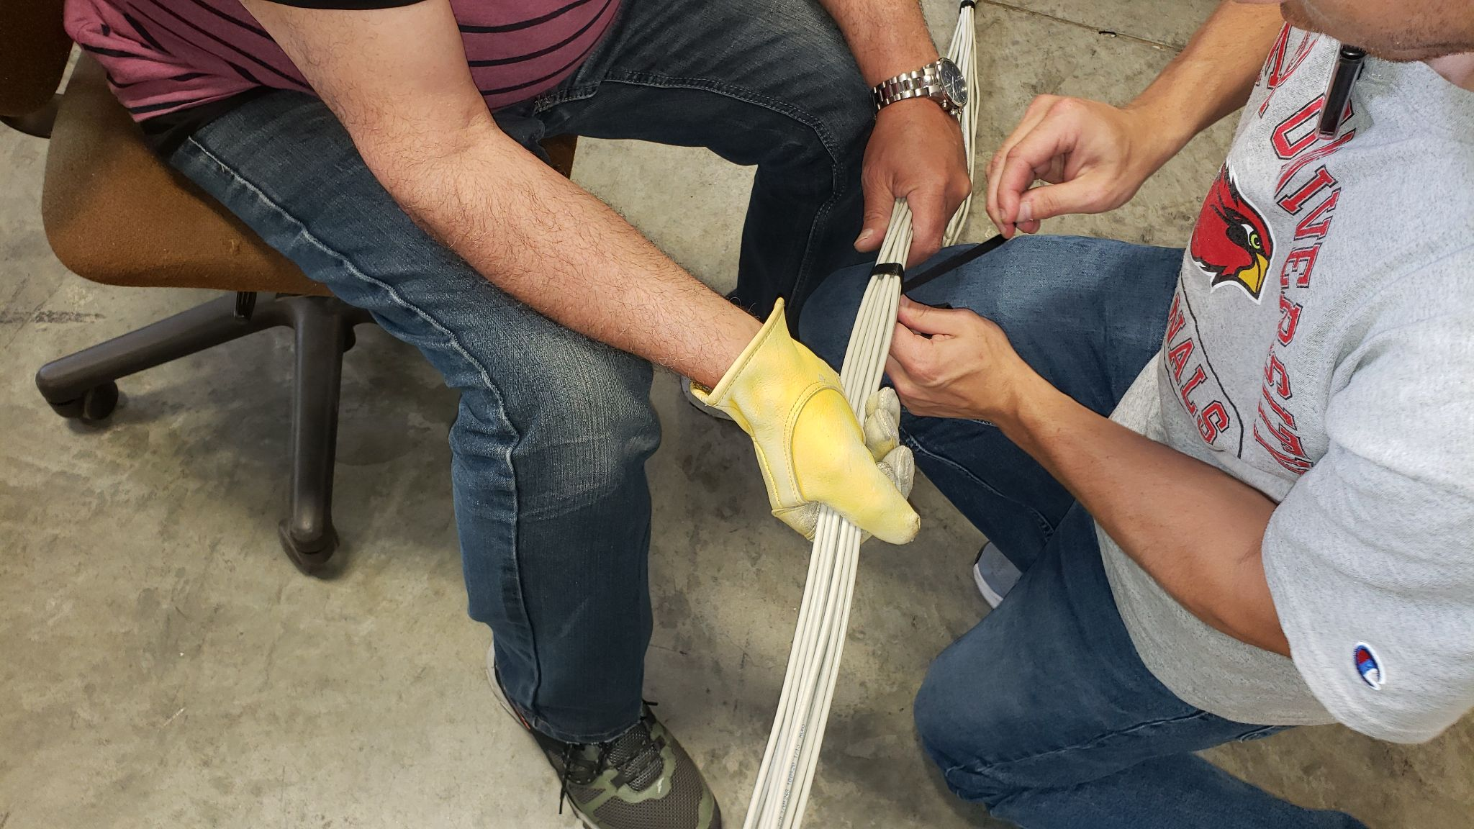
Step 8

The cables are wrapped around a rolling table for greater ease, or often around a worker’s arm. This bundle is then packed up.

