Checklist for Quality Assessment of Modules

A.Somov, V. Berndinokov, A. Asaturyan, H. Voskanyan, I. Jaegle,
H.Beauliere, M. Bilakhia, M. Blatchfors, H. Cardenas, C. Cassidy, B. Friedman, M. Kaban, A. Martinez, V. Murakhovskiy, P. Nazzaro, B. New, P. Sanford, D. Silfast, Q. Stefan
Jefferson Lab, 2023

- Inspect joints (look for rust or failure of a joint)
- Check for uniform gap at joint (look for loose screws)
- Check gap between tensioning plate and flange (to confirm if the silicone cookie is there)
Good  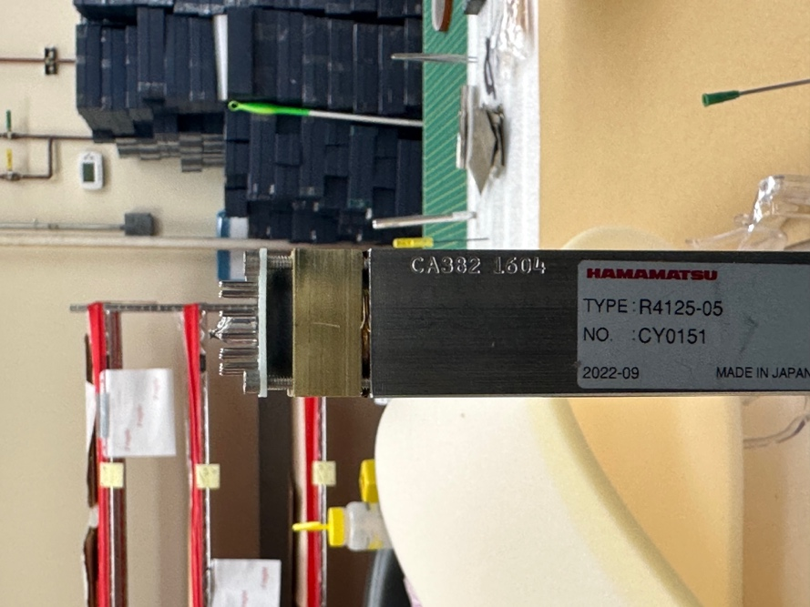  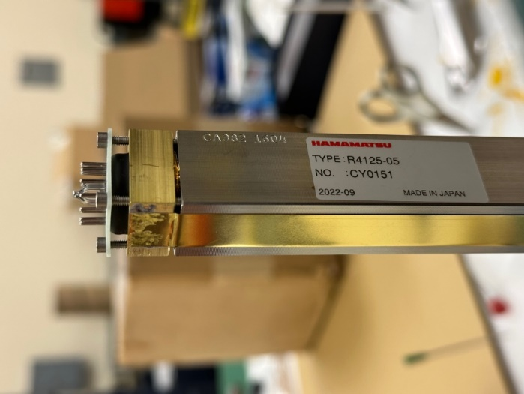 | Bad  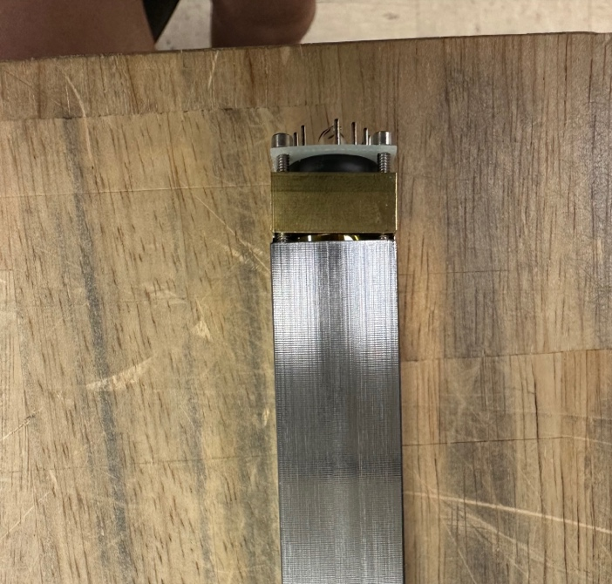  Example where silicone cookie is missing:  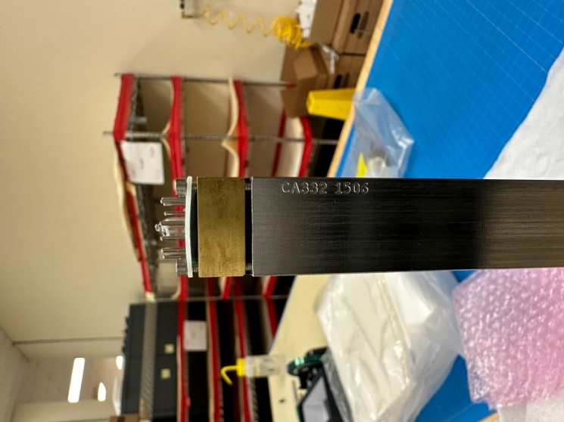

- Check orientation of the PMT and labels/numbers

Good  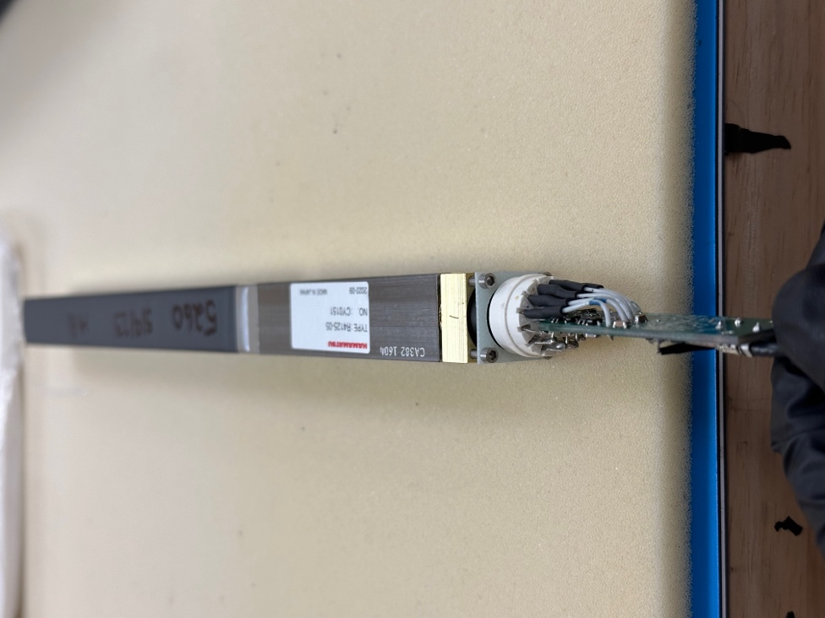  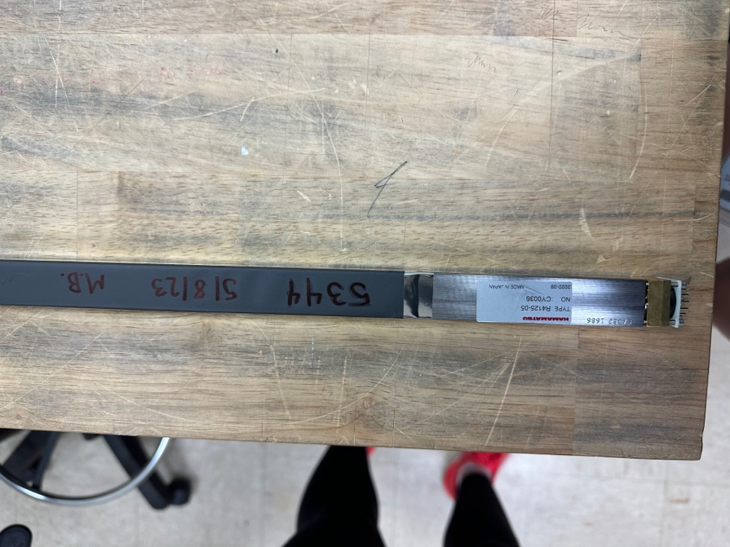 | Bad  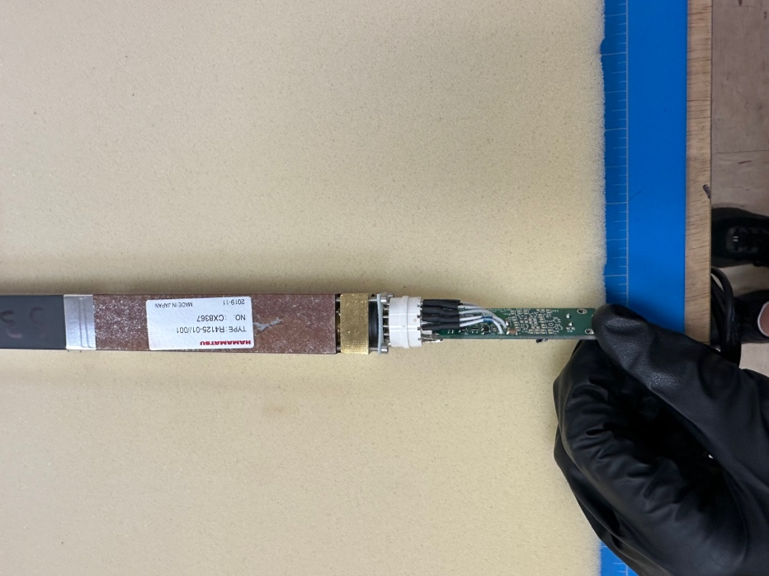

- Ensure that the front flange is centered
- Check crystal (look for any indication of chips/cracks)

Good  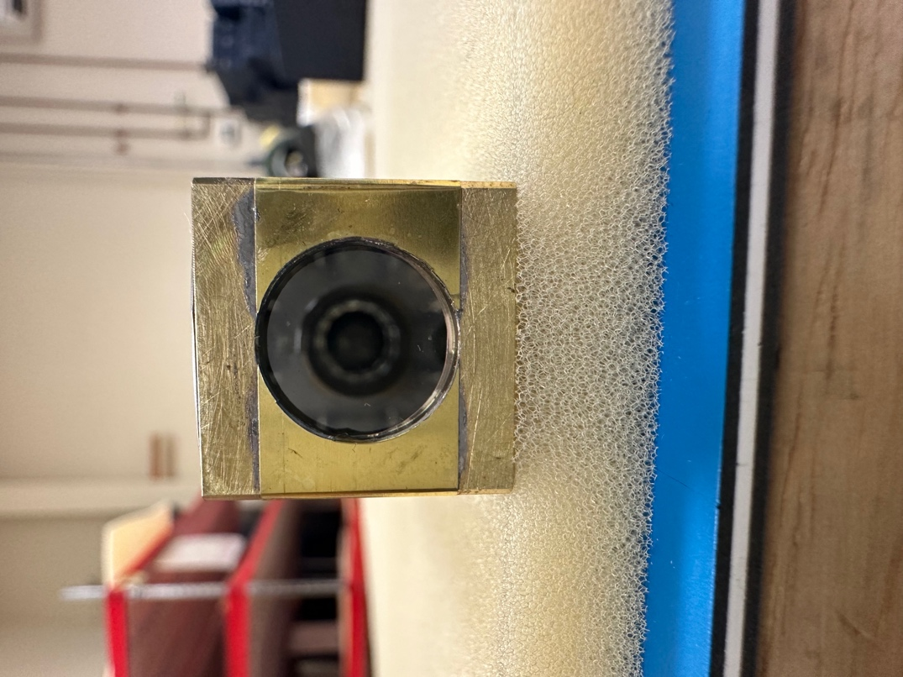 | Bad  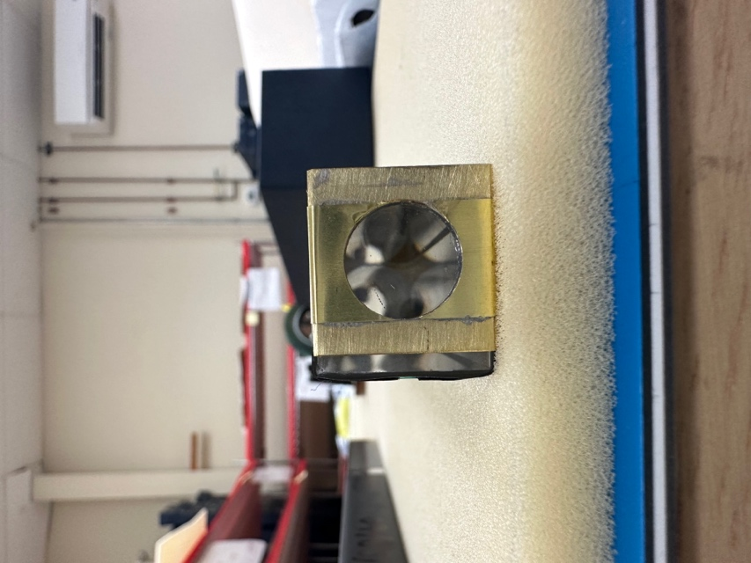  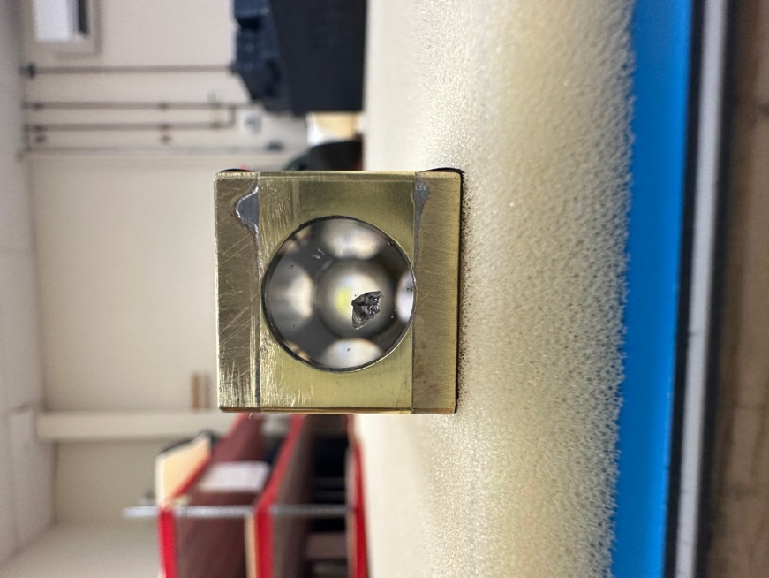

- Clean straps with alcohol

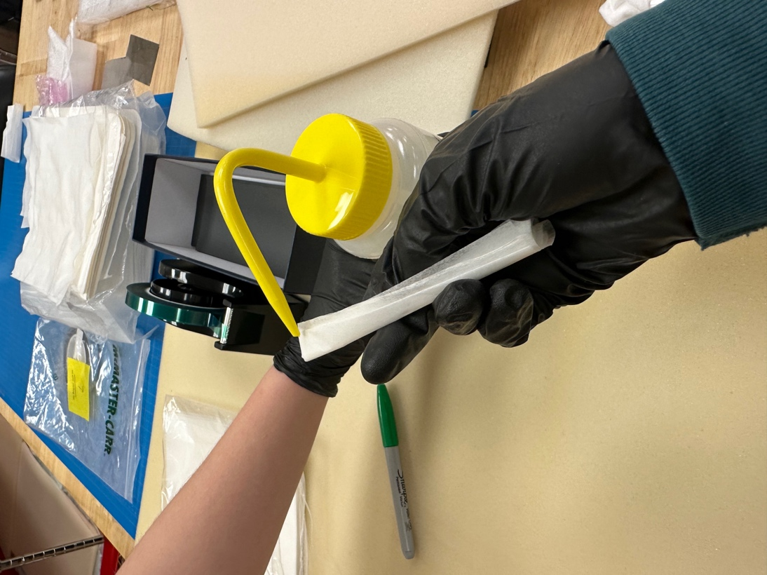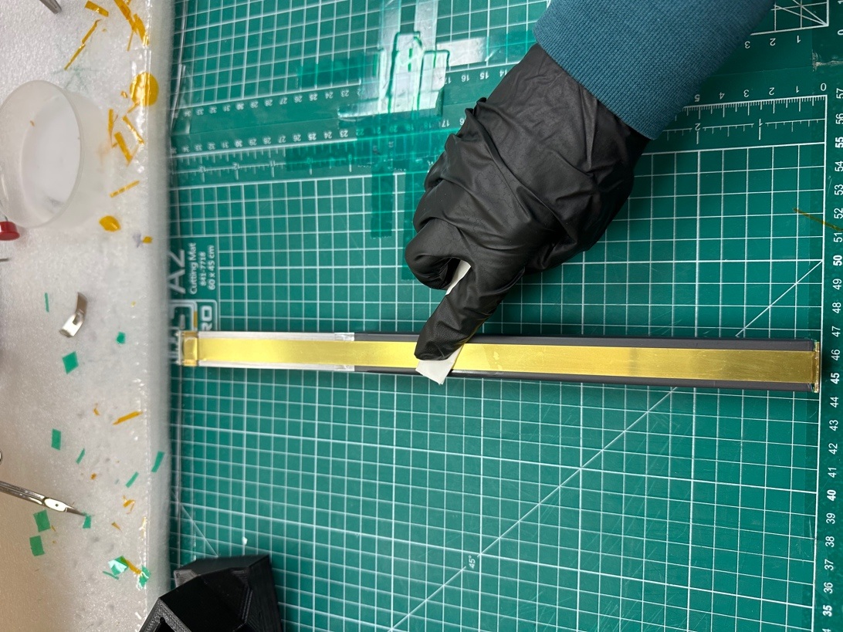

- Add Kapton tape (wrap around, but DO NOT OVERLAP the tape)

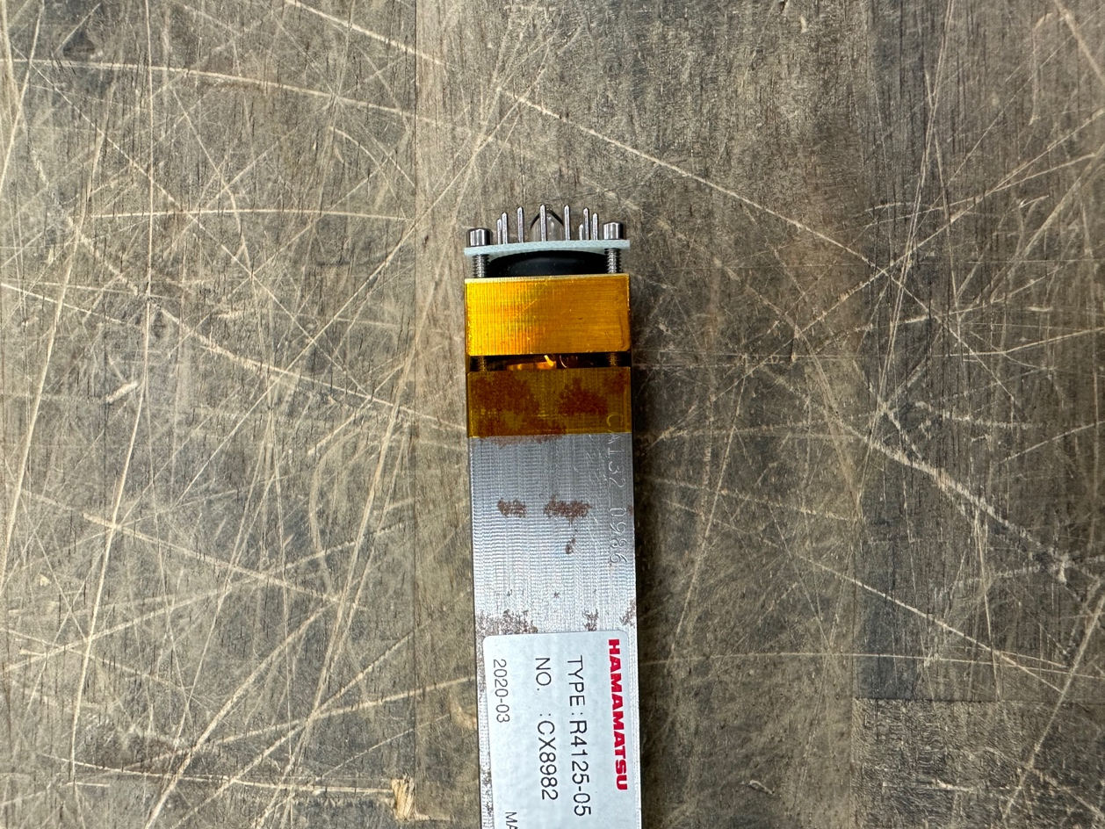

- Ensure there are no bumps/wrinkles/overlaps of tape on Tedlar

Good  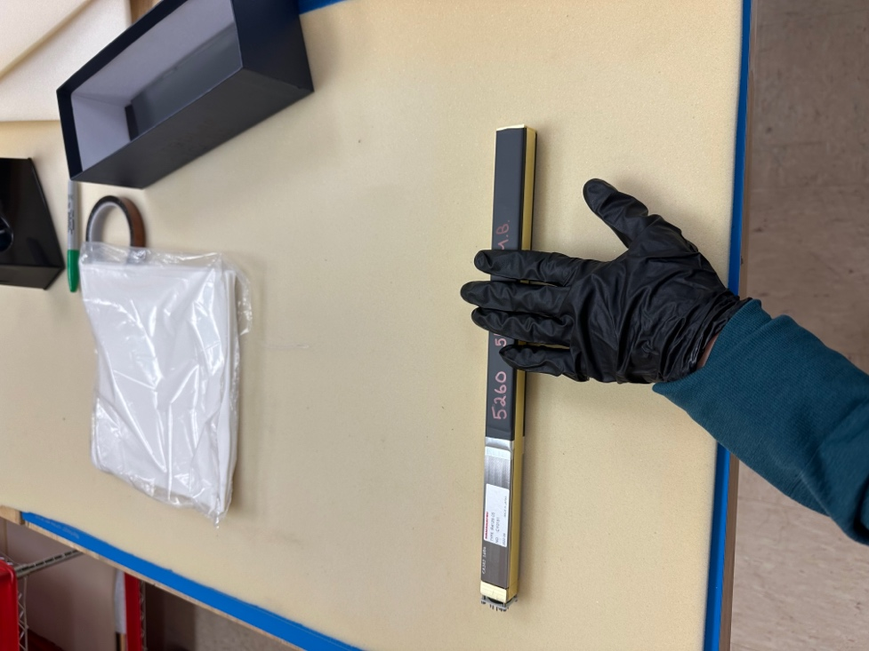  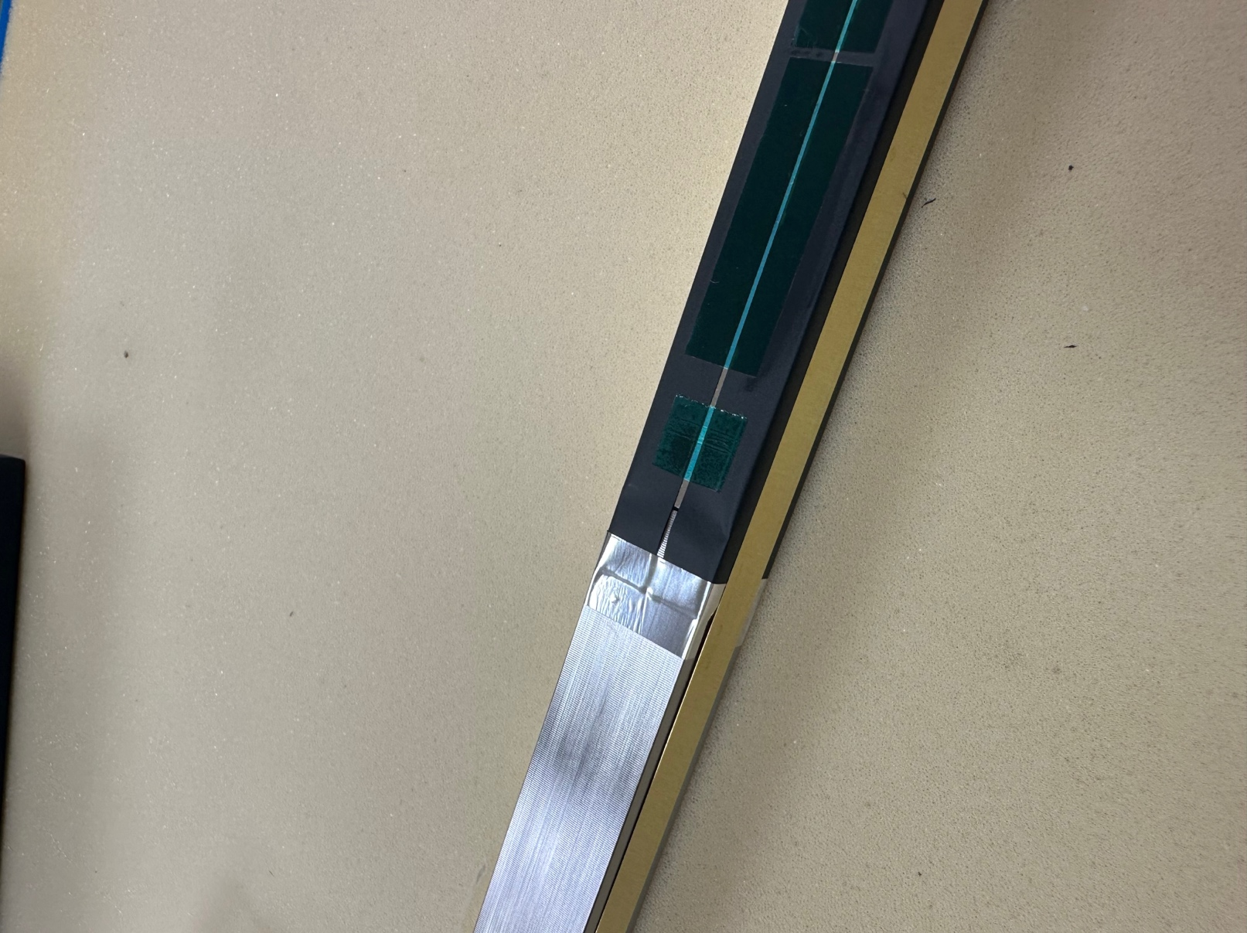 | Bad  