Test of ECAL modules using LED (in preparation)

A.Somov, V. Berndinokov, A. Asaturyan, H. Voskanyan, I. Jaegle,
H.Beauliere, M. Bilakhia, M. Blatchfors, H. Cardenas, C. Cassidy, B. Friedman, M. Kaban, A. Martinez, V. Murakhovskiy, P. Nazzaro, B. New, P. Sanford, D. Silfast, Q. Stefan
Jefferson Lab, 2023

Step 1

Place two ECAL modules Inside the dark box

Step 2

Switch on LED system
- Switch on 5 V power (Fig. 1)
- Switch on bias voltage
- Switch on pulse generator
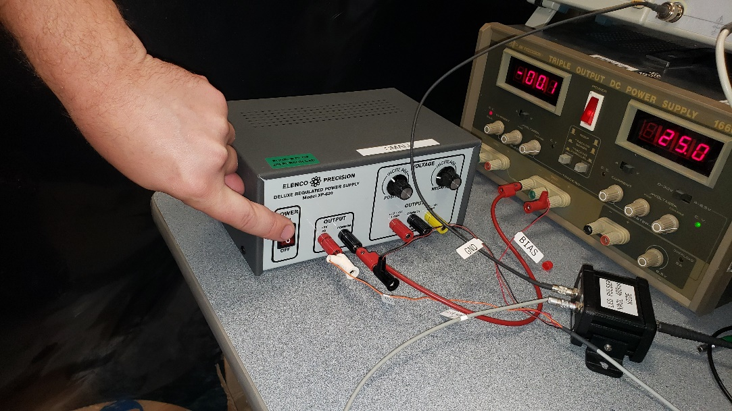

Fig.1 Switch on 5 V power supply

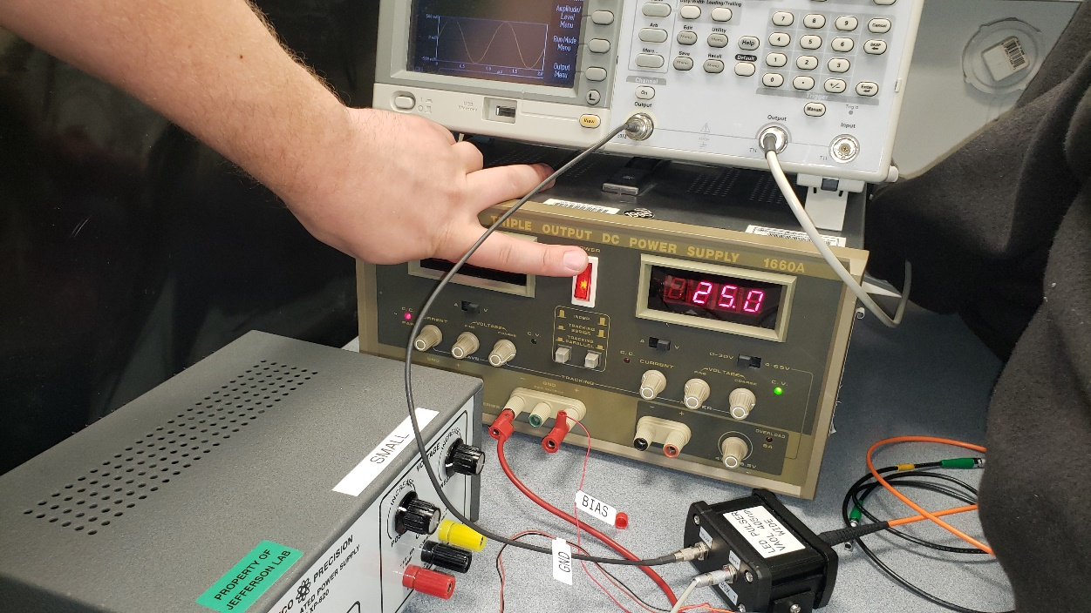

Fig.2 Switch on bias voltage power supply

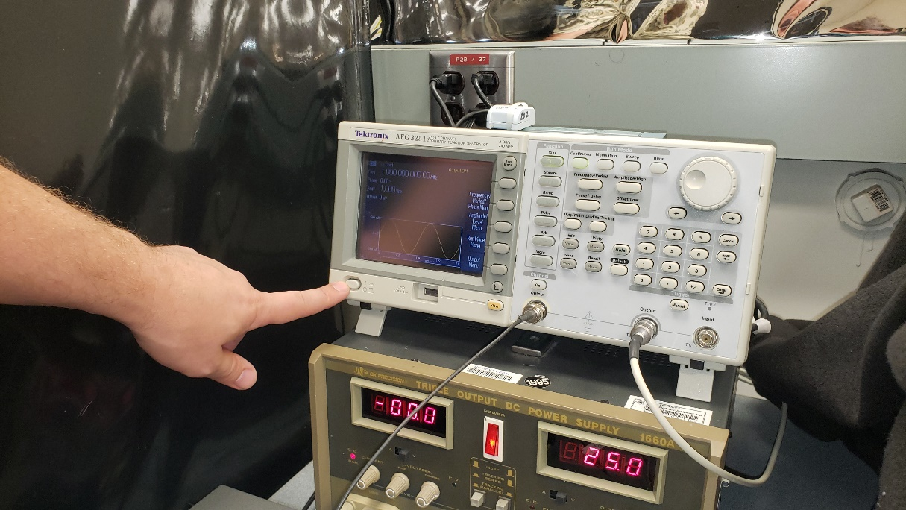

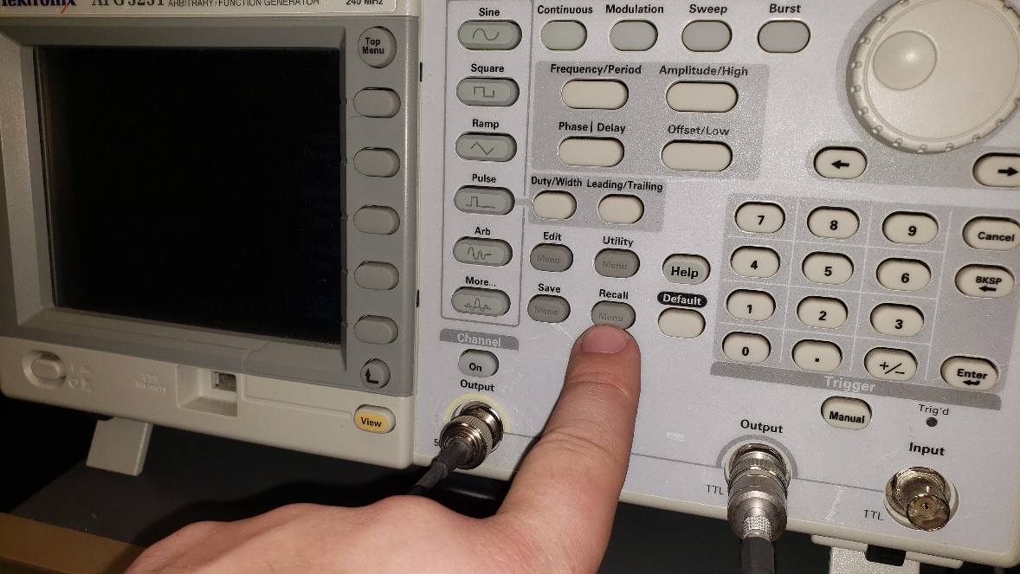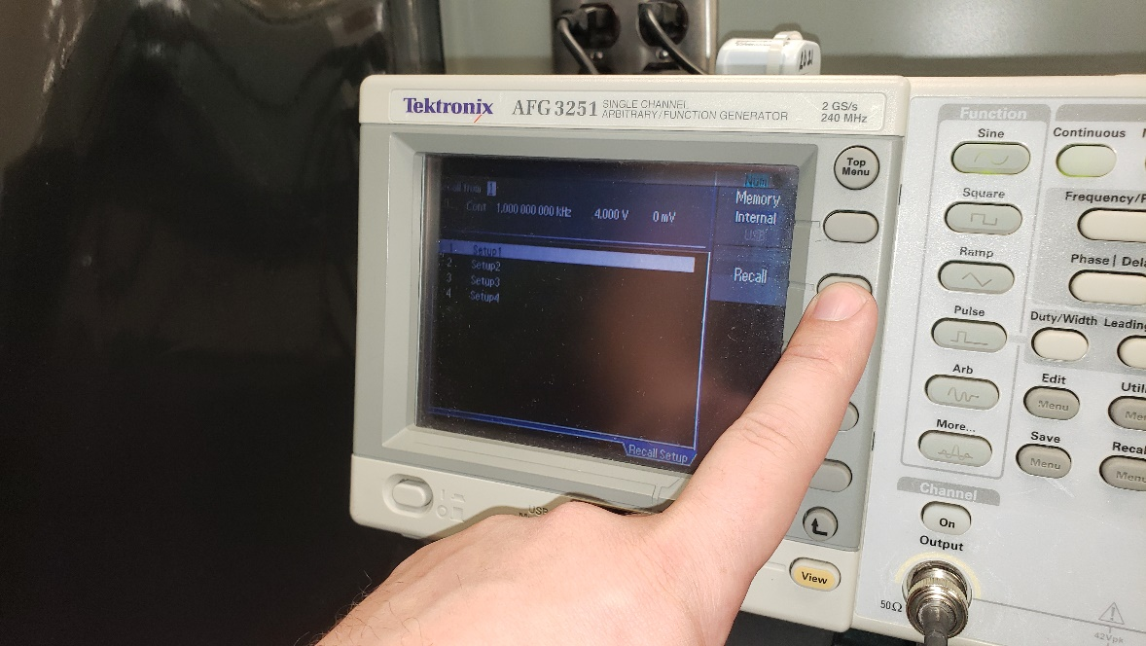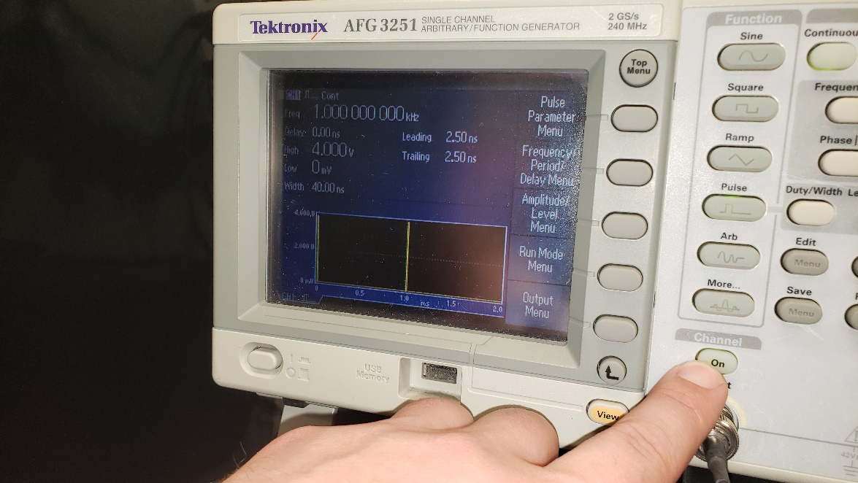

Fig.3 Switch on pulse generator
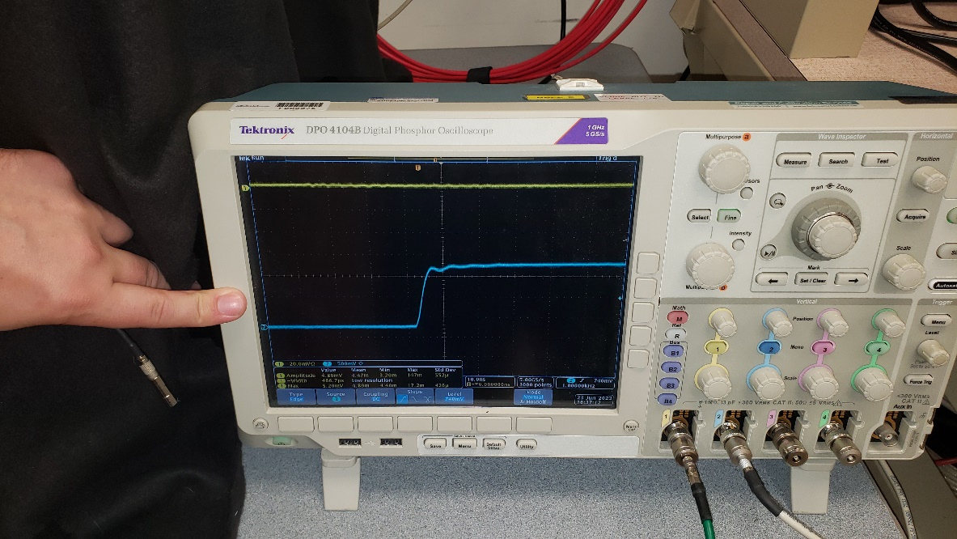

Fig.3 Generator pulse on osciloscope

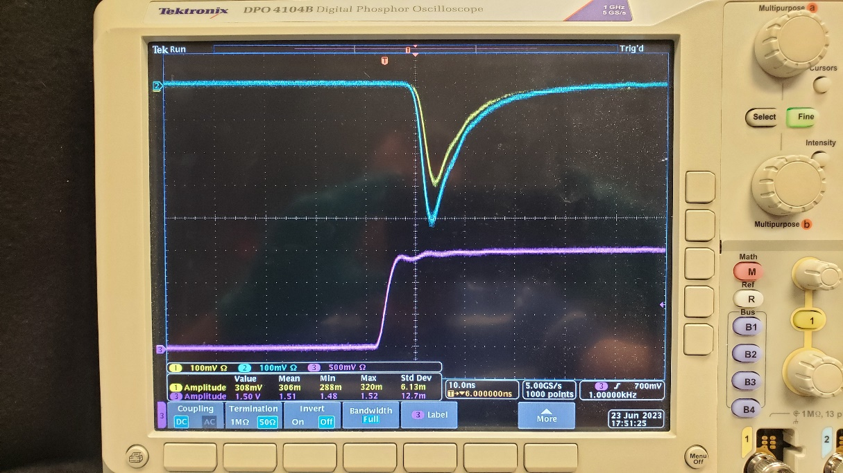

Fig.3 Signal pulses from two ECAL modules (yellow and blue)

