TITLE: WRAP MYLAR AND TEDLAR AROUND LOWER PORTION OF LIGHT GUIDE | DATE: 09/18/2013
BY: WILLIAM CRAHEN | APP: ___________________________
 | PRINT: _________________________
CHK:______________________  PRINT: ____________________ | APP: ___________________________  PRINT:_________________________

REV. | DESCRIPTION | BY | CHK. | APP. | APP. | DATE

PREPERATION
Safety Equipment Required:
Work Area Requirements:

The work area should be well ventilated with good lighting. There should be no adjacent activities that generate particles/dust or aerosol contaminants.
# of Technicians Required:
1

Material Required:
48 Gauge (12 micron/.00048” thick) aluminized Mylar rectangle precut to 5 ½” by 3 5/8”. One required/PMT.
Black (opaque) TEDLAR film rectangle .0015” thick, precut to 5 ½” by 3 5/8”. One required/PMT.

¾” wide 3M 810 Scotch MAGIC tape precut into rectangles ¾” by ¼”. two required/PMT.

3M super 33+ electrical tape, ¾” wide.

Isopropyl Alcohol

Scales

Note: Safety glasses are required when using Isopropyl Alcohol

Note: GLOVES MUST BE NITRILE, NOT LATEX! LATEX INTERFERES WITH CURING OF THE SILICONE.

Procedure

- Wipe down the light guide with Isopropyl alcohol and a lint free wipe. Use the Isopropyl alcohol wipe to clean any finger prints off the Aluminized Mylar as well:
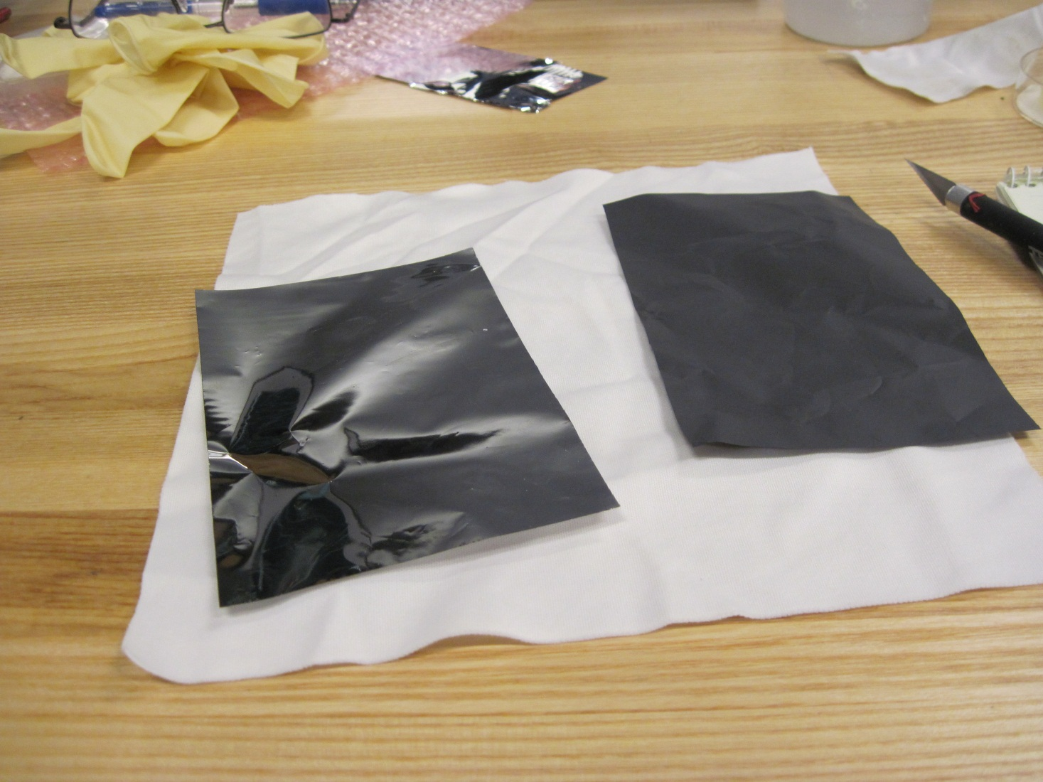

- Position the Aluminized Mylar piece at the edge of the Silicone joint as shown below. The 5 ½” dimension will wrap the guide twice. Do not tape the beginning of the Mylar to the guide. Wrap tightly around the guide with no wrinkles (wrinkles would affect the final diameter, which will be clamped with a precision split collar). The area where the collar will be is shown below. Do not tape over the Mylar lap, instead, tape the Tedlar onto the end of the Mylar with the Scotch Magic strips as shown in the second picture:

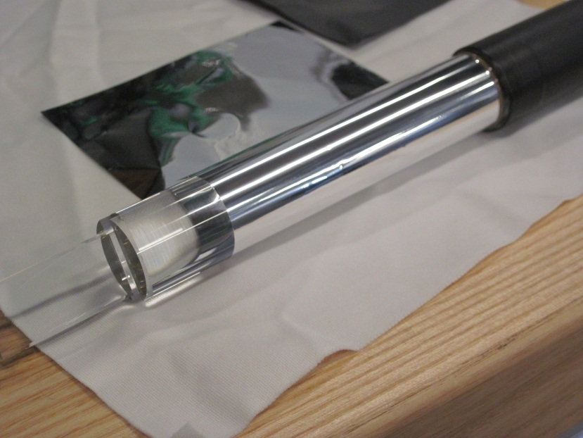
Possible alternate steps- tape the Tedlar onto the Mylar before wrapping.
Collar area
0.7”
2.1”

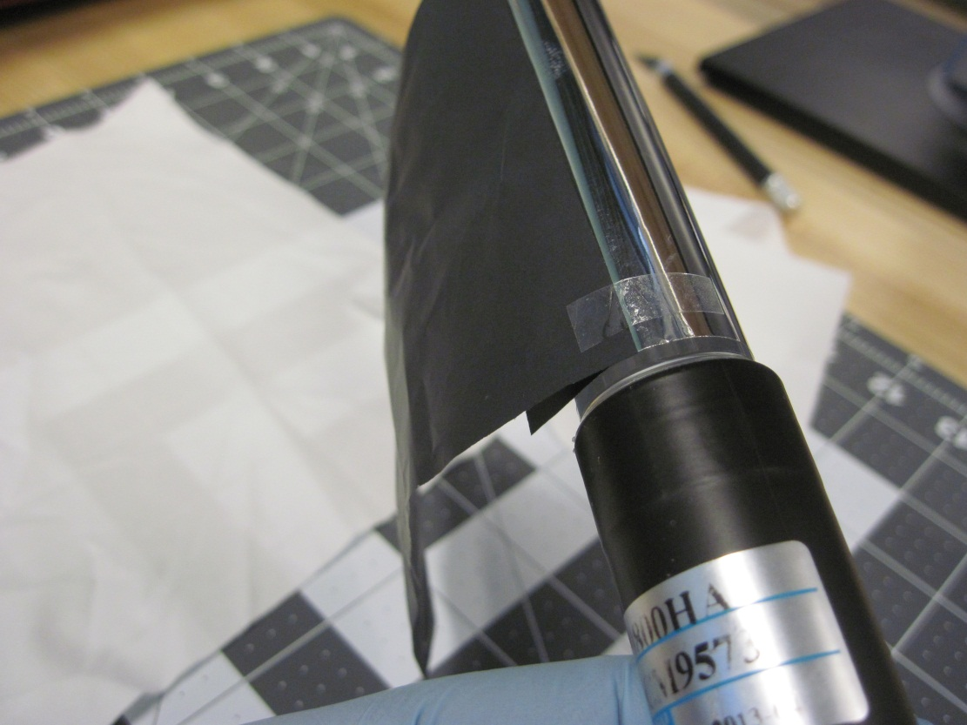

- Continue the wrap with the Tedlar, keeping it tight and wrinkle free. The ends can now be wrapped with ONE COMPLETE WRAP of Scotch 33+ electrical tape. Note that the left wrap shown below MUST NOT be closer than 2.8” to the edge of the PMT (collar area) Note in the second photo that the left tape edge must leave a narrow band of Mylar exposed (this will be in turn covered with mylar at a later step:
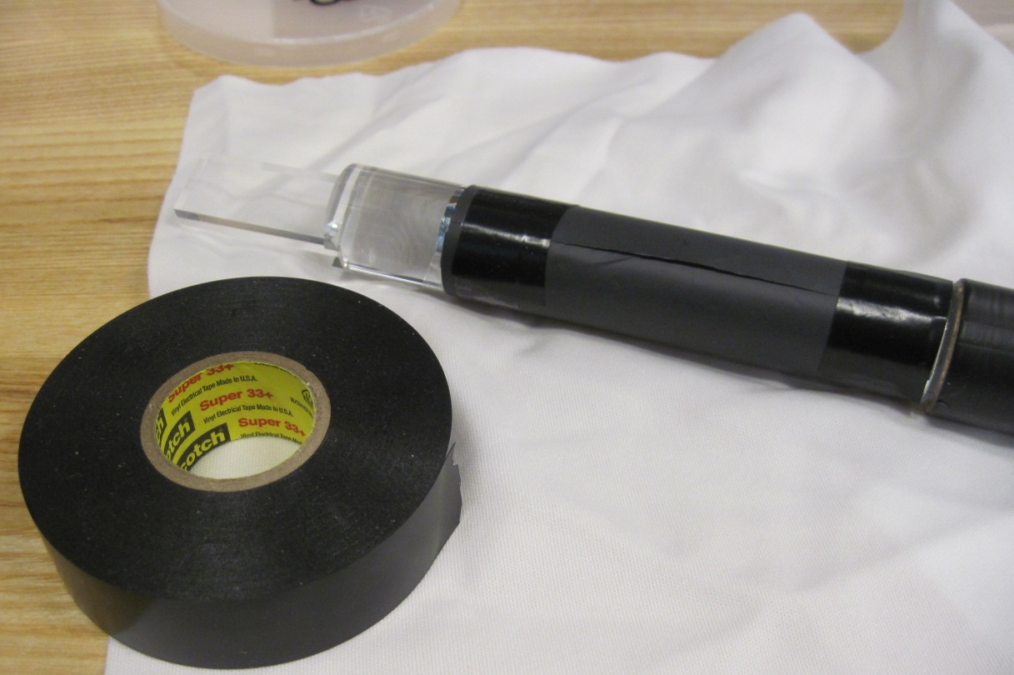
2.8”
Electrical tape ends just to right of the Mylar. Mylar wrap will be extended later to make a reflector with no gaps.

- Use calipers to confirm that the collar clamp area is 0.888 +/-.003” in diameter. If this measurement is out of range, you may have wrinkles. Correct/repeat the wrap as needed.

- The light guide/PMT joint area can now be over-wrapped with layers of electrical tape. Do not add tape to the other end! Store the assembly in a light tight container until the next step.
